NOTICE OF PUBLIC HEARING

Tuesday, October 27, 2026 @ 6:00 PM

Morgan County Courthouse – 48 West Young Street

Commission Chambers

Public Hearing/Discussion/Recommendation – Eggett FLUMA & Rezone: A request to change the future land use map from A-20 (Agriculture, 20 acres min.) and RR-1 (Rural Residential, 1 acre min.) to Ranch Residential 5 and to change the zoning from A-20 and RR-1 to RR-5 (Rural Residential, 5 acre min.) on 20.30 acres at 667 W. Hardscrabble Court located in the Porterville area in unincorporated Morgan County.

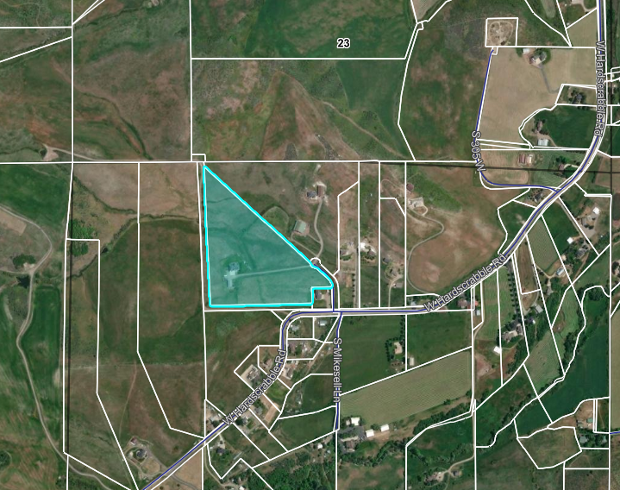

Prior to the meeting date, written comments may be sent to:

kbecker@morgancountyutah.gov

Additional information may be obtained by contacting

Planning & Development at 801-845-4015 or submit@morgancountyutah.gov

