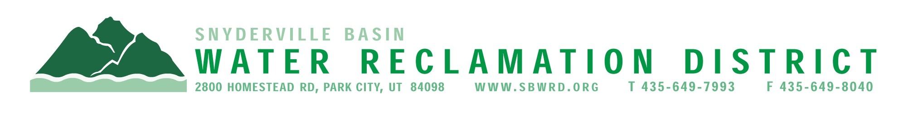
BOARD OF TRUSTEES MEETING

AGENDA

October 19, 2026
** District Office**
5:00 p.m.

** The meeting is open to the public and will also be
conducted electronically using Microsoft Teams**

** For information on how to connect to the meeting, please call 435.649.7993 or email
Kim Dudley @ kdudley@sbwrd-ut.gov by 4:30 p.m. on Monday, October 19, 2026**

I. CALL TO ORDER

II. CONSENT AGENDA
- Approval of Board Meeting Minutes for September 21, 2026
- Final Project Approval
  - Promontory – Scenic Valley Subdivision
  - Promontory – Hawks Pass Subdivision
- Escrow Fund Reduction Approval
  - Last Chance Subdivision Phase 2 – Retain 60%
  - Promontory – Scenic Valley Subdivision – Retain 10%
  - Promontory – Hawks Pass Subdivision – Retain 10%

III. PUBLIC INPUT

IV. APPROVAL OF EXPENDITURES – Bills in the Amount of $1,073,506.01

V. SERVICE AWARDS – Nick Walton – 5 years

VI. SUBDIVISION PROJECTS
Estimated LEA REs Year to Date: # Above Splitter 0; # ECWRF 268.5; # SCWRF 53.3; Total 321.8
Proposed this Meeting: # Above Splitter 0; # ECWRF 0; # SCWRF 0; Total 0

VII. DISTRICT MANAGER
- Discussion Items
  - Review 2027 Tentative Budget
  - Discuss Customer Survey
- Information Items
- Financial Statement
- Impact Fee Report

VIII. FUTURE AGENDA ITEMS
- Projects
- Operations
- Finance
- Governmental Matters

IV. ADJOURN
If you are planning to attend this public meeting and, due to a disability, require reasonable accommodation in understanding, participating in or attending the meeting, please notify the District twenty-four or more hours in advance of the meeting, and we will try to provide whatever assistance may be required. Board members may appear telephonically.

