MINUTES
Washington County Flood Control Authority
Executive Committee
Washington County Administration Building
111 E Tabernacle, St. George, UT 84770
September 1, 2026

PRESENT

Executive Committee
Craig Coats, Washington City Council
Troy Belliston, Washington City Council
Gil Almquist, Washington County Commissioner
Mark Hendrickson, Santa Clara City Council
Natalie Larsen, St. George City Council
Austin Anderson, St. George City Council, Via Zoom

Other
Todd Edwards, Washington County
Camille Hastings, Washington County
Alicia Carlton, St. George City Legal
Rick Rosenberg, Rosenberg Associates
Steve Meismer, Virgin River Program
Paul Mogle, Washington City Engineer

Welcome:

Troy Bellison called the meeting to order at 5:00 pm and welcomed everyone in attendance. It was determined that a quorum was not present, so discussion items were presented first. Then, when the quorum was present for voting on action items, the action items were discussed.

DISCUSSION ITEMS
- Discuss Virgin River Vegetation Mapping regarding Phragmites Monitoring and Treatment Activities
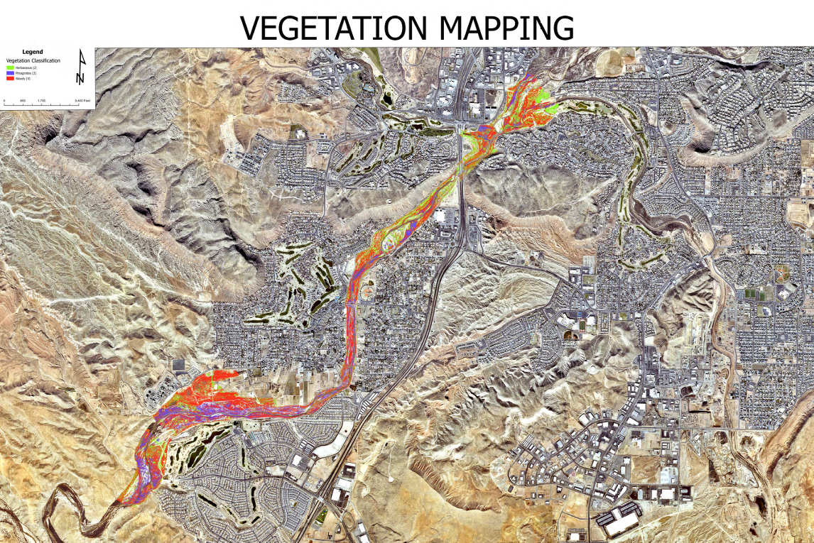
Rick Rosenburg explained the Vegetation Map and the density of the phragmites in the mapped area. There is a treatment plan in effect that prioritizes treating dense populations of invasive phragmites.

- Discuss the Preliminary Budget Spreadsheet from TAC
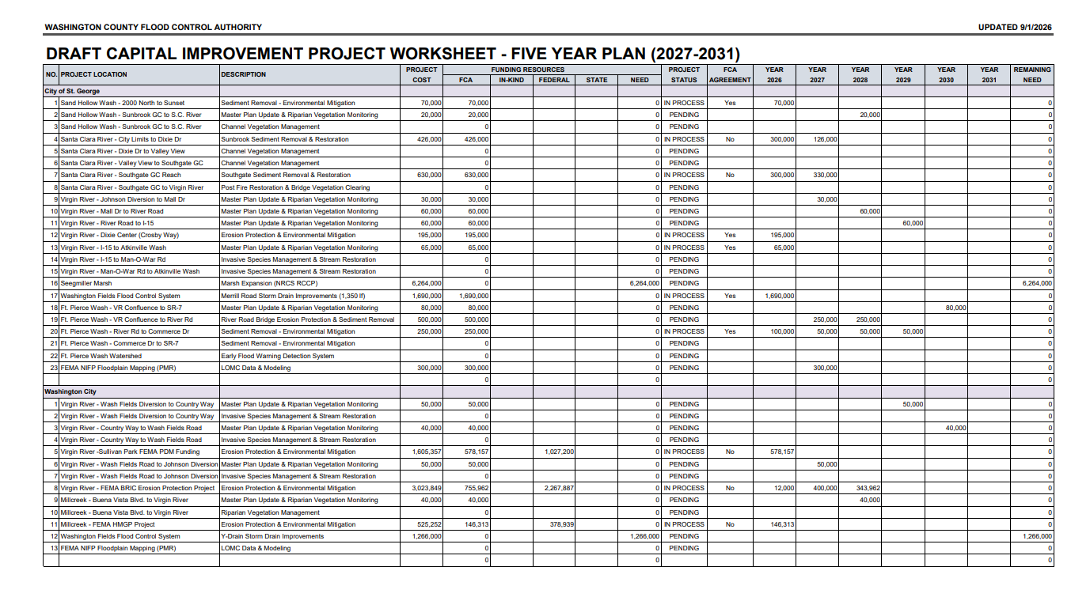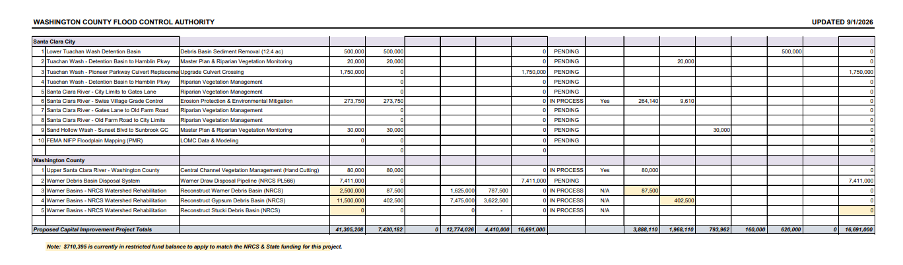
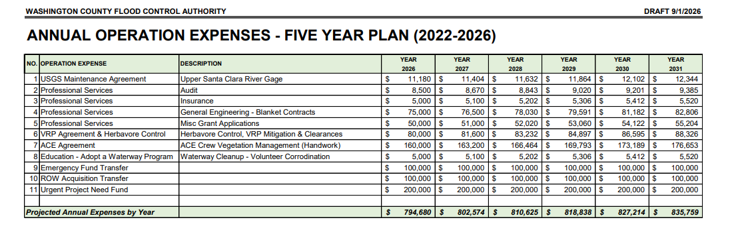
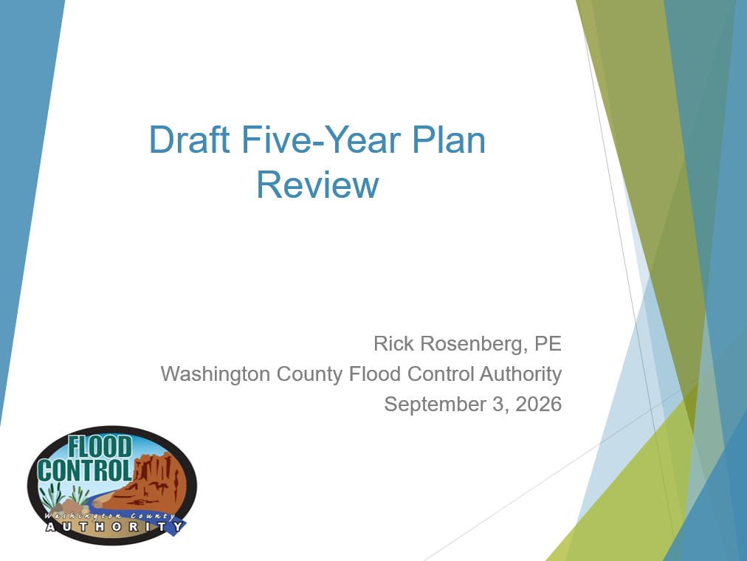
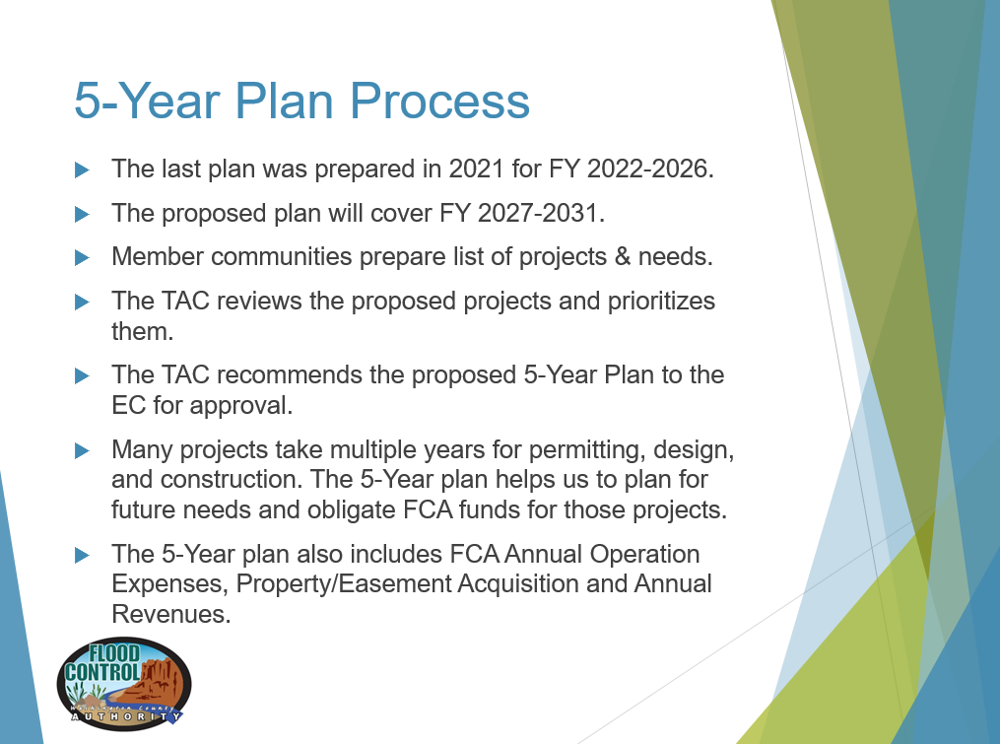
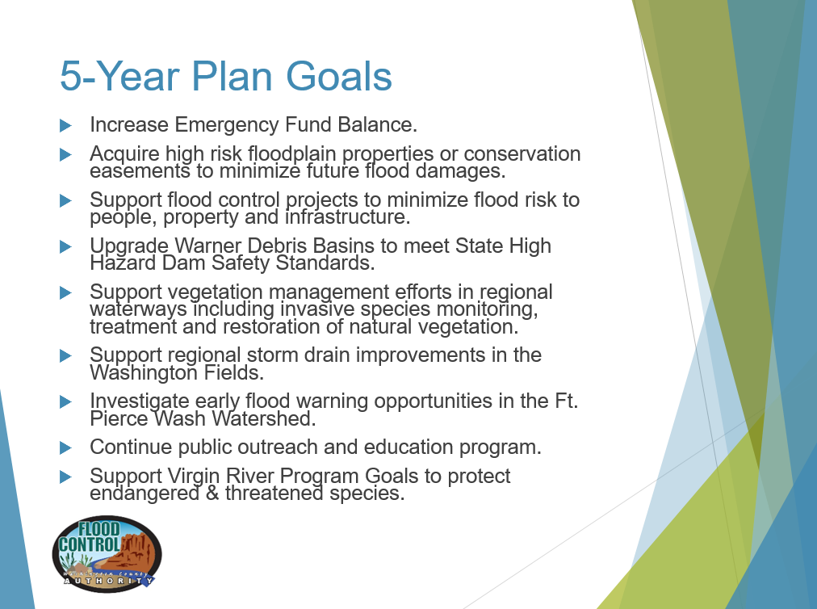



Rick Rosenburg explained the draft 5-year plan for the FCA. This discussion focused on projects and financial explanations.

- Financial Update
Camille Hastings led the discussion on the Financial Update. She stated that the budget will be open for adjustment in the following meeting and will be adjusted in November. FCA did not spend the full budget on educational outreach, so that will be adjusted. The River Plan Master Update was approved for $20,000, so that will be adjusted.

- Other Business
No other business was discussed.

ACTION ITEMS

- Approve Minutes of EC Meeting held on August 4, 2026

The Minutes passed unanimously.

Motion: Motion by Craig Coats to Approve Minutes of EC Meeting held on August 4, 2026. Motion Seconded by Natalie Larsen.

- Approve Reimbursement Agreement from American Conservation Experience

Rick Rosenburg explained that the reimbursement was based on the standard agreement used in the first half of the year and was ready for signatures.

Motion: Motion by Craig Coats to Approve Reimbursement Agreement from American Conservation Experience. Motion Seconded by Mark Hendrickson.

Motion: Motion to Adjourn by Mark Hendrickson. Motion Seconded by Craig Coats.

Adjourned: 5:25 PM

Minutes prepared by: Carissa Vera

