Monthly Fire District Report EMS
Transport for the Year
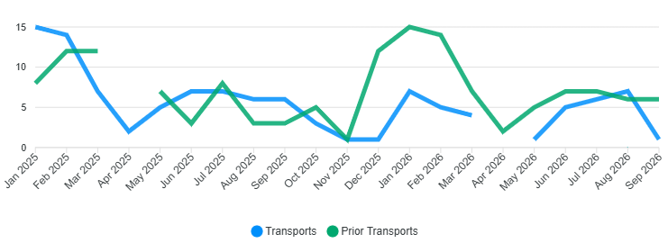
Billing
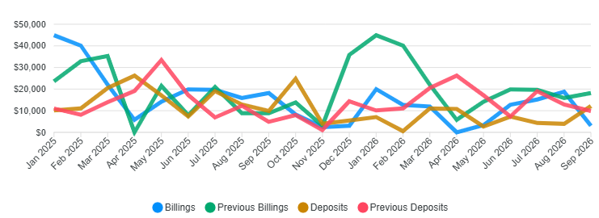
2026 Totals
Transport 36/Billed $97,568.34/Collected $59,761.82 /2026 YTD
Monthly Calls for Service
Calls for Service 208/YTD

Wildland Billing

Billing (Gross) $2,002,315.00

Received $1,233,500.56

Notes
Received a FEMA Grant for EMS $53,000.00
2-Type III engines to Southern California
Chipping will end at the end of the month.

