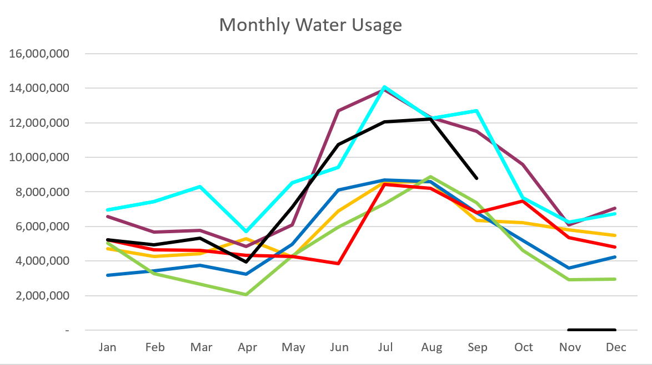
2026 - Black
2025 – Light Blue 2024 – Purple
2023 – Red 2022 – Yellow
2021 – Blue 2020 – Green
September 2026

20% unaccounted!

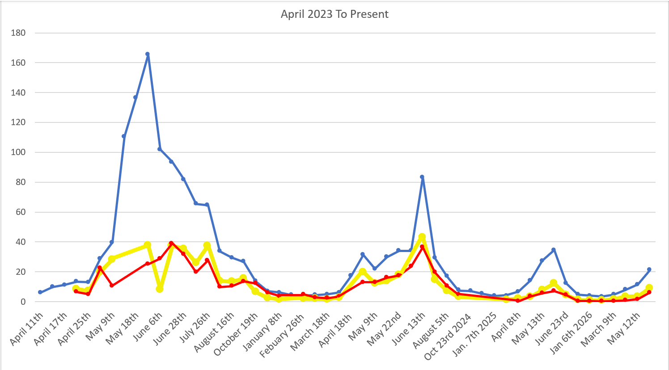
C
F
S

Water Department Information for September
- Our overall water consumption is lower than in the last two years.
- Aspen Grove wet-well levels are averaging 6.3 feet for September 2026 which is a little down from last month. This time last year, in September 2025, our average was 6.7 feet.
- Stewart Spring is averaging 59 gpm for September 2026, which is down from last month. This time last year it was averaging 89 gpm for September 2025.
- Stewart spring overflow is running 22 gpm for the month of September which is down from last month. Total Stewart Spring produced an average of 81 gpm for September 2026, same as last month.
- Construction is almost complete at the treatment plant
  - Power conduit is installed. Working through RMP permits.
  - We still need to have additional equipment installed. They started this week.
- We have had 111 submit lead and copper surveys.
  - We are verifying pipes in meter cans.
- The SRF application is in. Have been working with the DDW. They are moving our application up.
- Raised all the valves and meters in Timphaven Road.
- Dug up a suspected leak on Timphaven Road.
- Working on water rates.
- Working on water rights.

- Unaccounted water elimination processes:
  - We have replaced almost all the service meters including the 6-inch meters.
  - Corrected meters with wrong calculations, and mismatched register sizes.
  - We have had the spring meters heartbeat checked multiple times
  - We have had 2 leak detection companies conduct leak surveys
  - We have fixed multiple leaks
  - We have replaced 2 leaking hydrants.
  - We have inspected about 50 percent of the hydrants with a camera device.
  - We have had all the PRV’s inspected and replaced one 6 inch one 4 inch and two 2 inch PRV’s
  - We eliminated a section of old pipes on coming from the old Stewart Tank
  - We isolated Stewart tank to check for tank leaks.
  - We have two new zero meters ordered to replace the spring meters.
  - We started isolating zones in the system by transferring usage from Stewart to Aspen grove sides.
  - Leak locators came back out.
  - Dug and fixed a leak on stewart rd.
  - Replaced both spring meters.
  - Fixed a double leak on stewart rd.

Wastewater Department Information for September
- We completed one lab test in September, and all results were within limits. FOG was reported as not detected; because the lab cannot measure below 5 mg/L, the result is below the detectable limit.
- MBR tank 3 is now offline
- MBR 2 in now online.
- MBR 1 is in standby.
- They will be working moving the screw press in the next week.
- The sencond screw press will not be here until June.
- Parking lot pavement is complete.
- They started on siding.
- They still need to finish up the HVAC.
- The Epoxy floor will be one of the last items.
- We are working to get the rest of the drain field on the scada system.
- We are looking at the wastewater rates.

We are planning to have the garbage compactor back up and running in the next few weeks.

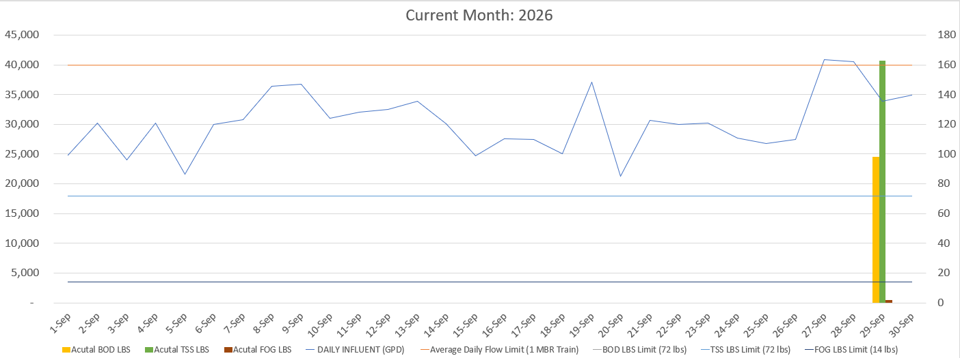

AVERAGE DAILY FLOW (GPD) | 30,352
HIGHEST DAILY FLOW (GPD) | 40,869

