



Site Plan Review
Meeting Date October 5, 2026, 7 pm 1528 Sunset Road, Lake Point, UT 84074
Applicant Chris Matthews
Property Owner Dave Burkett
Request Commercial Site Plan Review
Property Address 8278 Commerce Dr. Lake Point, Utah 84074
Parcel 21-016-0-0107
Acreage 1.5 Acres
Zone CG Commercial General
Prepared by Jamie Olson
Presented by Jamie Olson

Scope of Decision- This is an administrative matter to be decided by the land use authority Lake Point City Council upon receiving a recommendation from the Planning and Zoning Commission and a review from the Development Review Team (DRT).
Request Summary
- Absolute Heating & Air is a family-owned company we opened in 2005. We do commercial and residential heating and air conditioning. Our office is currently located at 5165 Liberator Dr. SLC
- The applicant requests a Site Plan Review for 2 new commercial buildings on an undeveloped parcel.
- The Zoning is CG- Commercial General and is an allowed use under Chapter 13.5.2. through 13.5.3.
- Building 1 is 8,800 sq ft – 80 ft x 110 ft and height of 24.0 feet
- Building 2 is 6,000 sq ft – 50 ft x 120 ft and height of 20.5 feet
- The site plans for plenty of parking 19 total parking places including 2 accessible parking spaces.
- Landscaping is xeriscaping.

Special Approvals

Yesco- This parcel has billboard easements and Yesco approved the site plan.
Setback reduction- Front setback is being requested to be reduced from 30 feet to 18.8 feet because of the existing billboard easements.
-As a requirement for this consideration. The neighboring property was consulted and expressed no concerns with the reduction.
General Plan Considerations
This application does not go against anything in the Lake Point General Plan adopted in
Ordinance 2024-05 on April 10, 2024.

DRT Committee Review, Findings and Corrections
- Building Official approved and any comments or corrections made
- Engineering approved and any comments or corrections made
  - Requests for Structural, Civil, and Mechanical Plans
  - Adjustments to the ADA stalls being too steep
- Fire Marshal approved and any comments or corrections made
  - Required 2 hydrants
  - Making sure he had fire access
- Zoning Administration approved and any comments or corrections
  - No concerns that were not addressed, most of the collaboration was regular communication and making sure the required items were collected and reviewed.
    - Items like sign plan, photometric plan, landscaping plan and will serve letters.
    - Yesco easement review and setback reduction letter for neighboring property
- Any public feedback
  - No public feedback to report
- Traffic Report waived by engineering- does not front UDOT road and subdivision was designed for this traffic.
- Geotechnical Study independently provided by applicant for this parcel by Infinity Consultants 06.26.2024
- Land Survey Provided
- Complies with proposed use under current zoning -state ordinance and use

Development Review Team (DRT) Approvals

The following departments have reviewed the site plan application which provides the subject for this staff report, and it has been found to be appropriate for review by the Lake Point City Planning Commission and/or City Council.

Fire Marshal (Buck Peck)
City Recorder/ Zoning Administrator (Jamie Olson)
Engineering (Dan Fechner)
Building Official (Kelly Brown)
Rocky Mountain Power (Lisa Baker)
Enbridge (Candice Miller)
Lake Point Improvement District (A.J. Shaffer)
Oquirrh Mountain Water Company (Levi Mele)

Recommendation

Based on the findings and conclusion listed in this report, staff recommends the Planning Commission review and approve the Site Plan Review Application for applicant David Burkett.

Supporting Document

Parcel Location and CG Zone Boundary
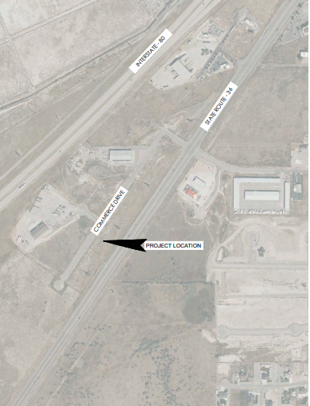

Site Plan of Building and Landscaping

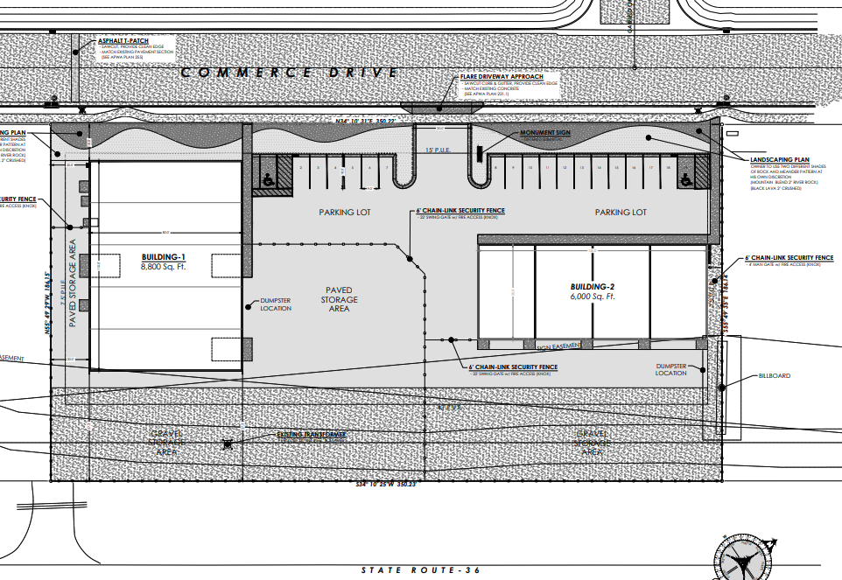

OFFICE SPACE IN BUILDING 1
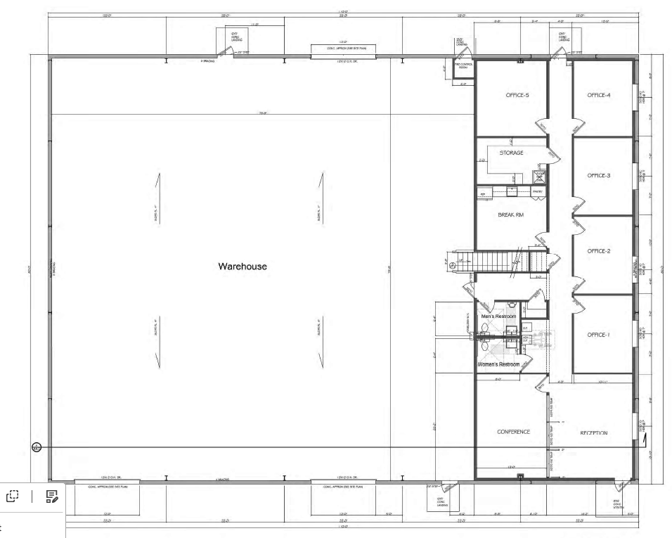
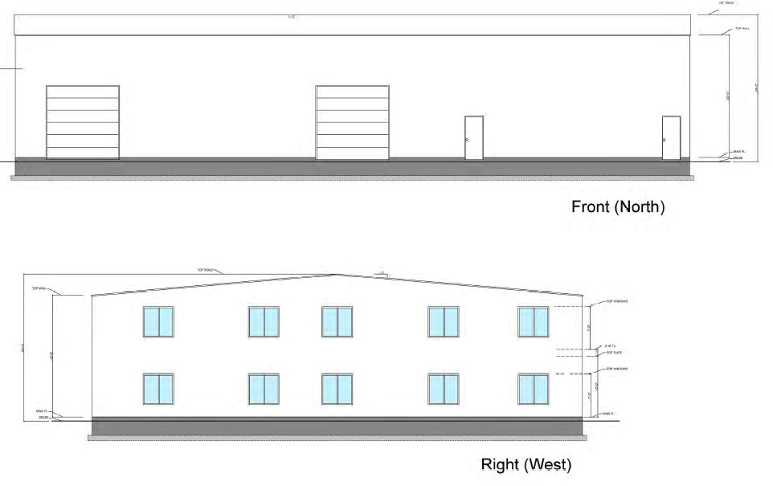
BUILDING 2
(building 2 is empty- no office space)

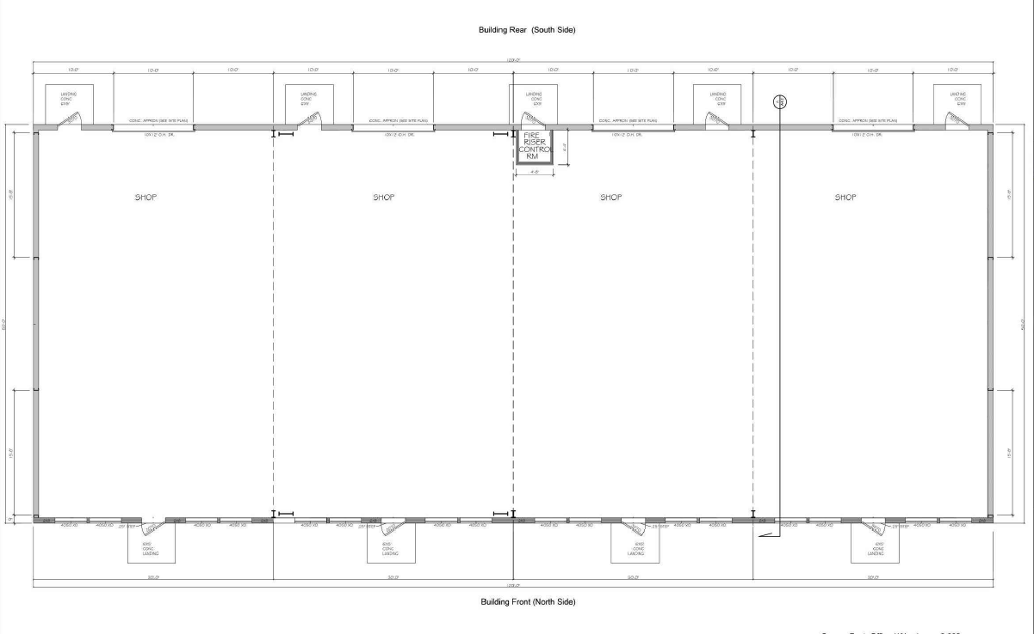

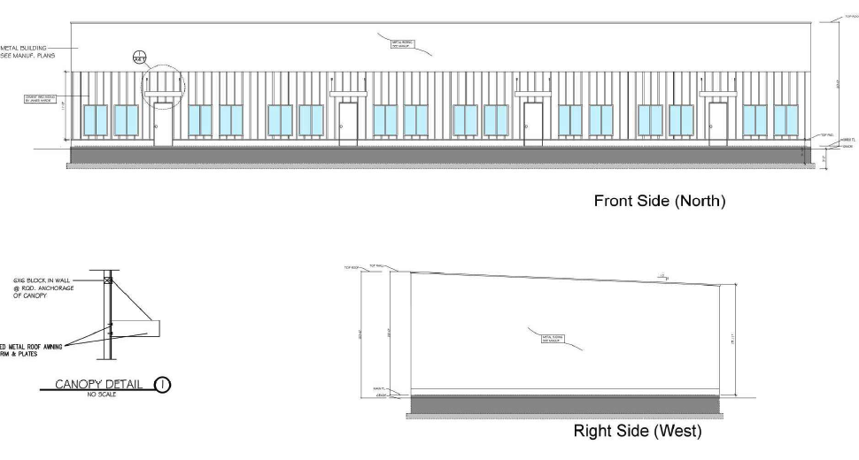

Signage Plan
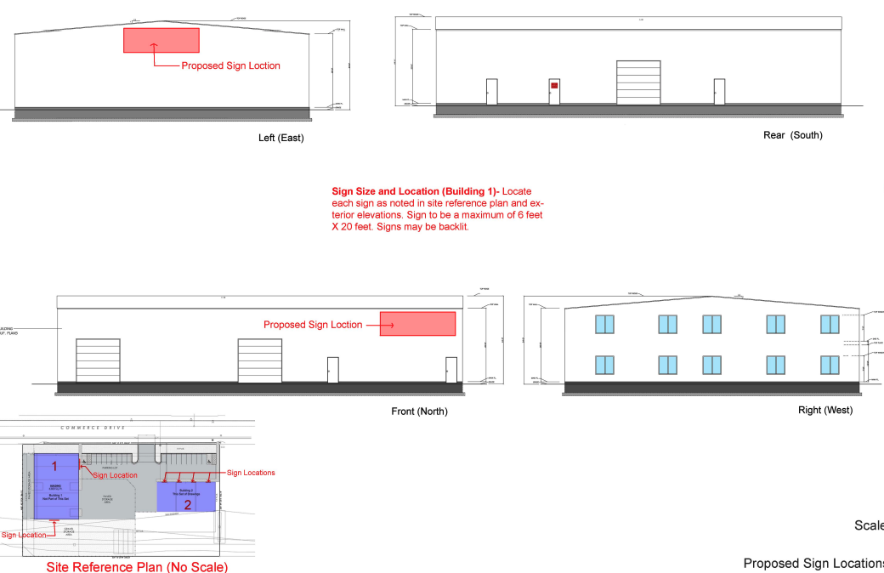

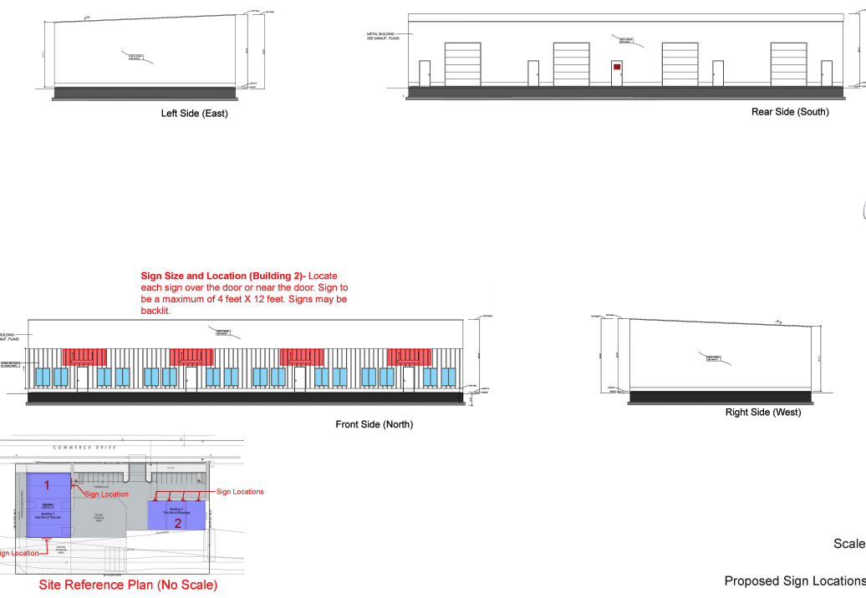
Photometric Plan/ Lighting Plan

