SALT LAKE COUNTY

2001 So. State Street Salt Lake City, UT 84114



Meeting Minutes

Tuesday, June 16, 2026
1:30 PM

Council Chambers, Room N1-110

Board of Equalization

Board of Equalization Meeting Minutes June 16, 2026

CALL TO ORDER
Type here.
Present: Chair Winder Newton, Board Member Theodore, Board Member Stringham, Board Member Moreno, Board Member Romero, Board Member Pinkney, Board Member Harrison, Board Member Johnson

Excused:
Absent: Vice Chair Stewart

PUBLIC COMMENT
There was no public comment.

APPROVAL OF MINUTES

Acceptance of BoE minutes for May 12, 2026 26-608
Presenter: Brad Neff, Tax Administrator Discussion - Vote Needed
Attachments:
    - 051226 BoE Minutes

A motion was made by Board Member Johnson, seconded by Board Member Harrison, that this agenda item be approved. The motion carried by a unanimous vote.

EXEMPT PROPERTY RECOMMENDATIONS

Recommendations on Exempt Property 26-612
Presenter: Brad Neff, Tax Administrator Discussion - Vote Needed
Attachments:
    - 061626 Exempt Property
A motion was made by Board Member Johnson, seconded by Board Member Stringham, that this agenda item be approved. The motion carried by a unanimous vote.

PERSONAL PROPERTY APPEALS

Page 2 of 3

Board of Equalization Meeting Minutes

  - Personal Property Recommended Actions Presenter: Brad Neff, Tax Administrator Discussion - Vote Needed
Attachments:
    - 061626 Personal Property Recommended Actions
    - 061626 Interstate Brick - Stipulation
June 16, 2026

26-609


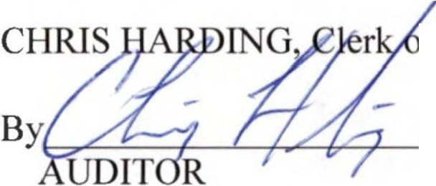
A motion was made by Board Member Pinkney, seconded by Board Member Johnson, that this agenda item be approved. The motion carried by a unanimous vote.
ADJOURN

THERE BEING NO FURTHER BUSINESS to come before the Board of Equalization at this time, the meeting was adjourned.

f the Board of Equalization

Page 3 of 3

