
Beaver City Council Emergency Meeting Minutes
July 20, 2026 – 8:00 PM
Beaver City Council Chambers
30 West 300 North, Beaver, Ut 84713

Elected Officials Present: Mayor Matt Robinson; Council Members Hunter Holt; Lance Cox; Tyler Schena; David Albrecht; Randy Hunter

City Staff Present: City Attorney Justin Wayment; City Recorder Meranda Martin; Executive assistant Taylor Gillins; Power Superintendent David Martin; Public Works Supervisor Brett Black; Paula Fails

Others Present: Kyle Wheeler, Nicole Steiff, Jason Dodds, Gary Webster,

EMEGENCY MEETING:
BEAVER CITY DECLARATION OF EMERGENCY:

Mayor Matt Robinson read the resolution R7202026, a resolution extending the local state of emergency related to the Cotton wood Fire post-fire flooding and debris flows. The resolution formally documented the catastrophic flash flooding, debris flows, evacuations, road closures, water systems concerns and infrastructure impacts that occurred on or about July 20, 2026, and extended the original emergency declaration of June 24, 2026, through 11:59 PM on September 30, 2026, unless terminated earlier. The resolution reaffirmed prior findings, authorized, continued emergency operations and recovery activities, and required fiscal and procurement compliance consistent with applicable Utah code.

ACTION ON DECLARATION OF EMERGENCY:
Motion to approve Resolution number R7202026 Extending the Local State of Emergency was made by Council Member Tyler Schena, Second by Council Member Lance Cox. The motion passed unanimously by roll call vote.

Following adoption, the Mayor invited staff to provide situational updates.

Brett Black public works supervisor shared with the council that the ductile iron line form Baker Canyon Spring had been proactively isolated prior to the flood event. The line broke at a coupler but was repaired with the help of Precision contractors by the evening of July 20. As a precautionary, a boiling order was issued for culinary water. Water samples were taken to Cedar City the following day for testing with the results to be expected within 24 hours. Staff from Utah Rural Water Association were on-site to assist. The HDPE line in Baker was found to be exposed and under pressure from debris, and work to address it was to be deferred until the weather window permitted safe access. Residents above the golf course and in the Grove area were without water pending restoration of the Baker line.

David Martin Power Superintendent shared with council that approximately 2.5 miles of 30-inch pipeline above mile marker 6.5 in the canyon was described as a complete loss, with sections found wrapped around trees. Most electrical poles in the canyon were destroyed. Hydropower Plant 3 was found teetering over a washed-out foundation, with water having reached within feet of the structure. Plant 4's intake was reported completely silted in. The brand-new hydropower plant, which had not yet been commissioned, sustained approximately three feet of water intrusion. Highway access above mile marker 6.5 was impassable.

Gary Webster from Senator Mike Lee’s Office outlined the federal assistance pathway, noting that a Preliminary Damage Assessment (PDA) in coordination with FEMA Region 8 would be a prerequisite to pursuing a presidential disaster declaration. Senator Lee's office, with the Senator serving as Chair of the Senate Energy and Natural Resources Committee, committed to working through appropriate channels to accelerate federal support.

Jason D from Jones and DeMille talked to the council about funding possibilities for the spring water fix. He said there are short term and long-term funding options. Natural Resources Conservation Service (NRCS) exigency funding was described as very likely for near-term debris removal, channel clearing, and critical infrastructure protection, to be administered through Beaver County for efficiency.

Randy Hunter shared that he is grateful for the community. He shared it’s very humble and he is praying for them and their family’s
David Albrecht thanked Mayor for all his time. He helped pass out food and water to those In need. He said our community is awesome and it’s been great to see surrounding communities reach out.
Tyler Schena thanked other communities that have helped us. He hopes to keep everyone safe.
Lance Cox said this has been very humble, with everyone calling to help. He helped hand out food and water with Dave. He couldn’t believe everyone who showed up to help. He also shared we have the best crew in the whole state
Hunter Holt shared that our crews were doing everything they could starting Sunday. Everything we planned went well. Seeing everyone coming together is very touching

Mayor Matt Robinson: The Mayor reported having spoken with Governor Cox, Senator Lee's office, Senator Curtis, Congresswoman Celeste Malloy, Representative Carl Albrecht, Senator Evan Vickers, and the presidents of several regional higher education institutions. A framework for organizing volunteer and contractor resources has been established. The Mayor also noted that the 24th of July celebration was tentatively planned in a modified form like a morning parade, and community prayer while the horse races and rodeo were effectively canceled due to water service loss and flood damage to the arena. A ban on personal fireworks was confirmed, while the community fireworks show was to proceed if resources permitted.
Adjournment:
Council Member Tyler Schena motioned, and Council Member Lance Cox seconded to adjourn the meeting. All voted in favor. None opposed.

The Council Meeting was adjourned at 8:50 PM. The next scheduled regular Council meeting will be held August 11, 2026 at 5:00 PM.

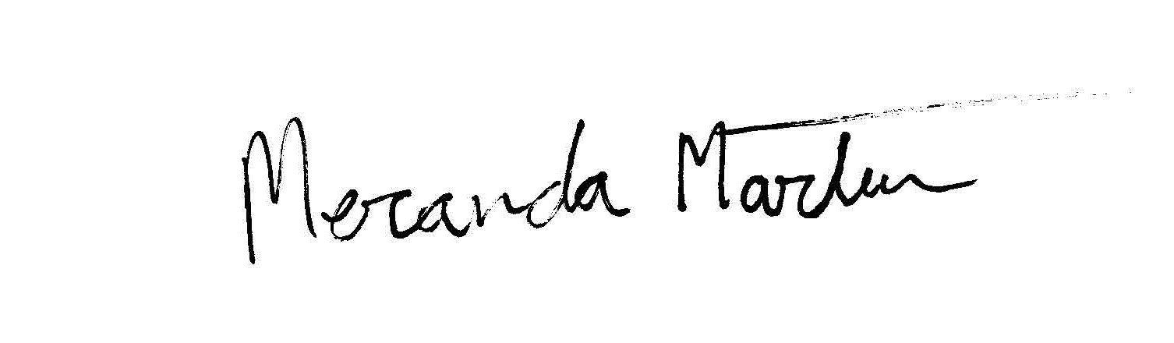
APPROVED: _______________________ ATTEST:______________________
MATTHEW ROBINSON MERANDA MARTIN
MAYOR CITY RECORDER

