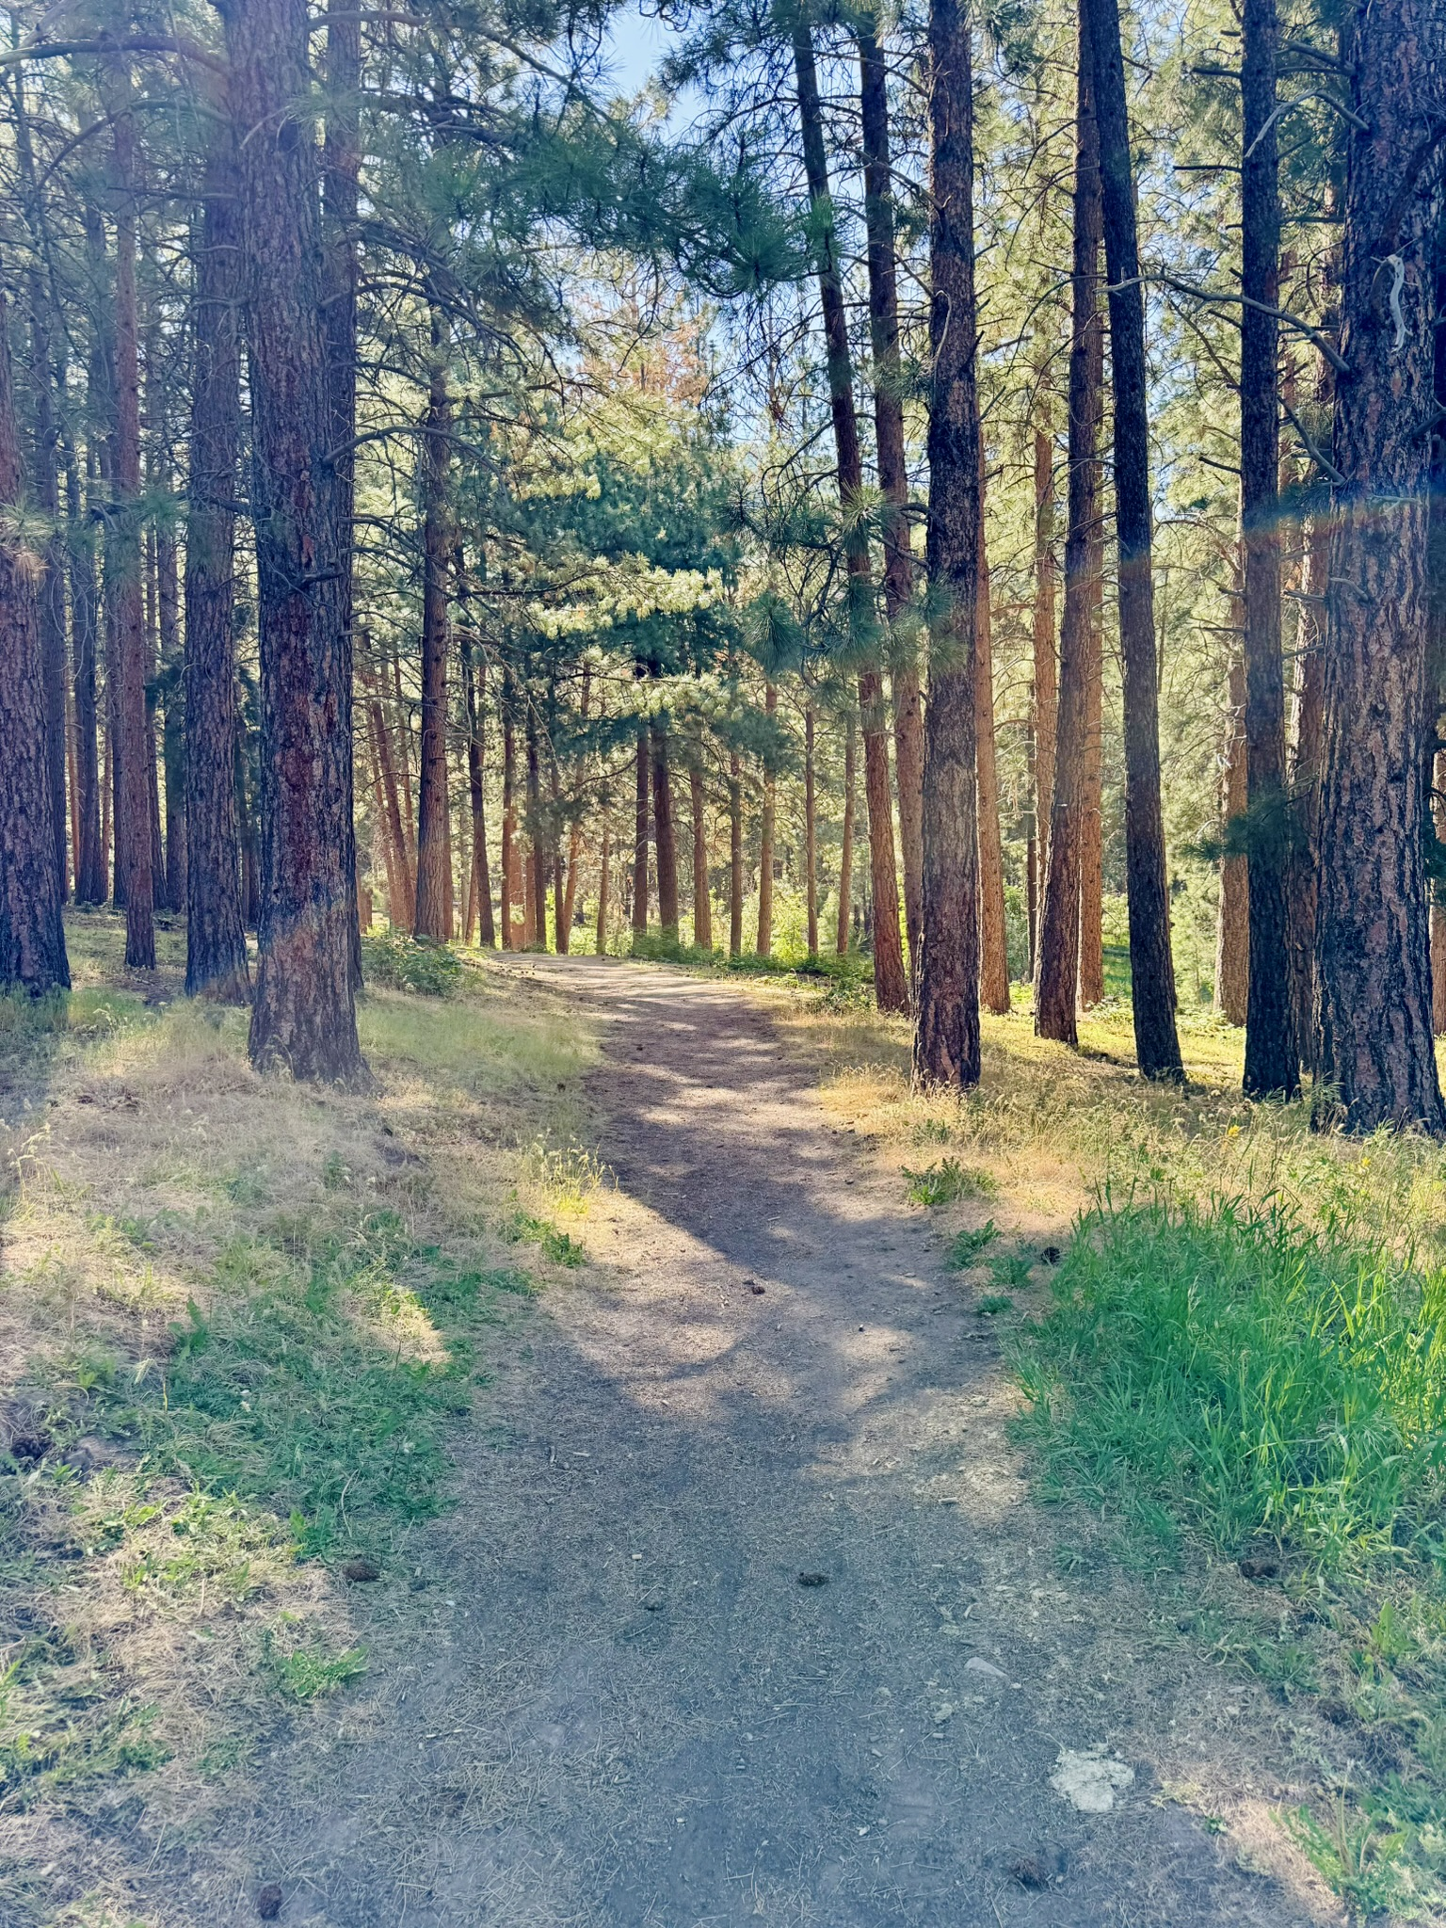

DRAFT

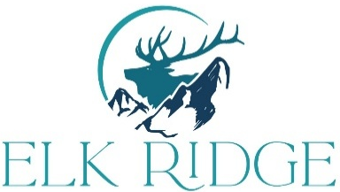

2026 Trails, Parks, and Open Space

Master Plan
City of Elk Ridge, Utah

Acknowledgements
City Council

Rob Haddock, Mayor
Melanie Paxton
Jared Peterson
Cory Thompson
Tanya Willis
Charles Wixom

Planning Commission

Lisa Graham, Chair
Ron Gailey
Andy May
Dani Shultz
Greg Shelton

Approved by Planning Commission 8/3/2026
Adopted by City Council ??

Document prepared by Hales Engineering
Contents

Public Input on Trails, Parks, and Open Space 3
Purpose of the Plan 3
Survey Results Summary Regarding Parks, Trails, and Open Space: 3
Community Engagement: 4
Coordination with Other Documents 4
Coordination with Other Documents 4
Trails Plan 5
Official Trails Map 6
Trails Goals 7
Trail Design Standards 7
Trails Action Plan/Implementation 9
Potential Funding Sources 9
Parks Plan 10
Official Parks Map 11
Parks Goals 12
Parks Standard 13
Existing and Future Parks Improvement Plan 13
Parks Plans 15
Parks Plan Priorities 17
Action Plan/Implementation 18
Potential Funding Sources 18
Open Space Plan 19
Official Open Space Map 20
Open Space Goals 21
Existing and Future Open Space Improvement Plan 21
Open Space Plan Priorities 22
Action Plan/Implementation 23
Potential Funding Sources 23
Appendix 24

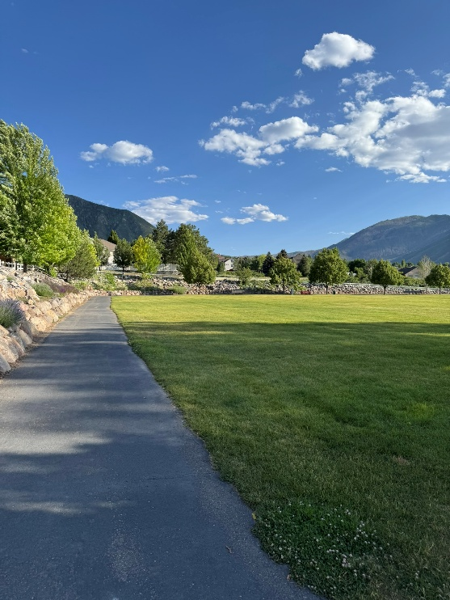
Public Input on Trails, Parks, and Open Space

Purpose of the Plan
Located in the foothills of the southern Wasatch Front, Elk Ridge is a thriving community that values its outdoor environment. In creating this plan, the goal is to create a comprehensive, well-distributed and interconnected system of trails, parks, and open space that supports a healthy community and the preservation of resources for current residents and many generations to come. This plan is envisioned to be a living document that can change and adjust as future needs arise. More importantly, it is a plan to be used to help guide citizens, city leaders, and future development to make the proposed projects in the plan a reality.
Community View surveys were conducted in 2021, 2022, and 2024. The 2024 survey focused on development and design of the Goosenest Park property. Complete details of each survey can be found in the appendix.

Survey Results Summary Regarding Parks, Trails, and Open Space:
- Our natural surroundings and proximity to wildlife, combined with our friendly, safe, and quiet lifestyle, make us a highly prized community.
- City parks, open spaces, pathways, and trails are the most important amenities in our city.
- Maintaining nature, access to the outdoors, preserving our view of the mountains and the valley are important.
- Walking trails provide a safe, pleasant, and cost-effective way to enjoy our beautiful area.
- Connecting trails to the mountains and Fore Bay area, linking city trails and sidewalks to each other, and connecting to neighboring cities are the priorities.
- A natural water feature at Goosenest Park would benefit children, families, and the community.
- An All-Abilities playground at Goosenest Park would address the current gaps in recreational facilities to a growing population of children and families.
- Improving and maintaining existing parks is vital: grass appearance and health is a priority. Safety improvements to existing playground equipment, the tennis court, pavilion, benches, and tables should be ongoing.
- Adding amenities, especially pickleball courts, are a high priority. Other amenities of interest are pavilions, electrical infrastructure, basketball court, bike paths, mountain bike skills park, and an ice ribbon/skating feature.
- Water-wise landscaping is desired.
- Preferred funding mechanisms: grants, donations of labor, equipment, and material. Volunteer programs for regular citywide clean up. Organized volunteer projects for landscaping, grooming trails, etc.

Community Engagement:
- In 2023 the Planning Commission did a visual survey of all the city park properties. The resulting table is included under the Parks section of this document.
- In October of 2023, the Elk Ridge city beautification committee was established – “Elk Ridge the Beautiful.” The purpose was to organize a citywide clean-up/weeding/planting event at least once a year. Specific areas of the city were targeted so that all public areas – parks, streets, trails, open space, and buildings, would have a group of volunteer residents assigned to care for that area. This will be an ongoing event taking place every year.

- In February 2024, the Elk Ridge Parks and Trails Committee held their first meeting. Based on the General Plan and city surveys, priorities were established:
  - Community trails to access the mountains and Forebay area,
  - Create a Goosenest Park plan,
  - Obtain funding (grants) for parks and trails projects.
- Committee meetings will continue to be held on a regular basis, inviting all interested community members to attend.
- Subsequent Parks and Trails Committee meetings refined Goosenest Park Plans. Information was shared with the public at the City Celebration, June 14, 2024.
- In 2024, the Parks and Trails Committee approved hiring a grant writer to pursue funds for Sky Hawk Park and Goosenest Park, as well as applying for other grants for trails and park projects.
- In 2024-2025, a park designer was hired to create a Goosenest Park Master Plan. The master plan, as well as phase 1 of the park, was completed in January 2025 and presented to the Parks and Trails Committee in March 2025.

Coordination with Other Documents
The Trails, Parks, and Open Space Master Plan shall adhere to and coordinate with the General Plan, Transportation Master Plan, and Capital Facilities Plan. Any deviation of trail routes/placement, classification changes, park location, or acreage adjustments will require an amendment to this plan and shall be presented in a public hearing, recommended by the Planning Commission, and approved by the City Council. Regular updates to this Master Plan should occur approximately every five (5) years to reflect growth, infrastructure changes, and evolving community needs.

- In June 2026, the City introduced the Adopt-a-Tree and Adopt-a-Perennial Program. This ongoing initiative will support landscaping improvements in both existing and future City parks.
- In August 2026, the City worked with Nebo School District to acquire approximately one-third of an acre to straighten Cotton Tail Lane and better accommodate the planned improvements at Skyhawk Park. The construction plans have been finalized to incorporate this change. Construction is anticipated to begin in fall 2026 and be completed in spring 2027.

Coordination with Other Documents
The Trails, Parks, and Open Space Master Plan shall adhere to and coordinate with the General Plan, Transportation Master Plan, and Capital Facilities Plan. Any deviation of trail routes/placement, classification changes, park location, or acreage adjustments will require an amendment to this plan and shall be presented in a public hearing, recommended by the Planning Commission, and approved by the City Council. Regular updates to this Master Plan should occur approximately every five (5) years to reflect growth, infrastructure changes, and evolving community needs.

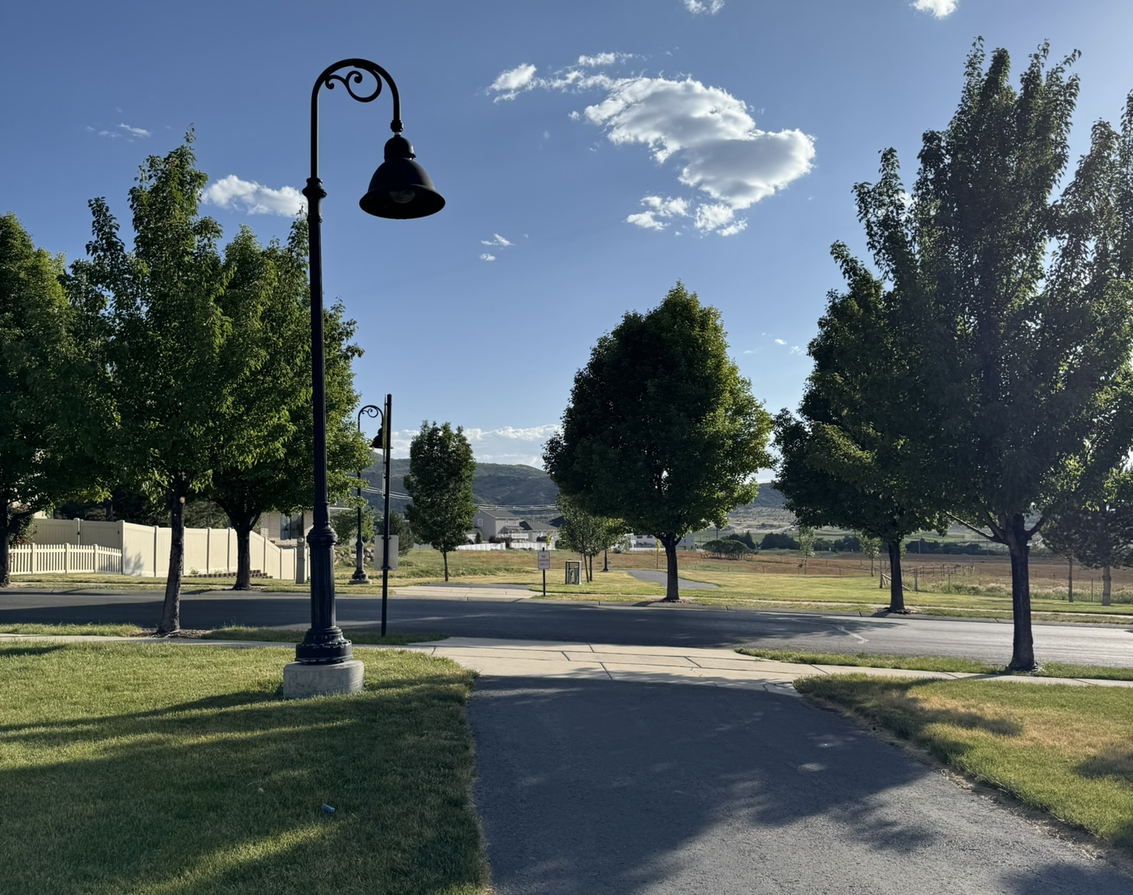
Vision
Trails are a high priority for Elk Ridge residents, with strong public support for expanding the City’s trail system. Creating connections between the mountains, neighborhoods, parks, and regional trails is essential to developing a successful network. Continued public input regarding project priorities and funding options will be an important part of planning future improvements.

Trails Plan

Official Trails Map
The official trails map serves to identify location and type of trails approved within the city. Citizens, landowners, developers, and city officials can refer to this map for planning and development purposes. Proposed changes to this map, through the development process, must be amended with a public hearing, planning commission recommendation, and city council approval.

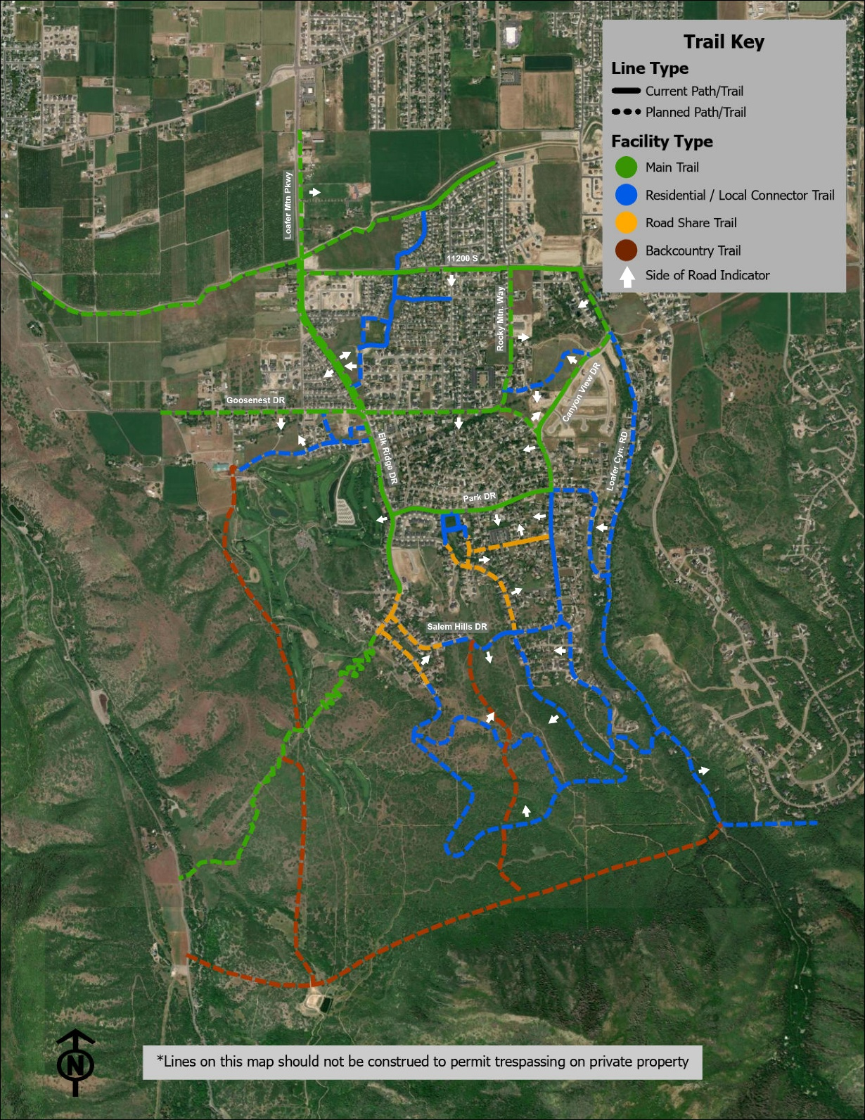

Trails Goals
The trails plan contains goals guided by public and stakeholder input that can help chart the course forward to making the plan a reality.
Goal 1
The overall trails plan is one that connects residents to all parts of the community with exclusive use of the trails system. An emphasis should be placed on establishing sidewalks within subdivisions for safe walking along residential streets.
Goal 2
The plan will include a trails system that connects neighboring communities and the regional trails system to allow pedestrians and non-motorized vehicles to have an extensive and safe route to traverse the beautiful mountains, foothills, and canyons of Utah Valley. Clear, consistent wayfinding signage and safety measures shall be a priority of the trails system, including distance markers, trails rules, lighting, and appropriate road crossing visibility.

Goal 3
The plan will include trailhead & restroom amenities at appropriate locations along mountain access trails.

Goal 4
The plan will seek to include ADA-compliant trails where feasible.

Trail Design Standards
See Elk Ridge City Development Code (10-15D-3) for trail construction and development standards.

Trails Plan Priorities

Specific tasks to achieve the Plan vision are assigned immediate (0-5 years), short-term (5-10 years), medium-term (10-20 years) and long-term (20+ years) implementation timeframes.

Immediate (0-5 years)
- Backcountry Trails System: Secure property and complete trail connections to the mountains – including a trail to Forebay.
- 11200 South Trail: Completed/connected trail along 11200 South.
- Canyon View DR Trail: Complete a shared roadside trail from Park DR to Hudson LN when the road is widened.
- Road Share Trails: Repainting of current shared road share trails along Canyon View DR, Alpine DR, and Park DR. as development proceeds and as safety necessities.
- Neighboring Jurisdictions Collaboration: Multi-city/regional trail connectivity efforts through multi-city discussions, projects, and common goals.
- Elk Ridge DR Trail: Complete the trail system along the entire length of Elk Ridge DR.
Short-term (5-10 years)
- Residential / Local Trails: Expansion of trail network within subdivisions as development proceeds and safety necessitates.
- Safety and Information Improvements: Addition of signage and safety features.
- Neighboring Jurisdictions Collaboration: Multi-city/regional trail connectivity efforts
Medium-term (10-20 years)
- Neighboring Jurisdictions Collaboration: Multi-city/regional trail connectivity efforts.
Long-term (20+ years)
- Regional Trail Connections: Connection to regional/statewide trail system.

Trails Action Plan/Implementation
- Implement the recommended trail facilities by build-out.
- Develop the planned trails network to 2050 and seek to align with state and regional outdoor recreation goals.
- Encourage multi-jurisdictional cooperation and funding relationships with the Mountainland Association of Governments (MAG), Utah County, and the neighboring cities of Salem, Woodland Hills, and Payson.
- Update the Transportation Master Plan and this plan regularly.

- Assure the Elk Ridge Trails Systems meets public needs and expectations.
- Develop an accessible network of supportive pedestrian infrastructure, including sidewalks, curb ramps, and trails near existing parks and other high-use destinations.
- Work with the Public Works department to ensure all existing trails are adequately maintained.
- Inform and educate Elk Ridge residents about plans to create trails on existing public streets.
- Trails in exiting neighborhoods will be done on a case-by-case basis, as deemed necessary for safety.

- Require community planning, land use planning, and development review processes to incorporate trail master planning, including access to trails.
- Continually evaluate system-wide trails as part of future planning efforts, focusing on closing gaps and improving connections with existing and future neighborhoods, and parks.
- Require private development projects to finance and install sidewalks and trails as recommended in the City General Plan and Master Trails map. Working with developers / property owners is an essential part of the process.
- Ensure open space is considered during land-use planning and zoning approvals.

Potential Funding Sources
Current funding sources within the city cannot make this plan a reality. Development of the remaining developable land can help, but to implement these improvements within the already-developed areas and in the open space areas to the south, other means of funding will be required and could include:

- Impact Fees
- Grants
  - Utah Outdoor Recreation Grant (UORG)
  - Recreational Trails Program (RTP)– development and maintenance of trails
  - Off Highway Vehicle Recreation Grant (OHVR)
  - Land and Water Conservation Fund (LWCF)
  - Outdoor Recreation Initiative (ORI)
  - UDOT – Utah Trail Network ($45,000,000 per year)
- Bonding and Conservation Easements
- General Fund (for grants matches and other priorities)
- Volunteer and Community Fundraising Programs/Donations
- Public/Private Partnership
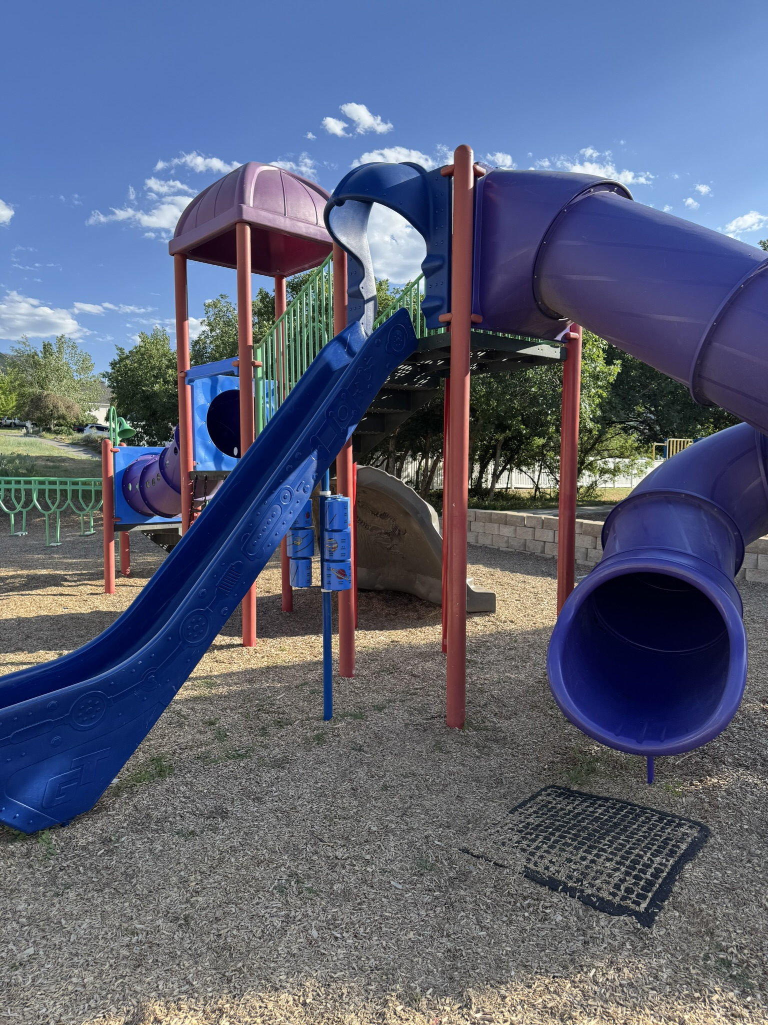

Parks Plan
Vision
Parks, open space, and recreational opportunities are fundamental parts of every good community. Citizens of all ages and abilities need recreational space that is accessible, well maintained, and contain amenities that make a park pleasant and useful. Elk Ridge City shall ensure current and future residents are well-served by a comprehensive system of parks, recreation facilities, and open space.

Official Parks Map
The official parks map serves to identify the location of parks approved within the city. Citizens, landowners, developers, and city officials can refer to this map for planning and development purposes. Proposed changes to this map, through the development process, must be amended with a public hearing, planning commission recommendation, and city council approval.
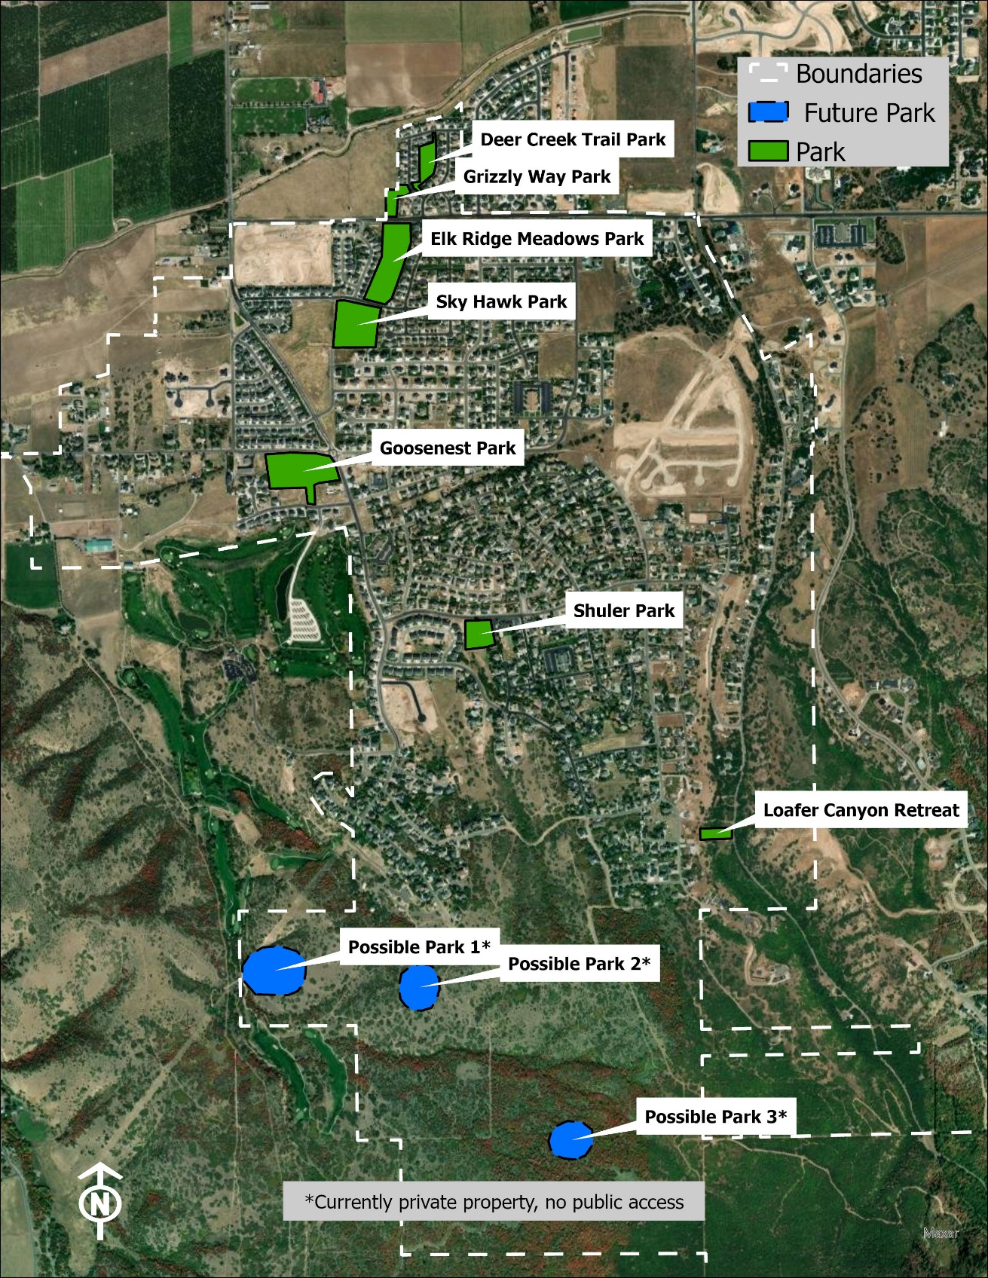

Parks Goals
The parks plan contains goals guided by public and stakeholder input that can help chart the course forward to making the plan a reality.
Goal 1
Assess needs of each park area and prioritize improvement/construction projects including:

Improving the water efficiency of existing parks by utilizing Smart and Water Wise irrigations systems.

Future parks should be developed with water conservation in mind, sizing grass areas based upon the minimum needed for specific amenities and allowing additional acreage to be left in its natural state with trails for active use or other uses.

Identifying areas suitable for future parks as the city expands geographically.
Goal 2
Obtain and provide adequate funding for park maintenance, park construction, recreation programs, and adequate maintenance staff including:
Pursue a diverse array of funding sources, such as grants (county, state, and national), bonds, public-private partnerships, and special entities such as Conservation Easement funds.
Pursue an appropriate impact fee assessment to support new growth and development.
Goal 3
Provide ongoing opportunities for community engagement including:
Offer improvement and maintenance volunteer opportunities for the parks.
Use community engagement to identify opportunities for new programming that aligns with needs and trends (e.g. soccer teams, pickleball play)
Allow community members to comment on the design/amenities of proposed new parks/ recreation facilities (parks committee, beautification committee, recreation committee)
Create a web page with park descriptions and maps that highlight current and future park improvements.

Parks Standard
The guidelines of the National Parks and Recreation Association (NRPA) suggest a Level of Service (LOS) of 5 acres of park space per 1,000 residents. The population of Elk Ridge (2024) is approximately 5,000 residents, with 25 acres of park space integrated throughout the city. As the city grows, develops, and reaches capacity, another 10 to 15 acres should be added to meet park space expectations and needs (LOS). While Elk Ridge is currently a young community with many children, it is aging and maturing as well. This dichotomy means that parks should be designed to meet the needs of the broadest range of users and age groups, all of whom have unique demands.

Existing and Future Parks Improvement Plan
A detailed list of existing park amenities, suggested improvements, and future parks.
Map # | Name | Current Amenities | Suggested Amenities/Improvements
1 | Deer Creek Trail  Park  Deer Creek Trail /  Grizzly WY  2.083 acres | - Paved trail with lighting.  - Picnic tables on cement pads.  - The playground equipment is in good condition.  - The majority is grass - sloped with a large water retention basin.  - Dog waste station with plastic bags. | - Repair streetlights.  - Replace grass area on the east side with resident fences with gravel or mulch.  - Add waterwise plants and trees in appropriate places.  - Consider planting a different type of grass on the grassy slope.  - Update watering system.  - Connect the trail at the far north end to the Salem trail.
2 | Grizzly Way Park  Grizzly WY /  11200 South  1.298 acres | - Large grass area with a paved trail, benches, and streetlights.  - Paved trail crosses 11200 South to Elk Ridge Meadows Park. | - Get an estimate for repairing streetlights. Explore funding options.  - Landscape to reduce water use and mowing cost.  - Add safety features for 11200 South crossing.  - Survey residents for suggestions for the best use of this space.
3 | Elk Ridge  Meadows Park  Between 11200  South to Sky  Hawk WY  6.672 acres | - Paved trail with streetlights and benches.  - Natural vegetation - no grass.  - Frisbee golf.  - Water retention basin.  - "Wildflower Park" - bulbs planted by residents. | - Repair streetlights.  - Create a landscaping plan that will reduce water use, incorporate natural vegetation, and resident desires.  - Refurbish Frisbee golf course.
4 | Sky Hawk Park  Sky Hawk WY /  Cotton Tail LN  5.91 acres | - Well house - fenced.  - Paved trail with benches and streetlights.  - Large grass area - soccer. Sloped hill with grass. | - Complete the Sky Hawk Park plan, including a paved parking lot, restrooms, pickleball courts, basketball court, pavilion, and a paved walking trail.  - Repair Streetlights
5 | Goosenest Park (future)  Elk Ridge DR /  Goosenest DR  8 acres | - House - Elk Ridge City property as of 2006. | - Remove the old salt shed and existing home.  - Continue to seek funding to complete the Goosenest Park plan.  - The plan includes paved walking trails, paved parking, restrooms, and other amenities desired by residents.
6 | Shuler Park/  Ingram Field  Park DR  6 acres | - Parking lot, grassy field, paved walking trail, pavilion, restrooms, children's play equipment, cement tennis area, grassy volleyball area, basketball court, benches, picnic tables. | - Repairs and upkeep to tennis court, children's playground, basketball area, pavilion.  - Replace wooden picnic tables and benches.  - Repair drinking fountain, add water bottle filling station in the pavilion.
7 | Loafer Canyon  Retreat  South past Park  DR  1 acre | - Purchased in 2018. The Federal drainage project will use this as needed. | - AFTER the Federal drainage project: Keep as natural open space as much as possible.  - Family nature area?  - Trailhead parking as a stopping place for bikers/walkers going up Loafer Canyon and eventually on to Woodland Hills.
8| Southern  Hillside Parks  (Future TBD) | ---------- | - Discussion is needed about what amenities would fit in this area.

Parks Plans

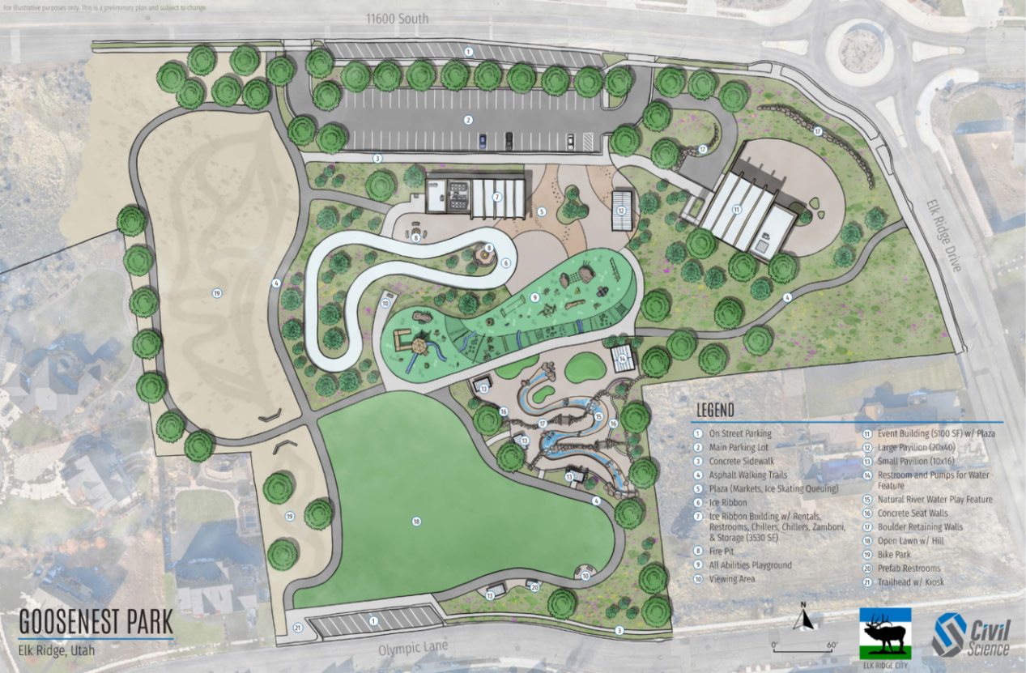
Goosenest Park Plan

Skyhawk Park Plan
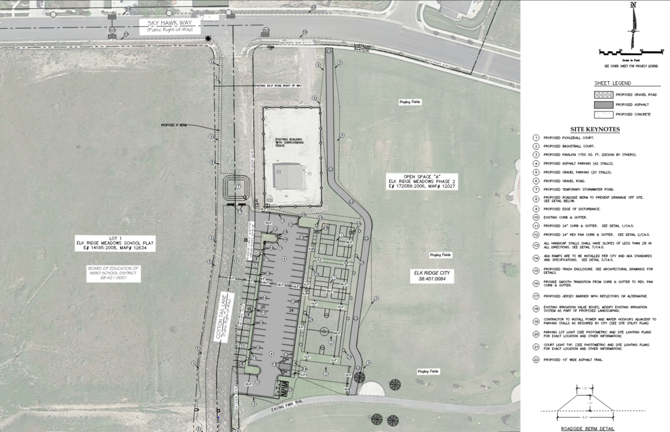

Wildflowert Park Plan

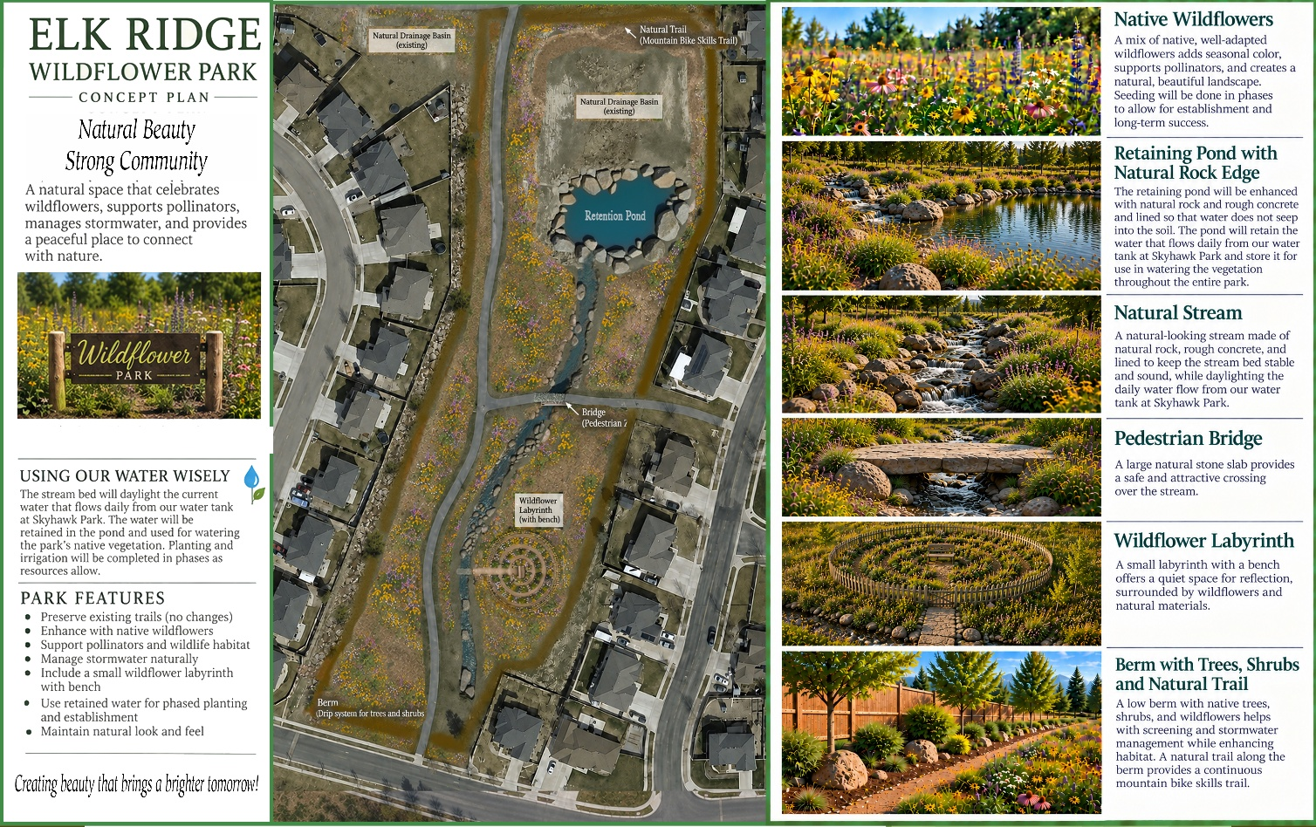

Parks Plan Priorities
Specific tasks to achieve the Plan vision are assigned immediate (0-5 years), short-term (5-10 years), medium-term (10-20 years) and long-term (20+ years) implementation timeframes. Annual plans shall be reviewed and maintained by the Parks Committee.
Immediate (0-5 years)
- Retain a grant writer and establish a grant writing committee.
- Sky Hawk Park upgrade
- Goosenest Park: Design and selection of amenities. Continue to actively seek funding (grants, public-private partnerships, appropriate impact fees) for completion of Goosenest Park.
- Enhance existing park facilities with upgraded amenities.
- Park improvement and maintenance needs: Utilize volunteer groups to best advantage in appropriate projects.
- Actively seek funding for maintenance.
- Wildflower Park upgrades.
Short-term (5-10 years)
- Begin long term maintenance planning and funding.
Medium-term (10-20 years)
- Acquisition and development of additional park space to meet growing population needs.
- Work with future developers. Cooperate and consult with landowners about park plans.
Long-term (20+ years)
- Expansion of regional park facilities and long-term maintenance planning.

Action Plan/Implementation
- Develop a park maintenance plan to ensure regular upkeep and timely improvements.
- Establish a Parks and Recreation Committee to oversee planning, fundraising, and community involvement.
- Collaborate with local schools, community groups, and businesses to support park enhancement projects.
- Secure funding through grants, impact fees, and public-private partnerships to support park expansion and renovations.
- Improve accessibility to parks by ensuring ADA-compliant pathways, seating, and playgrounds.
- Create an annual park evaluation report to assess conditions, identify improvement areas, and guide future investments.
- Encourage community participation in park development through volunteer programs such as the Parks & Trails Committee and Beautification Committee, sponsorship opportunities, and citizen feedback forums.
- Continue promoting the Adopt-A-Tree/ Adopt-A-Perennial Program

Potential Funding Sources
Current funding sources within the city cannot make this plan a reality. Development of the remaining developable land can help, but to implement these improvements within the already-developed areas and in the open space areas to the south, other means of funding will be required and could include:
- Impact Fees
- Grants
- Bonding and Conservation Easements
- General Fund (for grants matches and other priorities)
- Volunteer and Community Fundraising Programs
- Public-Private partnerships

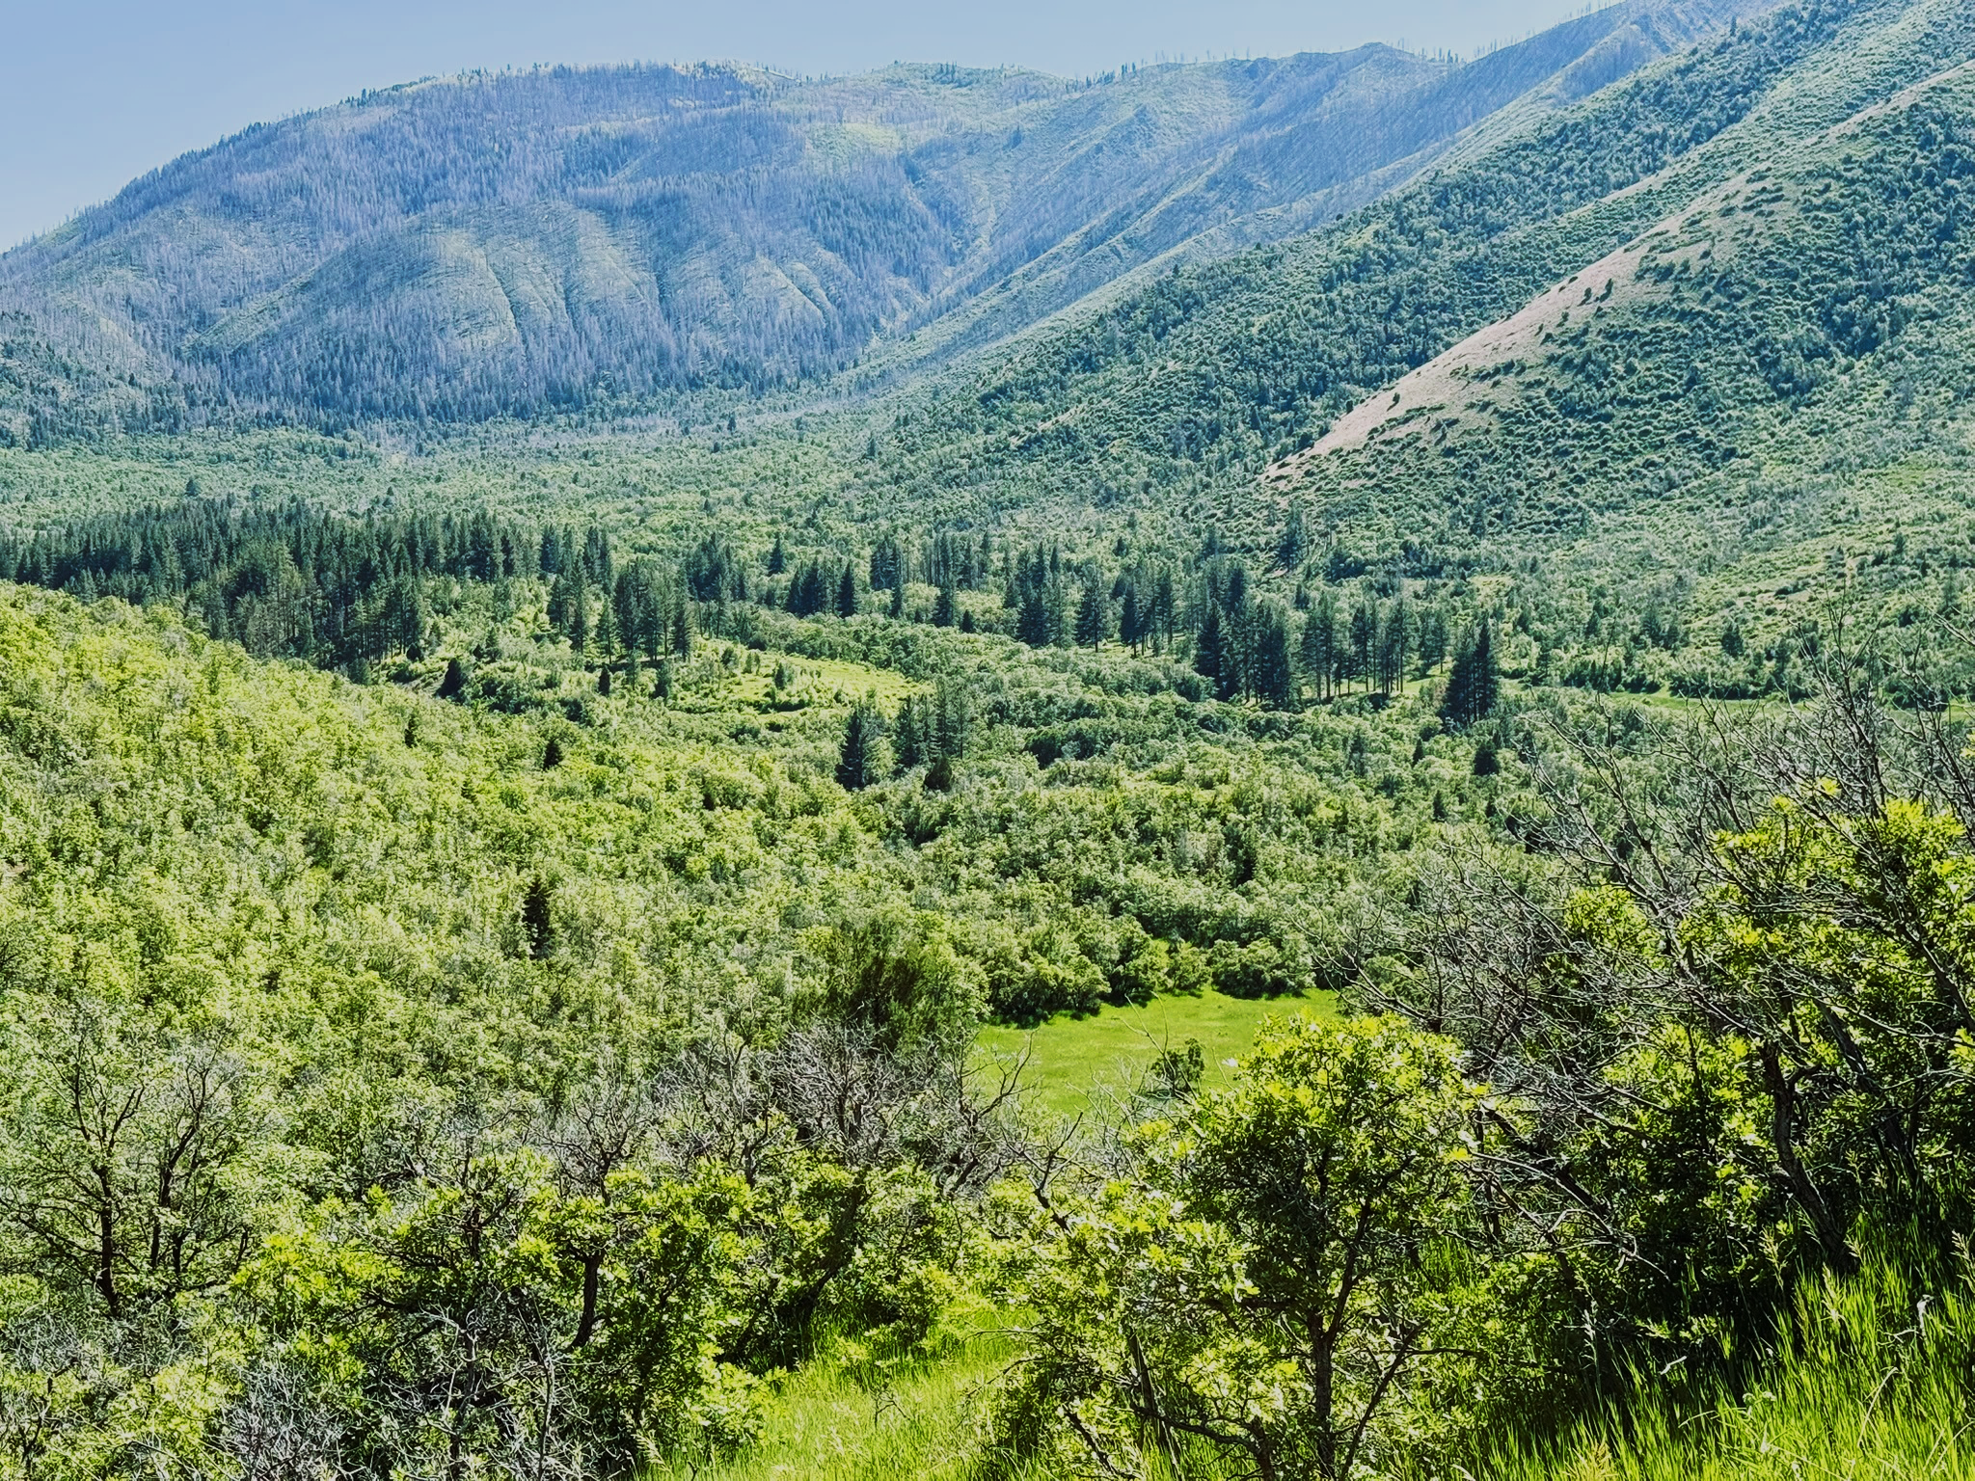
Vision
Open space is a critical component of a comprehensive, well-balanced parks and recreation system. Both private and public open spaces provide a host of ecological and ecosystem benefits, such as sites for purification of the soil, water, and air; places where the impacts of noise, wind, and visual disturbances can be buffered and absorbed; and places where native vegetation and natural wildlife can prosper. In other words, a robust open space system helps create a healthier community.

Open Space Plan

Official Open Space Map
The official open space map serves to identify the location of open space approved within the city. Citizens, landowners, developers, and city officials can refer to this map for planning and development purposes. Proposed changes to this map, through the development process, must be amended with a public hearing, planning commission recommendation, and city council approval.
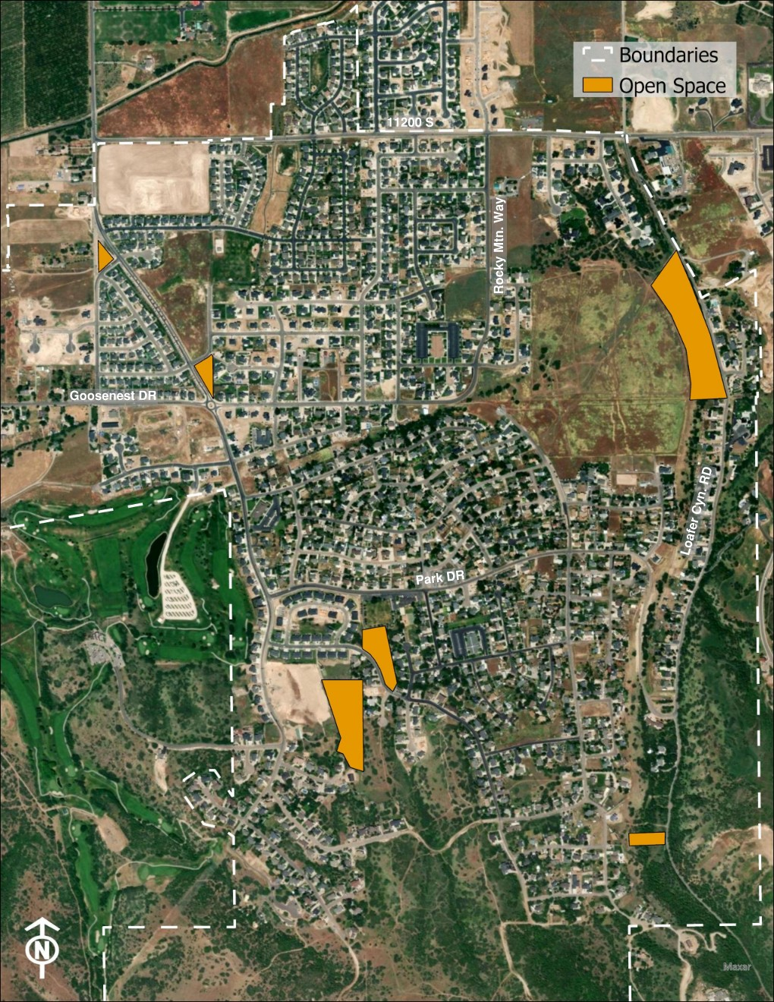

Open Space Goals
The open space plan contains goals guided by public and stakeholder input that can help chart the course forward to making the plan a reality.
Goal 1
As development occurs, the city will work with landowners to conserve valuable spaces while creating beautiful, well-planned places to live, work, and play.
Goal 2
Identify prime areas for open space preservation by referencing the Sensitive Areas map in the General Plan and focusing on areas that cannot be developed due to steep slopes, ridgelines, ravines/drainage areas, wildlife habitat areas and corridors, watershed, and water well protection areas.

Existing and Future Open Space Improvement Plan
A detailed list of existing open space, suggested improvements, and future open space.
Map # | Name | Current Amenities | Suggested Amenities/Improvements
Loafer Canyon /  Canyon View  Open Space  Loafer Canyon RD/  Canyon View DR | - South side has a basin and a natural ravine. | - South of Canyon View DR beyond the water retention basin  - Natural connecting trail for bikers and walkers.

Open Space Plan Priorities
Specific tasks to achieve the Plan vision are assigned immediate (0-5 years), short-term (5-10 years), medium-term (10-20 years), and long-term (20+ years) implementation timeframes.
Immediate (0-5 years)
- Maintain existing open space areas within developed areas.
Short-term (5-10 years)
- Create a map of desired/potential open space areas (an Open Space Map) on undeveloped land within city boundaries and the purpose for each open space (wildlife corridor, protect watershed, protect city water tank/well).
- Consider firebreak needs in conjunction with open space desires.
Medium-term (10-20 years)
- Purchase/preserve priority lands for open space.
Long-term (20+ years)
- Expand open space connectivity for regional conservation efforts.

Action Plan/Implementation
- Develop a long-term open space preservation strategy, including conservation easements and land acquisition programs.
- Work with local and state agencies to identify and secure funding for open space conservation.
- Promote responsible land stewardship through community education and incentives for private landowners.
- Implement wildfire mitigation efforts in designated open space areas.
- Survey current open space areas to determine upkeep and use (deer trails, water drainage, etc.).
- Create a citywide cleanup day twice a year for maintenance (chipper day) – May and September.

Potential Funding Sources
Current funding sources within the city cannot make this plan a reality. Development of the remaining developable land can help, but to implement these improvements within the already-developed areas and in the open space areas to the south, other means of funding will be required and could include:
- Grants
- Bonding and Conservation Easements
- General Fund (for grants matches and other priorities)
- Volunteer and Community Fundraising Programs
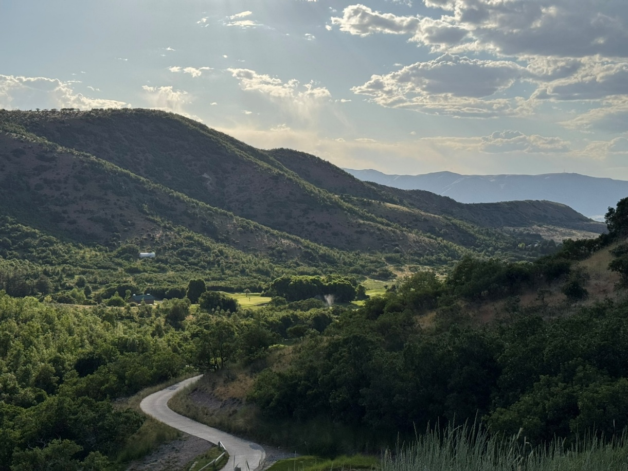

Appendix
- Survey Results

https://docs.elkridgecity.org/published/forms/Reports%20and%20Documents/2021%20SURVEY%20RESULTS.pdf

