MINUTES
Weber School Foundation Board Meeting
8/20/2026 12:00 PM | Meeting held at Weber School District Facilities Training Room and called to order by Jeremy Dunn

Attendance
Present: Craig Adams, Mark Adams, Dave Andersen, Jenna Andrascik, Matt Bell, Lindee Bess, Barry Beus, Jan Burrell, Tyler Buxton, Heather Christensen, Michelle Darrington, Craig Dearden, Scott Dixon, Jeremy Dunn, Jen Dunyon, Kori Ann Edwards, Jamie Ellison, Kaylie Faucette, Kimberli Green, Cherie Hanson, Brett Karras, Steve Kier, Karen Leonardi, Ashley Loftus, Phil Mickey, Ryan Olsen, Emily Oyler, David Perkins, Kathy Saunders, Shekeydrah Smith, Adam Stuart, Jake Talbot & Jennifer Warren
Excused: Bryan Benard, Gina Butters, Flora Cassity, Tony Divino, Bryan Hurst, Matt Jensen, Austin Mickles, Josh Skidmore, Laurie Stuart & Jennie Taylor
Guests: Dave Hales, Weber High School Chamber Choir

Welcome
Board President Jeremy Dunn welcomed board members to the meeting and thanked the Weber School District Facilities Team for hosting us.
Weber High School Chamber Choir performed two songs for the board members.
Introduce new Board Members David Perkins, Cherie Hanson & Jennifer Warren-
David Perkins is the Chief Nursing Officer at Ogden Regional Medical Center. He has been a supporter of Jubilee for many years and is excited to serve on our board!
Cherie Hanson is the Senior Vice President over Marketing and Communications at the Bank of Utah. She is replacing Branden Hansen & Angie Towns and is excited to serve!
Jennifer Warren is the Weber School District Student Services Director. Her team will now be overseeing the Teen Centers and excited to join the Foundation!
Board Expectations-Jeremy Dunn went over the board expectations with the board members.
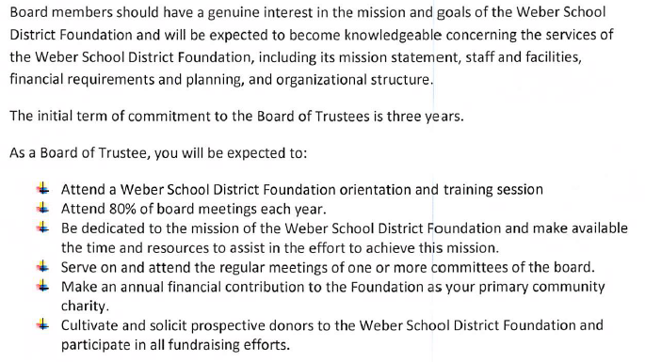
Announce 2026-2027 Executive Committee-Jeremy announced the new 2026-2027 Executive Committee:
Jeremy Dunn-Board President, Ashley Loftus-President Elect, Craig Adams-Treasurer, Gina Butters-Superintendent, Kimberli Green-At Large, Scott Dixon-At Large, Barry Beus-At Large & Emily Oyler-Foundation Executive Director
WSD Athletic Courtesy Card-Board members signed up for a WSD Athletic Courtesy Card which allows them and a guest to get into athletic events at our High Schools.
Group Photo-A group photo was taken with all board members present.

Get to Know You Game
Board members played a dice “Get to Know You Game” and then shared some fun things that they learned about each other!

Approval of Minutes
Approval of the April 16, 2026 Minutes-Kathy Saunders made the motion to approve the minutes from the April 16, 2026 meeting with a second from Barry Beus. The board unanimously approved.

Share our Story
Eye Tracking Machine& Hearing Aids-
Jeremy reported that Myla has Rett Syndrome. A primary characteristic of this disorder is severe difficulty with motor planning, which limits Myla’s ability to use speech or her hands to access standard augmentative and assistive communication devices. Since receiving this eye tracking device, she has increased her vocabulary to over 100 words! She is engaged and excited to start preschool this year!
Lillie is a 6th grade student who started to experience hearing loss 2 years ago. She was fit with a USDB loaner hearing aids and started to access speech therapy. Prior to her having these Phontak Hearing Aids and microphone her teacher was concerned about her behavior and academics. Since receiving them her negative behaviors have decreased and she’s eager to work on her speech and communicating with her peers!
Impact Report-Kimberli Green went over the Impact Report with board members-(Included at the end of the minutes)

Committee Reports
Special Needs— Jeremy Dunn informed the committee since our last meeting we have received 2 requests. One for a medical stroller wagon and the other for a tomato seat with tray. Total for these requests are $2,128.75. The Special Needs Committee has reviewed and approved these requests. Kori Ann Edwards made the motion to approve these requests with a second from Phil Mickey. The board unanimously approved. Jeremy informed the board that Josh Skidmore will now be the Chair for the Special Needs Committee.
Finance-Craig Adams reported that our investments are in good shape! They are up 7.0%. We have over 4 million dollars in investments and almost 1 million dollars in the Bank of Utah.
Projects-Michelle Darrington reported that there was a large match grant through DonorsChoose and the Foundation just funded 57 Class Grants totaling $17,089.97. We received 2 School Grants. One from Rocky Mountain Jr. High for Inclusion & Intermural and one from North Ogden Jr. High for Safety & Technology. The Projects Committee met in July and made some exciting changes. General Education and Special Education Class Grants have been combined into one application and funding source. The budget amount has been increased so the Foundation will be able to fund more classroom grants and increase the spending limit for each school. We are excited to introduce a new School Innovation Grant designed to support creative programs and projects that engage the entire student body! Schools can apply for a $1,500 grant to bring an exciting, meaningful and memorable experience to their students. Some examples would be a school play or musical, STEM activities, School Assemblies or a Creative Arts Program. Projects funded through DonorsChoose include: flexible seating, manipulatives, calculators, sports equipment, Phonic sets, classroom novel sets, headphones and writing tools.
With these updates and changes the 2026-2027 Funding Amounts will be:
Class Grants (Combined) $100,000
School Grants $25,000
New Innovation Grant $15,000
Jeremy Dunn made the motion to approve these projects with a second from Craig Dearden. The board unanimously approved.
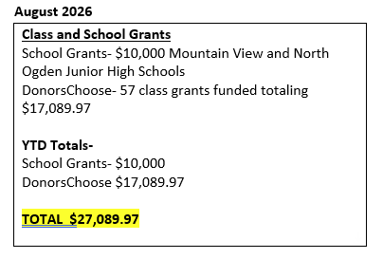
Teen Center-Steve Kier reported that Teen Center collaboration meetings were held quarterly last school year and proved to be very successful. One topic discussed at length is how to keep the Teen Centers open into the evening hours. We are still working through what this could look like, but it will likely involve support from community volunteers. The WSD Student Services Department will now be overseeing the Teen Centers. Their involvement will help ensure that students accessing these spaces are being connected with all of the resources and services available to them. We are now going to combine the Teen Center Committee and the Food Insecurity Committee into one committee called the Resource Centers Committee. We feel this committee can shift its focus toward strengthening the food pantries and resource centers within each space and making sure they continue to meet the needs of our students and families. Jennifer Warren reported that her team is very excited to be involved with the Teen Centers! There will also be training available to those working in the Teen Centers and they will work closely with the school counselors to help with all data collection.
Golf-Craig Dearden reported that our golf tournament was a huge success that brought in $131,000.00. The Ogden Golf & Country Club cost continues to go up. Thanks to our new SWAG Sponsor-Soltis Investment Advisors we provided our players with Oakley Sunglasses. They have agreed to be our SWAG Sponsor again next year. A survey was sent out to all of our golfers providing feedback. We will look into possibly going back to box lunches next year instead of having an in-person lunch.

Foundation Staff Spotlights
Foundation Staff; Shekeydrah Smith, Emily Oyler, Jamie Ellison and Michelle Darrington shared spotlight information with board members regarding fun facts, likes and family information.

Director’s Report
2026-2027 Budget Approval-Emily went over the detailed budget expenses, the proposed budget and the Balance Sheet with the board. (Attached at the end of the minutes) Mark Adams made the motion to approve the 2026-2027 Budget with a second from Craig Adams. The board unanimously approved.
Funding Ratifications-
StoryCon-Emily reported that StoryCon is a national convention and workshop series focused on literacy, reading and writing. This is hosted by Operation Literacy and combines elements of a book festival and a writing conference, offering workshops for teens, tweens, adults and educators. Amy Hall, who is over all of the district librarians has requested a $10,000.00 sponsorship again for the 2027 event. Craig Dearden made the motion to approve this request with a second from Phil Mickey. The board unanimously approved.
CHARD Funding-Valley Elementary-Emily reported that Valley Elementary has a funding request of $32,332.56 to purchase a new school marque. This funding will come from their Chard Fund. This funding is designed to support enhancements at Valley Elementary. They have obtained bids and have chosen a state-contracted vendor. They currently have $73,407.44 in this account. Matt Bell made a motion to approve this request with a second from Kathy Saunders. The board unanimously approved.
Community Christmas-Emily reported that we received a request from a local non-profit called Community Christmas. They provide Christmas assistance for over 200 children in our community and valuable resources for over 600 families. Last year they helped 122 families and over 420 children in the Weber School District. They are requesting a $2,500.00 donation from the Foundation to help with the 2026 Christmas season. Steve Kier made the motion to approve this request with a second from Jan Burrell. The board unanimously approved.
Ogden Pioneer Days Rodeo-Emily reported that the Director for the Ogden Pioneer Days Rodeo met with both the Weber and Ogden School Foundations on how to address literacy issues for students in the districts. The Rodeo partnered with Dolly Parton’s Imagination Library which provides free books to kids ages 0-5. $30,000.00 was raised to which each foundation will receive $7,500.00. The Rodeo is requesting a match from the Foundation for $2,500.00. These funds will be used to purchase books for the 2nd Graders in our district. Kimberli Green made the motion to approve this request with a second from Jeremy Dunn. The board unanimously approved.
Christmas Tree Jubilee-Emily reported that the Kick-Off meeting with the Jubilee Committee has been scheduled, Almond Knot delivery dates have been scheduled and the tasting with the Conference Center has been scheduled.
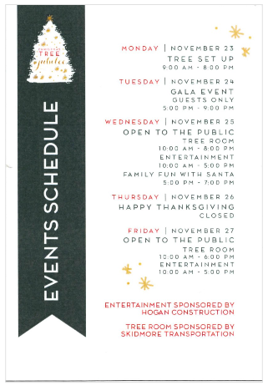
Sponsorship Packages-
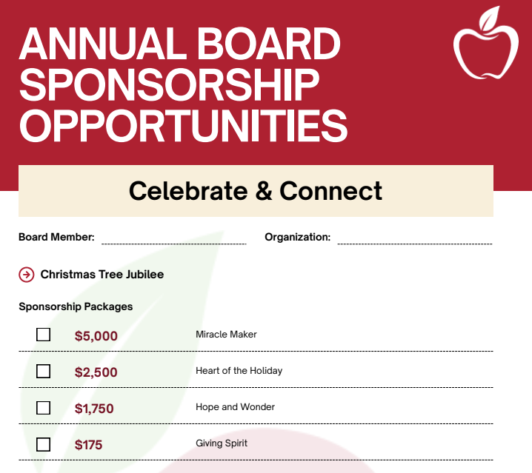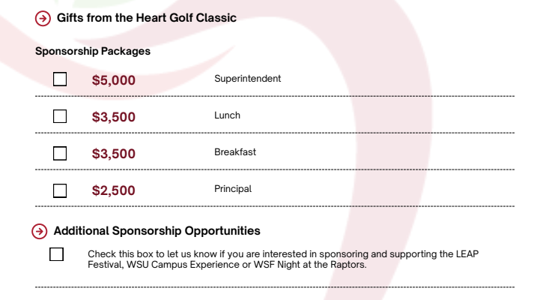
Board members now have the opportunity to sign up for sponsorship packages at the beginning of the school year for both Christmas Tree Jubilee and the Gifts from the Heart Golf Classic.

Ask-Emily informed the board that we have some ideas for the Jubilee Ask focusing on literacy. The details are still in progress. This was an area that our board members wanted to see some funding going towards.
Foundation Survey Results & Group Breakouts-Jeremy Dunn informed the board that we had 23 board members respond to the survey that was sent out regarding the Foundation. Based on the feedback received each table will focus on 2 questions. (The WSF Board Survey Highlights are included at the end of the minutes.)
Brainstorming & Report Back-Each table had a representative report back on each question that was asked.

Other Business-
Dates to Remember
-Unified Sports Soccer Tournament-September 24, 2026 9:45-12:45 at Bonneville High School
-Weber School Foundation Night at the Ogden Raptors tonight! Game starts at 6:30 p.m.
Adjourn

Next Meeting
September 16, 2026

