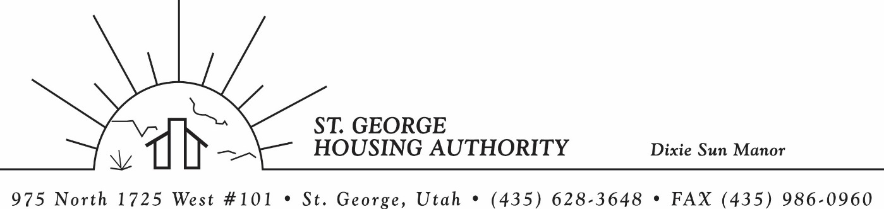
BOARD MEETING
DIXIE SUN MANOR 975 N. 1725 W. # 101
Tuesday August 11, 2026

PRESENT: Mike Barben, Jane Fehrenbacher, Daniel Baldwin, Steve Kemp, Gloria Shakespeare, Greg Whitehead, Kenny Miller

EXCUSED: All present.

MINUTES: Minutes of Board Meeting held June 9, 2026 were reviewed. Motion made by Gloria Shakespeare to approve minutes as reviewed, motion seconded by Kenny Miller. Motion carried.

Review Housing Assistance Report for July & August 2026: Mike Barben handed out the HAP reports for July and August 2026. Board members were able to see the money spent for the months on rental assistance, see the average unit cost, and verify the units leased for the month. The board was also able to ask questions and have a discussion about portability, C of C, VASH, EHV, & Mainstream Vouchers. Each board member present signed off on the HAP payments and month end totals.

Review current 2026-2027 budget: Mike Barben handed the board a copy of the fiscal year 2026-2027 SGHA budget. The board was able to see how the SGHA is doing in the current fiscal year budget. Mike reported that for the most part, SGHA was right on budget, and let the board ask questions on any of the items on the report. The board has asked Mike to provide and present the most recent budget accounts at each board meeting. By providing the current budget monthly, the board can see how the SGHA is keeping up with the current budget throughout the whole year. The board thought it would be great to ask questions and be on top of what the SGHA is doing financially. Greg Whitehead asked Mike if he could break the budget down into separate programs to verify which programs are doing well and which ones are needing help. Mike has now separated the budget into 3 programs so the board can better understand the flow of money in each program. Greg Whitehead requested that Mike send out the final month of the Fiscal Year 2026-2026. Mike agreed to email it out with the board minutes.

Discuss SGHA Shortfall: Mike Barben informed the board that the St. George Housing Authority was in a shortfall according to the 2-year tool projection. The amount projected to be in shortfall is $178,068. Mike informed the board that the HA has been through this process before and that Mike has already started the process of working with the Shortfall team to get this corrected and refunded. Mike said this is a concern, but the board should not worry because the HA has been through this process before and Mike knows how the process works. Mike said over 700 Housing Authorities across the U.S are also in shortfall. Mike mentioned the reason for the shortfall is either over leasing or rent increasing dramatically over the past couple of years. Mike said in SGHA case it is due to rent increasing so much. Mike said he would keep the board updated through this process and is confident that funding would be reimbursed to get out of the deficit.

Jane Fehrenbacker report on DSM: Jane reported that the community is doing well, reported that DSM is a great place to live. Jane reported that all units are full. Reported on Dixie Sun Manor Pot lucks. Jane expressed how important it is to have these social activities for DSM tenants. Jane reported that one tenant’s health is not well and hopes for a speedy recovery.

Steve Kemp City Council Report: Steve kemp was able to report a few items going on within the city. The county commission elections are over and Victor Iverson was beat out by Troy Belliston. Steve also talked a lot about 2 underpasses being built, that will help alleviate traffic. Steve also talked a lot about the cost of roads, trails, and park upkeep and how expensive it is. Steve also reported that the city council is functioning well and are getting a lot done for our wonderful city.

Reports from Board Member & Housing Director: Mike Barben asked the board if they could move the next board meeting in September from the 8th to the 15th due to Mike being out of town. The board all agreed and Mike said he would send out the invite.

Request of a closed meeting to discuss litigation, security, property acquisition or sale, or the character and professional competence or physical or mental health of an individual: None

Motion made by Kenny Miller to close the meeting. Gloria Shakespeare seconded the motion. Motion carried. Meeting adjourned at 9:30 a.m. Next board meeting will be Tuesday September 15, 2026 at 8:30 am.

