MEMORANDUM

DATE: Monday, September 21, 2026
TO: Marlo Oaks, State Treasurer and Utah Charter School Finance Authority Board
FROM: Japheth McGee, Vice President and Johnathan Ward, Senior Vice President of Zions Public Finance
RE: Wasatch Waldorf Academy Application to the Utah Charter School Finance Authority and Credit Enhancement Program

Conflicts of Interest

In general, Zions Bancorporation, National Association is made up of many departments and provides various services. Some of those services and departments can be involved on the same transaction. Zions Public Finance Inc. and Zions Corporate Trust are affiliated entities operating under Zions Bancorporation and we all benefit from a strong stock price derived from strong performance by the company and its component members and affiliates across the country. Zions Public Finance does not receive financial or other benefits in association with transactions performed by Zions Corporate Trust who may act as Trustee on charter school transactions. Likewise, Zions Public Finance operates separately from commercial loan divisions of the Bancorporation who may have provided private financing to developers or charter schools to construct the school initially. Zions Public Finance is not aware of the circumstances where this occurs unless told when a charter school applies. Zions Public Finance does not receive financial or other benefits that could result from actions taken by the Charter School Finance Authority outside of the agreed upon fees for services rendered to the Authority.

Zions’ entities engaged with the School:

Zions Public Finance: | Yes. (Advisor to the Authority)
Zions Corporate Trust: | No
Zions Commercial Involvement: | No

Executive Summary

Borrower: | Wasatch Waldorf Academy
Management Company: | Business Manager: Red Apple Financial
Municipal Advisor: | RoundTable Funding: Clint Biesinger
Borrower’s Counsel: | Farnsworth Johnson: Brandon Johnson
Underwriter: | Crews & Associates: Michael Lambert
Bond Counsel: | Chapman & Cutler: Eric Hunter
Issuer’s Counsel: | Utah Attorney General’s Office: Perri Babalis
Trustee: | US Bank National Association: Laurel Bailey
Par Amount: | $16,315,000 in tax-exempt bonds.
Enhancement Requested: | Yes
Purpose: | Fund the construction of an expansion and renovation at the current Holladay campus, refinance the existing Series 2018 bonds, fund a debt service reserve, and pay costs of issuance.
Structure: | Bonds will be repaid with a roughly level amortization of principal and interest over 40 years. The bonds will carry a fixed rate of interest.
Term: | Final maturity in 2066. Bonds will likely carry a 5-year call at 102% descending to par in year 7.
Rating: | Moody’s Ratings: Ba1
Costs of Issuance Estimate: | $300,000
Underwriter Fee Estimate: | $4.25/$1,000 (est. $69,338.75)
Litigation: | None of which we are aware.
Summary: | Wasatch Waldorf Academy is a relatively new School and new to the Credit Enhancement Program. It has been in operations for just 10 years. The School has had positive though choppy financial performance over the last five years. Part of the choppy financial picture is related to the small nature of the School with just over 640 students. The School is expanding its current campus to admit additional students and increase the scope of operations. The School has a large waitlist to draw on and should be able to fill the expected increase with no problem. The School had coverage on the future debt service based off prior year’s operations. It met each of the metrics for Credit Enhancement, though its current ratio was strained in part by a large unearned revenue liability related to a Federal Employee Retention Tax Credit (“ERC”). Auditors have indicated that ERC will be recognized as earned revenue this fiscal year.

Purpose

The purpose of this memo is to document the adherence of Wasatch Waldorf Academy (the “School”) to the application requirements of the Utah Charter School Finance Authority (the “Authority”) Credit Enhancement Program Standards and provide credit analysis of the School for the Authority’s consideration. The analysis contained herein is based on the School’s application to the Authority and inquiry for clarification of the Municipal Advisor to the Authority.

Introduction

The School is a non-profit, 501c3 designated, public K-8 charter school with one campus in Holladay. The School was approved by the Utah State Charter School Board (the “SCSB”) and opened for operation in 2016.

MISSION
Wasatch Waldorf Charter School provides a K–8 public Waldorf education that is dedicated to the optimal development of each individual child. WWCS nurtures intellectual, social and emotional, and physical capacities through an artistic, hands-on, interdisciplinary approach to core academic subjects which enables each student to blossom into an imaginative, engaged, competent, life-long learner.

VISION
Wasatch Waldorf Charter School is a Waldorf charter school in the Salt Lake Valley that provides a comprehensive education program integrating academics, arts, movement, nature, and social responsibility into everyday learning. Through a culture of holistic learning, our students, teachers, faculty, and families emerge as confident, creative, strong critical thinkers and environmental stewards, empowered to act positively in their own lives and communities.

Enrollment/Student Demand

October enrollment for the 2025 - 2026 school year was 643 students. The School plans to increase student enrollment to 684 students by 2030. The School has a strong waitlist and has shown strong retention and resulting enrollment throughout the entire look back period. Average daily membership is above 98%.

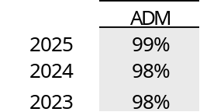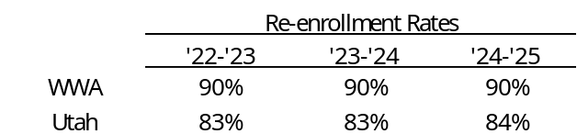

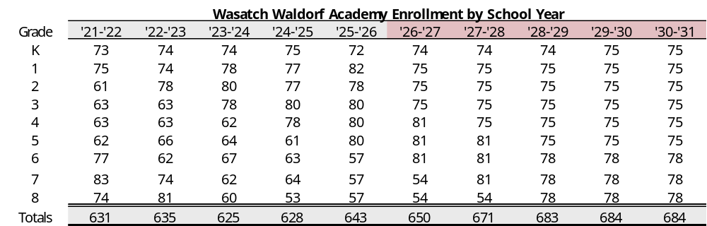

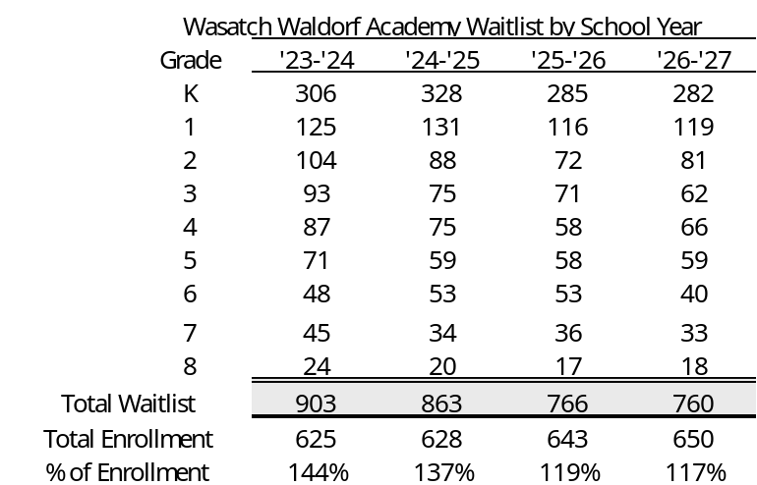

Academic Performance

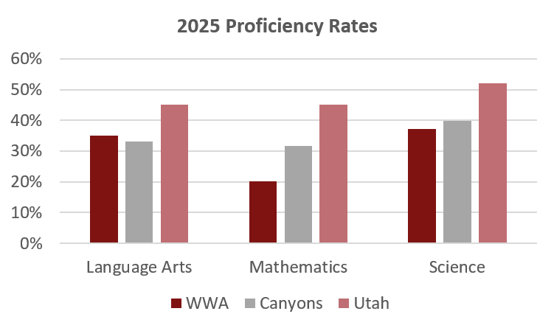

Management

- The School currently has a seven-member board. The board members have backgrounds in: education, law, healthcare, refugee and social work, graphic design, and accounting.
- The School employs Heather Campbell as Executive Director. Ms. Campbell has been with Wasatch Waldorf Academy since 2016. She holds an M.Ed in Special Education from the University of Utah, a BA in Political Science from SUNY Albany, a Teaching Certification for Severe K-12 Special Education, and a Certificate in Educational Leadership from the University of Utah.
- The School employs Red Apple for accounting and business services.
- The School has formal policies for budgeting, cash handling, fundraising and donations, and procurement. The school has no formal policies on debt or investments.

Plan of Finance

The School is seeking authorization to sell up to $16,315,000 of Ba1 rated bonds via negotiated sale with Crews & Associates serving as the Underwriter. The School is seeking credit enhancement through the Utah Charter School Credit Enhancement Program. The bonds will be tax-exempt bonds for the purpose of funding construction of an expansion at the existing campus (12,700 sq ft of gymnasium and classroom space), renovating the existing building (6,200 sq ft), funding a debt service reserve, refunding the existing bonds for economic savings, and paying costs of issuance. The bonds will carry a fixed rate of interest and will likely carry a 5 call at 102% that descends to par. The bonds are secured by an assignment and secured interest in the revenues of the School and trust accounts and a security interest and pledge of the deed of trust in the land and building located at:

- 1458 E Murray Holladay Road, Holladay, UT, 84117

Ratings

The bonds are rated Ba1 by Moody’s Ratings. Moody’s noted the following credit strengths in its rating report.
- Established market position with strong waitlist.
- Strong liquidity.
- Positive operating performance with recurring operating surpluses and solid operating cash flow generation.

The following credit challenges were noted:
- Small absolute scale.
- Inconsistent debt service coverage and moderate coverage relative to the rating category.
- Elevated leverage following the planned bond issuance.
- Limited revenue diversification.

Moody’s noted that the School could achieve a rating upgrade with over 2x coverage and increased operating revenue. Inability to achieve 1.5x coverage or draws on liquidity beyond 120 days cash on hand could result in a rating downgrade.

Financial Performance

Summary:
The School has a strong history of budgeting with performance largely mirroring budget expectations. The School has a good cash and operating position that should allow it to meet expanded debt service obligations.

- Actual budgets were largely in line with original budgets. No year in the past five varied significantly.

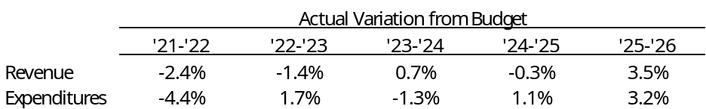

- Cash Position
 | Requirement | Measure at end of FY 2025
 | At least 75 days | 235

The School has strong cash on hand but is expected to utilize a portion of that cash towards the current project. The School will be making a $2 million contribution to the project which would have brought the School down to 109 days cash on hand in 2025.

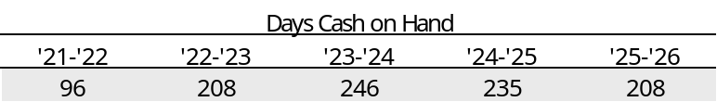

- Fund Balance
 | Requirement | Measure at end of FY 2025
 | At least 15% of following year expenses | 23%

The School has met this metric each year in the look back period. Fund balance was depressed relative to cash levels as the School had a large unearned revenue balance related to an Employee Retention Tax Credit. The School’s auditor anticipates the ERC will be recognized as earned in FY 2026.

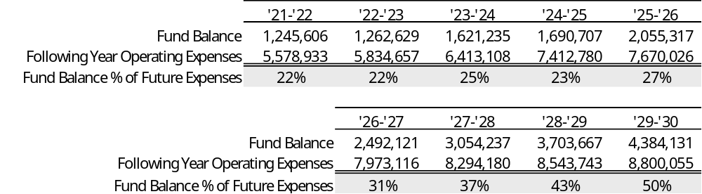

- Debt Coverage Ratio
 | Ba1 Requirement | Measure at end of FY 2025
 | At least 115% | 128%

Debt service coverage has been inconsistent, as noted by Moody’s. Expanded enrollment should provide more operating room for the School and lead to higher, more consistent coverage. The School would have had revenues sufficient to meet debt service payments in each of the past five years. Coverage would have been weak in 2023 and 2025 on expanded debt service.

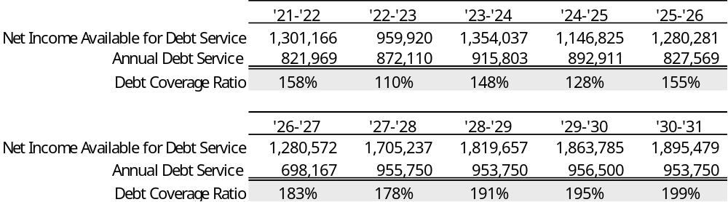

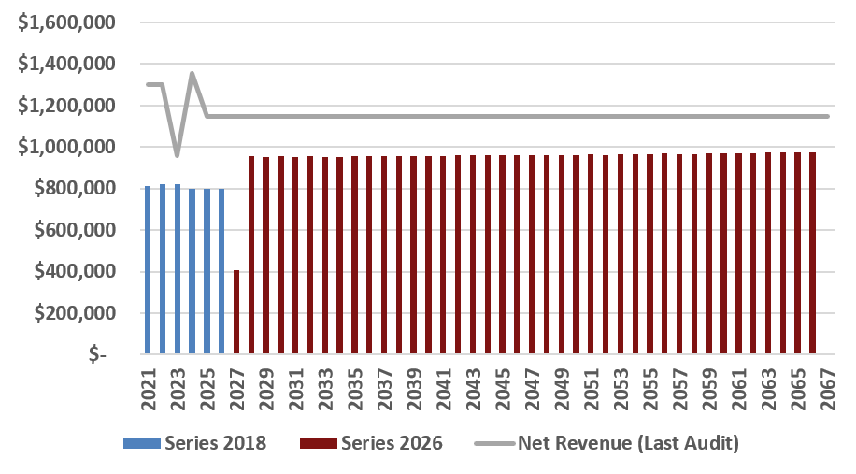

- Debt Burden Ratio
 | Ba1 Requirement | Measure at end of FY 2025
 | Less than 18% | 11.8%

The School met this metric in each year of the look back period and would have at FY 2025 revenue levels against future debt service.

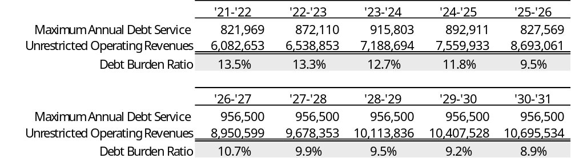

- Operating Margin
 | Ba1 Requirement | Measure at end of FY 2025
 | At least 14% | 15.2%

The School has maintained operating margins just over the requirement. Additional enrollment should improve the operating margins.

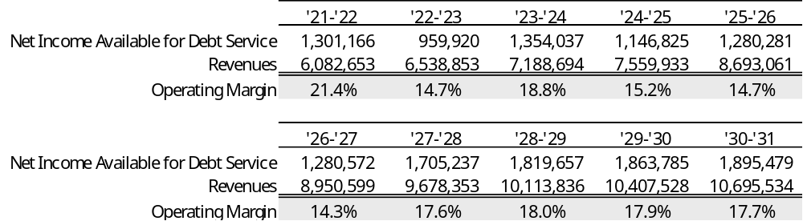

- Current Ratio
 | Requirement | Measure at end of FY 2025
 | At least 150% | 151%

The School’s current ratio was very weak in part due to the large unearned revenue item related to the Employee Retention Tax Credit.

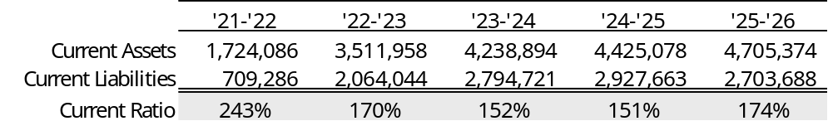

Bond Documents

Legal bond documents are being reviewed by the Utah Attorney General’s Office in its capacity as Issuer’s Special Counsel to the Authority, and all requirements are being incorporated. In addition, Chapman & Cutler, as Bond Counsel, has certified that each of the required legal provisions is present in the bond documents.

Continuing Disclosure

The School had some late filings though all late filings were rectified within days of the due date.

Conclusion

The School meets each of the requirements for credit enhancement. Expanded debt service has been within the operating budgets the School has met the past several years, and should be manageable with additional enrollment coming online with the classroom addition. The School has a solid waitlist to draw on to meet expected enrollment growth.

