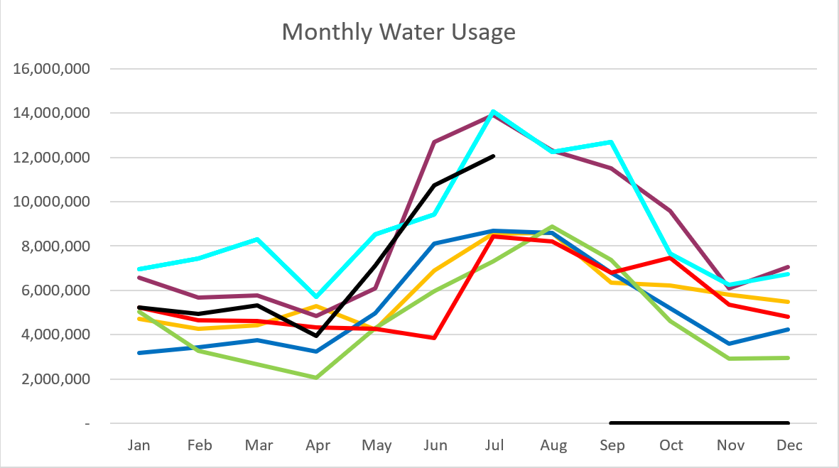
2026 - Black
2025 – Light Blue 2024 – Purple
2023 – Red 2022 – Yellow
2021 – Blue 2020 – Green
July 2026

Unaccounted water went from 30% last month to 23.88%
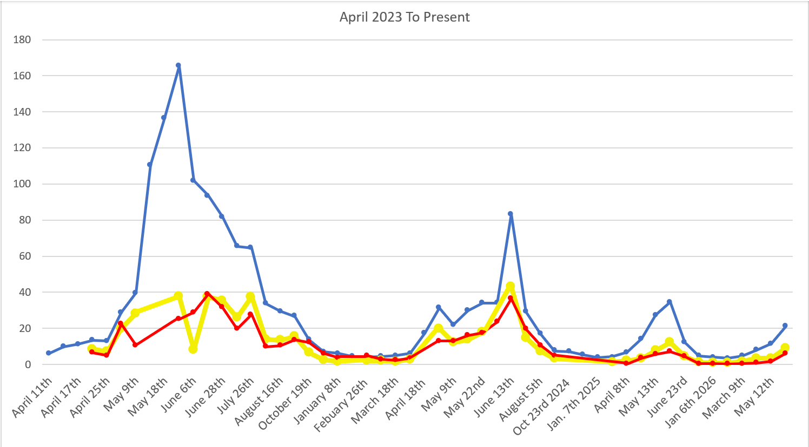
C
F
S

Water Department Information for July
- Our overall water consumption is lower than in the last two years.
- Aspen Grove wet-well levels are averaging 7.6 feet for July 2026 which is the same as last month. This time last year, in July 2025, our average was 8 feet.
- Stewart Spring is averaging 85 gpm for July 2026, which is up from last month. This time last year it was averaging 115 gpm for July 2025.
- Stewart spring overflow is running 20 gpm for the month of July which is down from last month. Total Stewart Spring produced an average of 105 gpm for July 2026.
- Construction is almost complete at the treatment plant
  - Power conduit is installed. Waiting on RMP to pull and energize the line.
  - They are painting the pipes inside.
  - We still need to have additional equipment installed.
- We repaired the leak we found on Stewart Road. There were two separate leaks next to each other.
- We have had 86 submit lead and copper surveys up from 15 last month.
- Unaccounted water elimination processes:
  - We have replaced almost all the service meters including the 6-inch meters.
  - Corrected meters with wrong calculations, and mismatched register sizes.
  - We have had the spring meters heartbeat checked multiple times
  - We have had 2 leak detection companies conduct leak surveys
  - We have fixed multiple leaks
  - We have replaced 2 leaking hydrants.
  - We have inspected about 50 percent of the hydrants with a camera device.
  - We have had all the PRV’s inspected and replaced one 6 inch one 4 inch and two 2 inch PRV’s
  - We eliminated a section of old pipes on coming from the old Stewart Tank
  - We isolated Stewart tank to check for tank leaks.
  - We have two new zero meters ordered to replace the spring meters.
  - We started isolating zones in the system by transferring usage from Stewart to Aspen grove sides.
  - Leak locators came back out.
  - Dug and fixed a leak on stewart rd.
  - Replaced both spring meters.
  - Fixed a double leak on stewart rd.

Wastewater Department Information for July
- We completed one lab test in July, and all results were within limits. FOG was reported as not detected; because the lab cannot measure below 5 mg/L, the result is below the detectable limit.
- MBR tank 3 is online and running.
- MBR 1 and 2 have the new Kabota membranes installed.
- They will be working on installing new piping and pumps.
- Sundance is planning to repair our electrical lines that were hit on the upper drain field.
  - Update they have put a new conduit in now we just need the line put in and wired up.

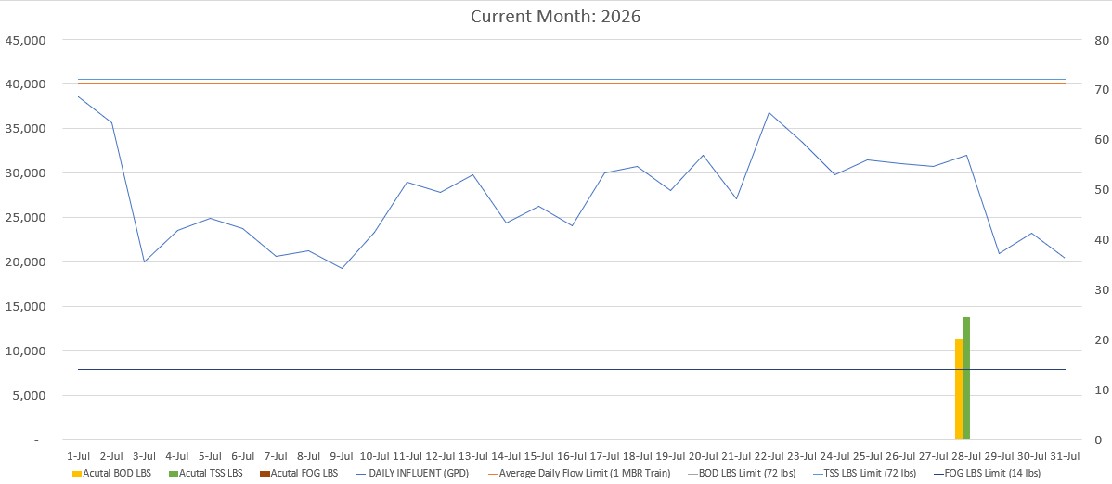

AVERAGE DAILY FLOW (GPD) | 27,425
HIGHEST DAILY FLOW (GPD) | 38.530

