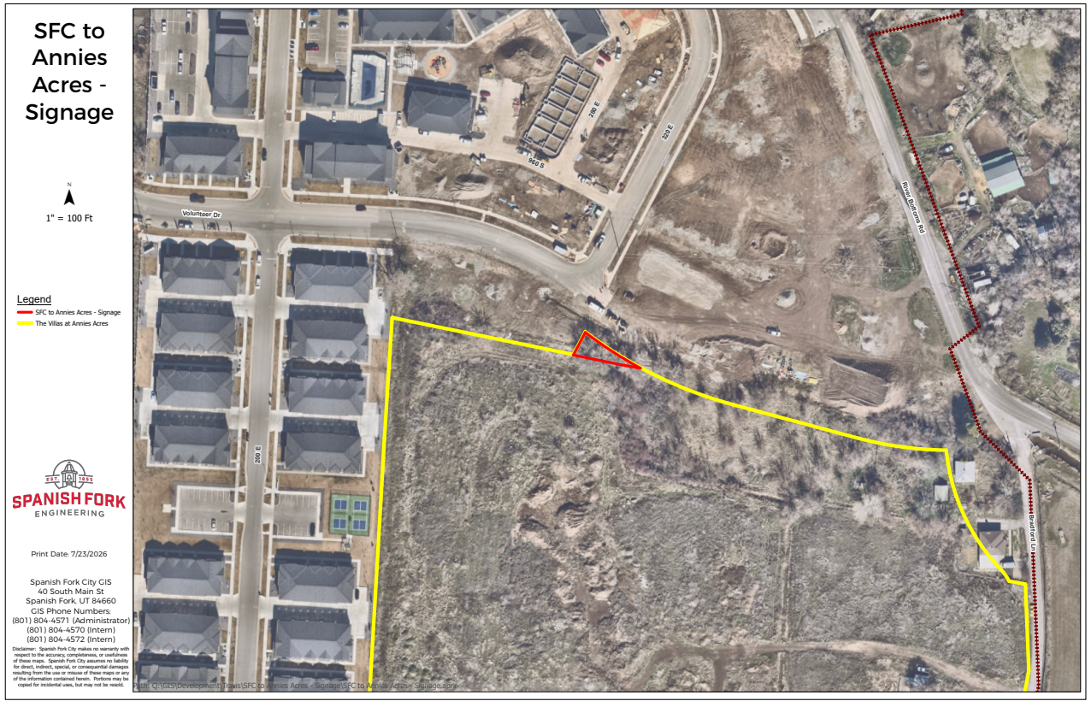

Public Hearing Notice

City Council Meeting: September 21, 2026 at 6:00 p.m.

Location: Library Hall Council Chambers
80 South Main Street
Spanish Fork, Utah

Proposal: Disposition of up to .04 acres (1,836 sq feet) of City Property located at approximately 320 East Volunteer Dr, Spanish Fork. Utah County, being a small portion of parcel #51:814:0217 .

For more information contact: Travis Warren at 801.804.4557 or by email at twarren@spanishfork.gov

