Monthly Fire District Report EMS

Transport for the Year
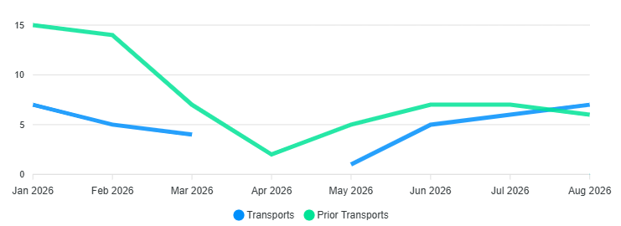

Billing
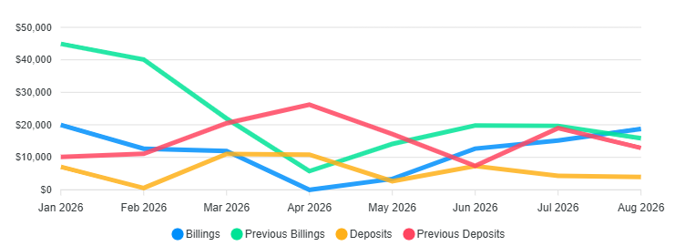

2026 Totals
Transport 35/Billed $94,508.10/Collected $47,612.80 /2026 YTD
Monthly Calls for Service
Calls for Service 192/YTD

