Hearing on Executive Pay - Exhibit A

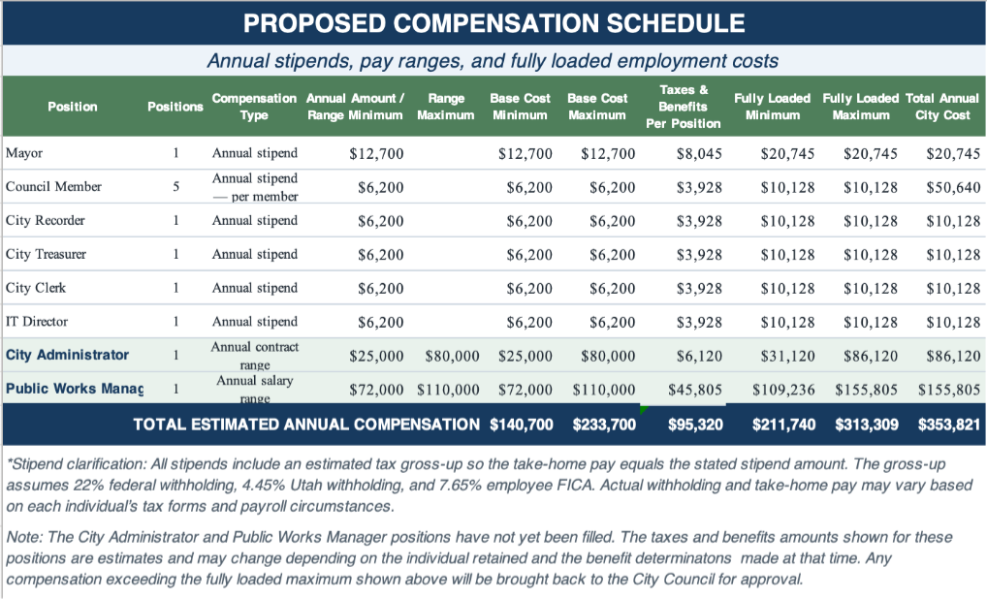
Notes:
- The amounts shown for Mayor, Council Members, City Recorder, City Treasurer, City Clerk, and IT Director are annual stipends, not salaries or hourly pay. The $6,200 stipend shown for “Council Member” is paid to each of five Council Members individually (5 × $6,200 = $31,000 total). These positions will receive no employee benefits but will receive an amount “grossed up” for tax purposes, so the net payment amount will be the stipend as shown above.
- Salary ranges shown for City Administrator and Public Works Manager reflect minimum and maximum authorized annual pay; actual appointments may be made within the approved range.
- The City Administrator pay will be pursuant to an independent contractor agreement.
- The Public Works Manager pay will be salary as a full-time employee.

