PANGUITCH CITY REQUEST FOR BIDS
Pre-Engineered Metal Building Package
Panguitch City is requesting bids to furnish and deliver a complete pre-engineered metal building package meeting the following basic requirements. Building erection is not included in the base bid. Bids must be submitted by email to Mat Houston at mat@panguitchutah.gov no later than 5:00 p.m. Mountain Time on September 18, 2026. Questions regarding this request for bids may be directed to Mat Houston by email or by telephone at 435-676-3080.

Building Dimensions
Element | Required configuration
Main building | 60' wide x 90' long; clear-span with no interior columns; 16' eave height measured from finished floor; 3:12 symmetrical gable roof.
Lean-to | 24' wide x 90' long; attached along one 90' side; open-sided; 2:12 roof pitch; approximately 12' outside eave height.

CONCRETE STEM WALL
The building will be installed on an approximately 2-foot-high concrete stem wall constructed separately by Panguitch City or its contractor. The 16-foot eave height is measured from finished floor, leaving approximately 14 feet of metal wall above the stem wall. The footings, foundation, stem wall, and floor slab are not part of this bid. The building supplier shall provide required foundation reactions, anchor-bolt layout, and connection details.

Minimum Requirements
- Pre-engineered structural steel building system
- Minimum 26-gauge painted steel roof and wall panels
- Complete matching exterior trim, flashing, closures, and fasteners
- Wall insulation rated R-25 or better and roof insulation rated R-30 or better
- Painted steel gutters and downspouts
- Stamped engineered plans prepared by an engineer licensed in Utah
- Delivery to the Panguitch project site
- Manufacturer's standard warranties, including an approximately 40-year or better panel paint-finish warranty
The complete building and lean-to shall be designed for applicable site-specific snow, wind, seismic, and other building-code requirements in Panguitch. Snow-load engineering shall account for balanced and unbalanced snow, drifting, accumulation, and potential sliding snow at the main-roof/lean-to connection. The bidder shall state the ground snow load, roof snow load, wind speed, exposure category, and governing building code used in preparing the bid.

Windows and Door Openings
Location | Required openings / windows
Front end wall | Two 14' x 14' overhead-door framed openings; one standard personnel-door framed opening; one 3' x 4' operable sliding window.
Back end wall | Two 14' x 14' overhead-door framed openings; one 10' x 10' overhead-door framed opening; one standard personnel-door framed opening.
Side opposite lean-to | Five 3' x 4' fixed windows installed high on the wall.
The building package shall include the windows and required window framing, flashing, and trim. Overhead doors, personnel doors, door frames, hardware, and operators will be purchased separately by Panguitch City and are not included. The building supplier shall provide the structural framing, reinforcement, flashing, and exterior trim required for installation of the doors by others.

Bid Information
Each bidder shall provide a total lump-sum price; manufacturer and proposed building specifications; structural framing, panel, insulation, window, design-load, and warranty information; estimated engineering, manufacturing, and delivery schedule; unloading requirements; and a clear list of exclusions or deviations. Equivalent or superior systems may be proposed.
OPTIONAL ERECTION AND INSULATION ESTIMATE
If the bidder provides erection services or works with a qualified building erector, include a separate estimate to erect the complete main building and lean-to and install the supplied roof and wall insulation. List the estimate separately from the building-package price and identify all exclusions, equipment requirements, and work expected from Panguitch City.

CONCEPTUAL BUILDING RENDERINGS
General arrangement only - written specifications control
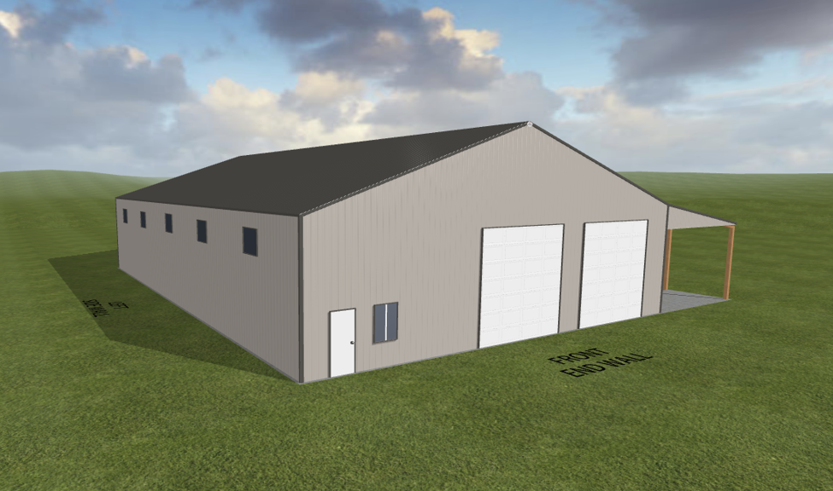
Front and side concept: two 14' x 14' front openings, one personnel-door opening, one sliding window, and five high fixed windows on the wall opposite the lean-to.

CONCEPTUAL BUILDING RENDERINGS
General arrangement only - written specifications control
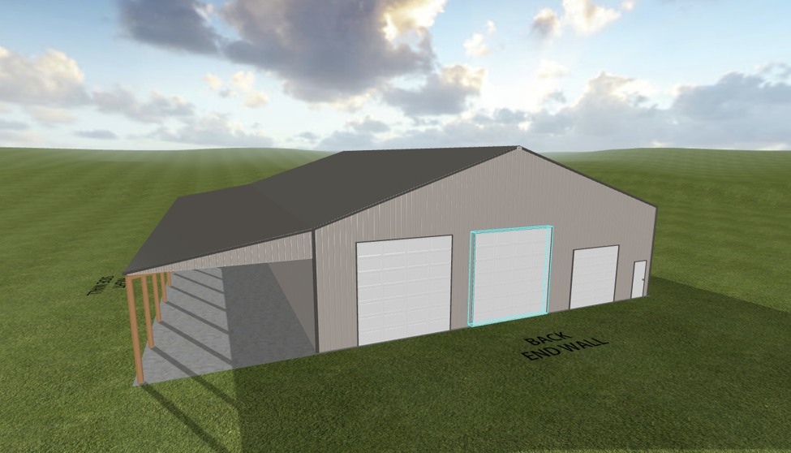
Back and lean-to concept: two 14' x 14' back openings, one 10' x 10' opening, one personnel-door opening, and the 24' x 90' open lean-to.
CONCEPTUAL ONLY - NOT FOR CONSTRUCTION
These renderings do not replace the written specifications or the successful supplier's engineered drawings. Doors shown are not included in the base bid. The approximately 2-foot concrete stem wall is not accurately shown and will be constructed separately by Panguitch City or its contractor.

