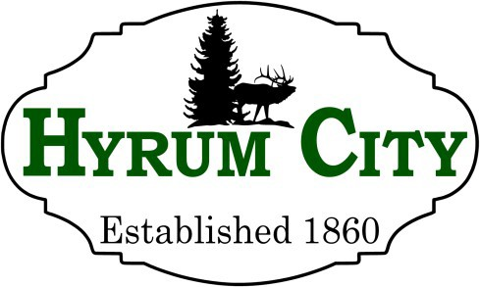
60 West Main Street, Hyrum, Utah 84319 ▪ 435-245-6033
Steve Miller, Mayor Council Members - Rebecca Foulger Michael Nelson NaLyn Nelson Craig L. Rasmussen
Mont Wright

NOTICE OF PUBLIC HEARING

Notice is hereby given that the Hyrum City Planning Commission of Hyrum City, Utah will hold a public hearing Thursday, September 10, 2026 at 6:30 p.m. in the Hyrum City Council Chambers, 60 West Main, Hyrum. The purpose of this hearing is to receive public comment regarding a rezone from Residential Agriculture Zone RA to Residential Zone R-2 for a low to medium density Planned Unit Development with varied lot sizes, common area, and community green space located at approximately 300 North 400 East.

Copies of the proposed rezone are available at the Hyrum City Office, 60
West Main, Hyrum, weekdays between the hours of 8:00 a.m. and 4:30 p.m.,
and on the City's website at www.hyrumcity.gov

_______________________________
Shara Toone
Secretary

Published: State Public Notice Website and Hyrum City Website on August 27, 2026.

Posted: Ridleys Grocery Store, Hyrum City Office, and Library, Cache Valley Bank, Manning Short Stop on August 27, 2026.

