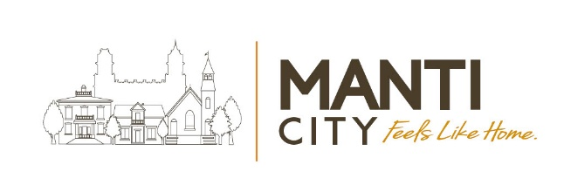

Special City Council Meeting Agenda
Manti City Building • 50 South Main Street
August 25, 2026 – 8:30 p.m.

Call to order & Welcoming: ☐Mayor Mary Wintch
Roll Call of City Council Members (Attendance):
☐Meagan Johnson ☐Mary Pipes ☐AJ Mower ☐Jen Christiansen ☐Brian Francois

- Discussion and approval for development of the South Gate Commercial Industrial Park initiatives.

- Adjourn:

In Accordance with the Americans with Disabilities Act (ADA) individuals needing special accommodations or interpretive services during this meeting should contact the city office at
435-835-2401 at least (3) working days prior to the meeting.

Certificate of Posting: The undersigned, duly appointed Recorder, does hereby certify that the above notice & agenda was posted and provided to the local media and the posted on the Utah State website.

Matt Gray, City Recorder

