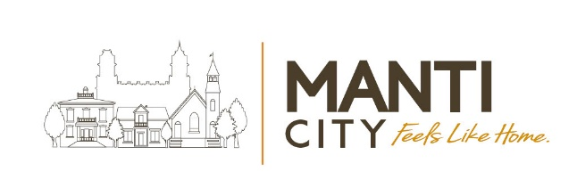

Closed Council Meeting Agenda
Manti City Building • 50 South Main Street
August 25, 2026 – 6:30 p.m.

Call to order & Welcoming: ☐Mayor Mary Wintch
Roll Call of City Council Members (Attendance):
☐Meagan Johnson ☐Mary Pipes ☐AJ Mower ☐Jen Christiansen ☐Brian Francois

- The Manti City Council is holding a closed session to discuss the character, professional competence, conduct, or other factors of an individual per Utah Code 52-4-205(1)(a); or to discuss the purchase, exchange, or lease of real property, or water rights/shares per Utah Code 52-4-205(1)(d) and (e); to hold a strategy session to discuss pending or reasonably imminent litigation per Utah Code 52-4-205(1)(c); discussions regarding security of City devices or systems. ACTION: Any necessary action to be taken as a result of discussions had in the closed session.

- Adjourn:

In Accordance with the Americans with Disabilities Act (ADA) individuals needing special accommodations or interpretive services during this meeting should contact the city office at
435-835-2401 at least (3) working days prior to the meeting.

Certificate of Posting: The undersigned, duly appointed Recorder, does hereby certify that the above notice & agenda was posted and provided to the local media and the posted on the Utah State website.

Matt Gray, City Recorder

