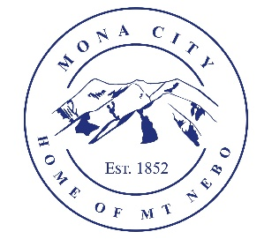
Mona City
435-623-4913
www.monautah.gov
20 West Center Street, Mona, Utah

Mona City Council Meeting Agenda
Tuesday, August 25, 2026
Mona City Building – 20 West Center
7:00 p.m.

Pledge
Prayer
Public Hearing:
- Ordinance 2026-11: Updates to Mona City Code Sections 1 and 3
- Resolution 2026-15: Updates to Mona City Fee Schedule
Previous Meeting Minutes
- Approval of August 11, 2026, City Council Meeting Minutes
- Approval of August 11, 2026, City Council Meeting Minutes
- Approval of August 12, 2026, Special Meeting Minutes
Action Items
- Consideration and Approval of Hiring Recommendations
- Consideration of Resolution 2026-14: Adoption of City Policy for Surplus Personal Property.
- Consideration and adoption of Resolution 2026-15: Updates to Mona City Fee Schedule
- Consideration and adoption of Ordinance 2026-16: Code Commitment
- Consideration and adoption of Ordinance 2026-11: Updates to Mona City Code Sections 1 and 3
R6 Advisor Shay Morrison
- Data Privacy
- Website/.gov
- Land Use Checklists
- Budget Online
Gas & Water & Roads
Sewer
Council Reports
Public Comment
Adjournment

CERTIFICATE OF POSTING
This agenda is hereby properly advertised on this 20th day of August, 2026, by posting copies in the following places: the Mona City Office, on the Mona City website at monautah.gov, at the United States Post Office Mona City Branch, and on the Utah Public Notice Website at www.utah.gov/pmn/index.html.

Upon Request, in compliance with the Americans with Disabilities Act, reasonable accommodations for individuals with disabilities will be provided. For assistance, please call 435-623-4913.

