JAKE BREAK SURVEY RESULTS

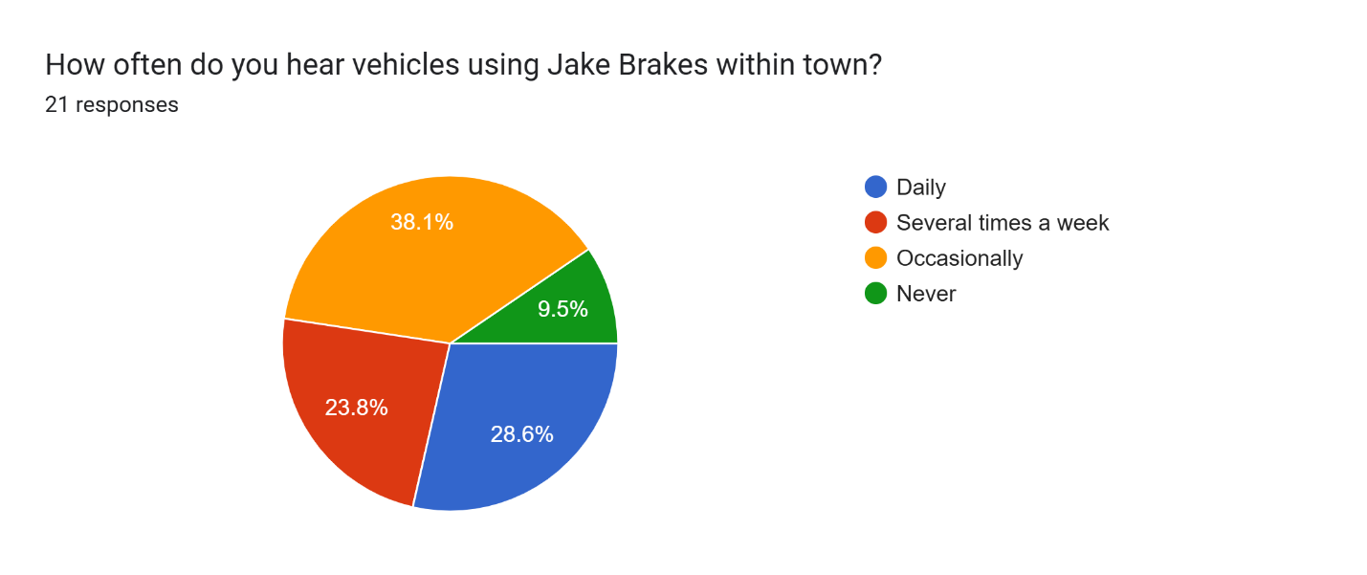

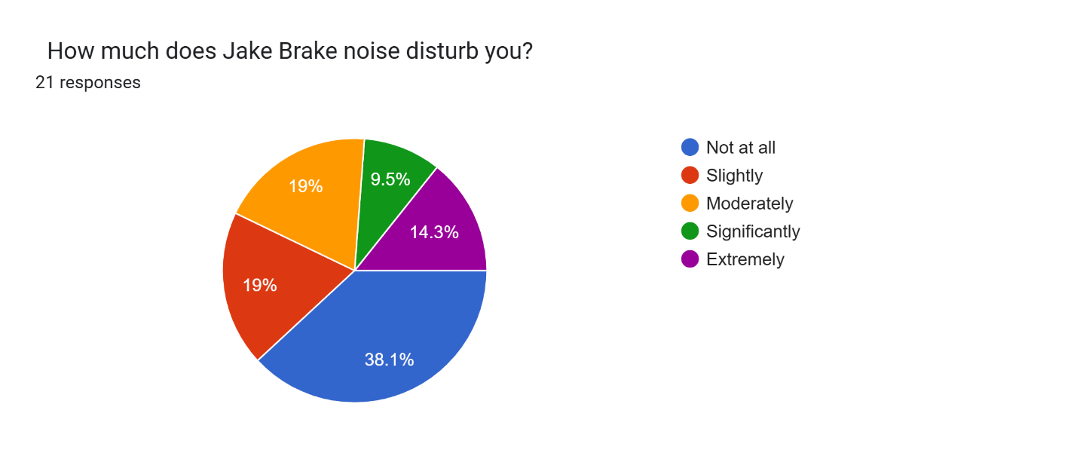
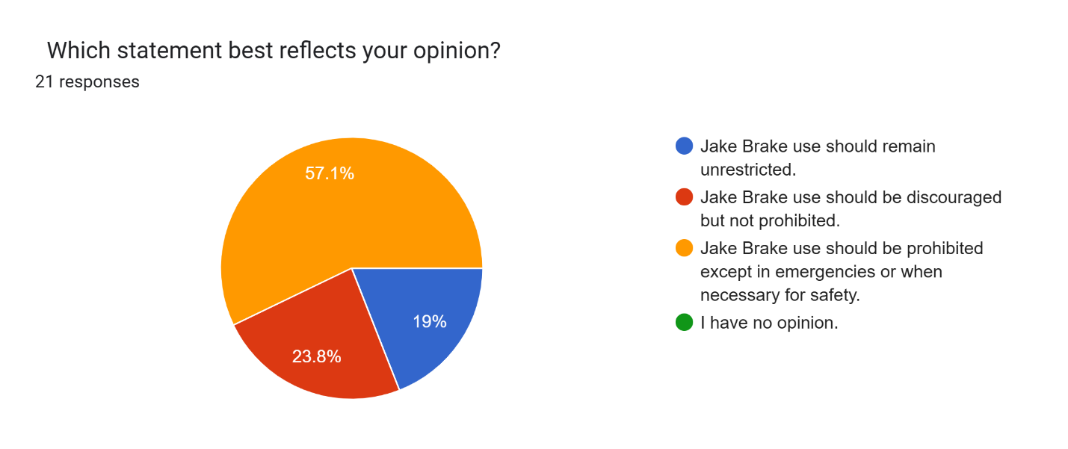
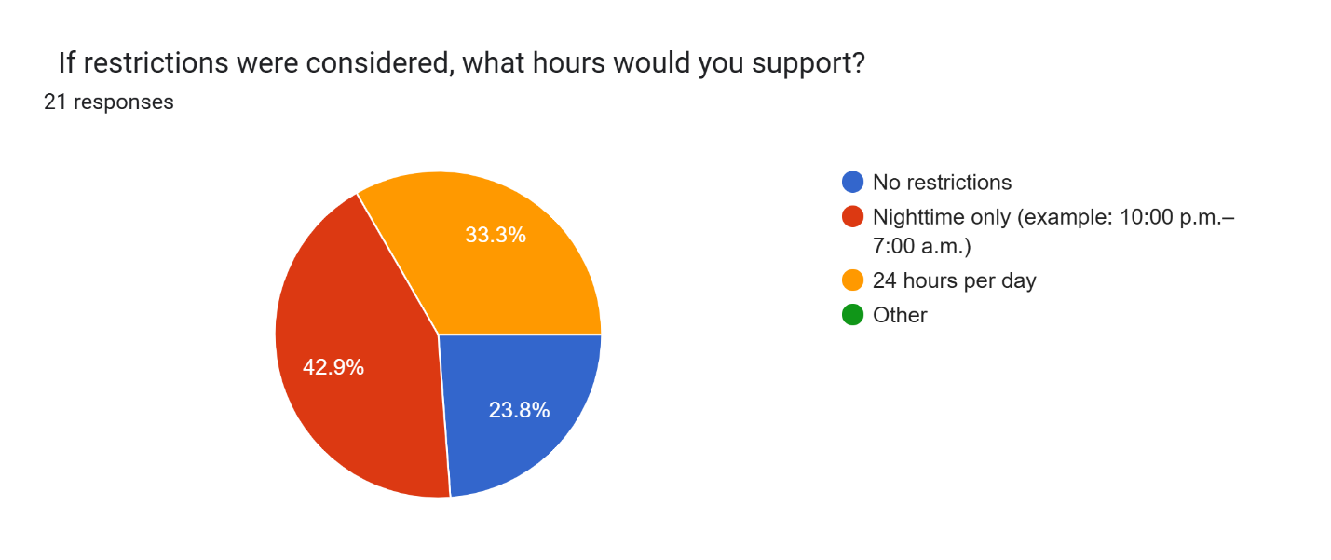
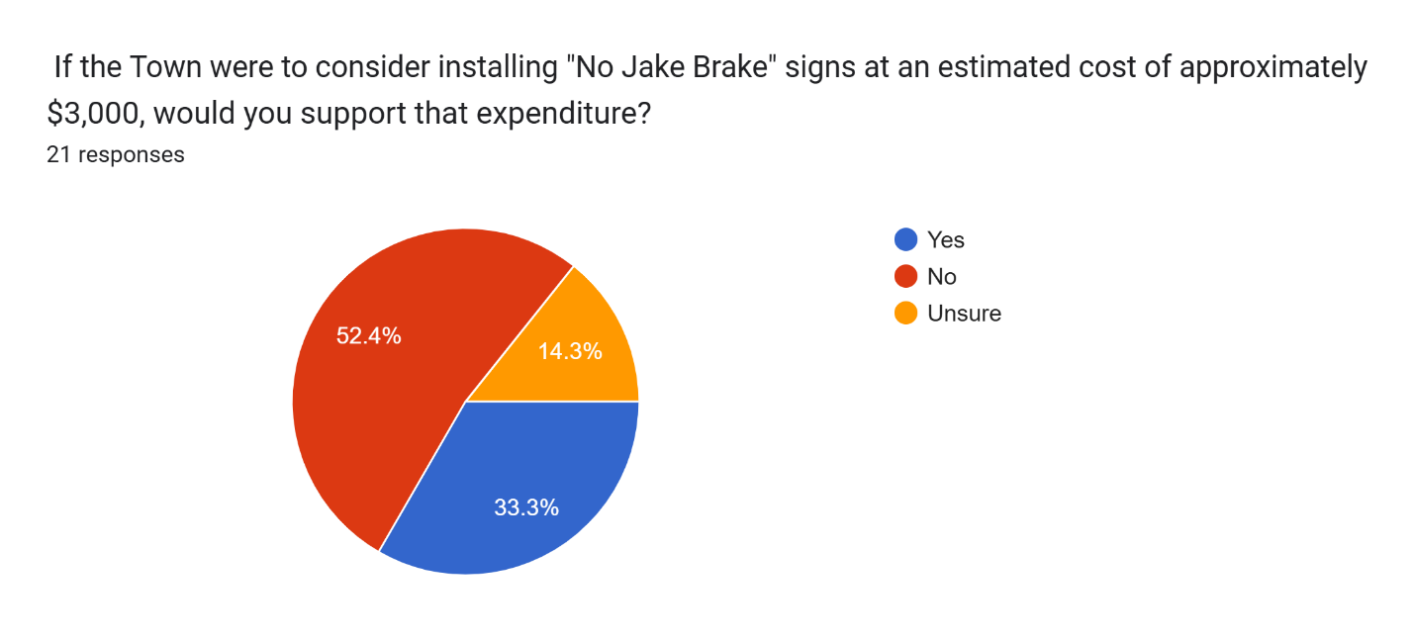
JAKE BREAK SURVEY COMMENTS
You can come up with great plans but when there’s no enforcement it just don’t work . Somebody got to make a call a few tickets would fix this . You don’t need a survey for this
This seems to be away to make sure you get just a few votes. Old people don’t use this and your worry about Jake break when you letting a Health hazard be put in
Being a family that has commercial haulers, livestock, and vessels. The ban on Jake breaks will allow for a lot more accidents in town limits. Highway 89 is one of the most dangerous roads, why would we take away something that’s helping a rig that weighs 81,000 pounds slow down. While there are no hills in town limits there are at least 8 highway crossings where there is on coming traffic that has to go from 0 to 55. If someone sees a big rig coming they don’t want to get stuck behind so they are going to pull out right in front of them. Are we going to pull our law enforcement resources away from people speeding or driving under the influence to pull over rigs using Jake breaks? i know from personal experience just a horse trailer and truck cannot stop on a dime. If I didn’t have Jake breaks in a few instances IN TOWN LIMITS I would have been in an accident. Not to mention not every highway exit in big water has a turn lane. We are sacrificing safety for what?
If we create no Jake brakes ordinance, I feel , due to multiple personal experiences over the years, that enforcing the ordinance will become like many other ordinances, nuisance, noise, Etc that are already in place, enforcing will not happen. I'm assuming night time would be the restrictive time of the day for Jake brakes, that makes sense, but we have a marshall, one in particular that does not like to respond to anything at night let alone Patrol at night. So what's the point of putting signs up at our expense.
Highway 89 through the town is a long hill and trucks with heavy loads need those engine breaks to help slow them down. You’re asking for overheating wheel breaks and trouble slowing down if you restrict them.
As the Town Marshal I deal with truck drivers as part of my job. My experience in Law Enforcement is that Truckers especially if they have 5 years or more experience on the road obey the law and don’t want to be stopped or ticketed for any reason.
Thank you for including the cost of these signs in this survey. The cost of these signs would best be paid for by business as a gift to the town. Similar to the “adopt a highway” program for litter pickup. Or ask for donations from interested parties. T own leadership stresses we are cash strapped routinely and the $3K price tag is a lot of money for a town with a growing fixed income population. With the elimination of our justice court, all fines collected from possible violations goes to Kane County, not Big Water.
Loud noises in the middle of the night greatly disturbs Big Water’s many young children and dogs, particularly my rescue animals that react strongly to unfamiliar sounds.
Safer roads have priority over noise. The long hill coming into Big Water can be dangerous for the oversize loads coming through without using Jake brakes.
Being someone who was born and raised in Big Water UT, the noise pollution of “Jake Brakes” in such a small town is always upsetting me and many others who live in the area.
I think there are more important issues like speeding. Russ and Chris do an amazing job but they can't catch everyone.
I have lived in Big Water for more than 30 years and the problem is getting worse. Hey 89 passes through the middle of town and I am sick and tired of being woke up in the middle of the night by the noise of a Jake brake.
I think the people most affected are those on the west end of town near the hill coming into town. Their vote should probably carry the most weight.
I can't recall ever noticing engine brake sounds and I'm hesitant to believe that signs would stop it from happening anyway. But if it's bothering other residents I'm okay with money going to signs if we think it would help
If the majority votes in favor of spending that much on signage, it would change my answer regarding applicable hours to 24/7 (so that we get our money’s worth).
Do not allow Western Rock to being working before legally allowed quiet hours. A disturbance of the peace should be treated as a misdemeanor and fines should be given to them every time they make noise outside of those hours. Install a decibel meter if you have to, as that's cheaper than a $3000 sign that no one will give a shit about.
I like the idea of putting “Reduced speed ahead” and “Jake Brakes Prohibited” signs further up the highway to give them more time to slow down before they get to town.

