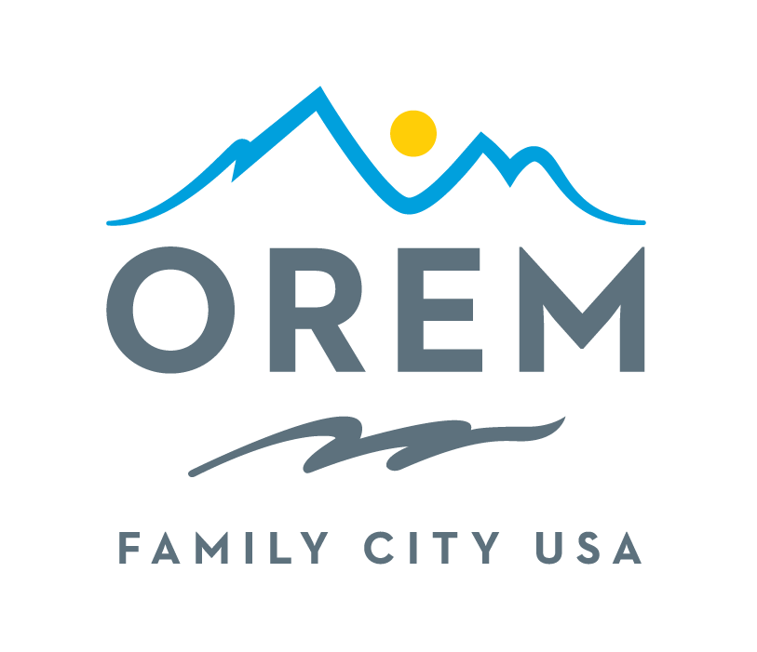
CITY OF OREM
ADVISORY BOARD/COMMISSION
MEETING MINUTES
meeting may be held electronically to allow a board/commission member to participate.
PUBLIC BODY: Events Advisory Commission
DATE: Thursday, July 9, 2026 ROOM: City Council Conference Room #1002
(Right next to the City Council Chambers)
TIME: 4:00 p.m. - 5:30 p.m. ADDRESS: 56 North State Street, Orem, Utah

Meeting Link: https://youtu.be/jNlQuAZ7i4g
Commission Members in Attendance: Ashley Shumay (Chair), Christie Ekins, Rodney Gardner, Debby Lauret, Suzanne Whitaker, Paula Pilivi (zoom), Madisen McArthur (zoom)
City Council: Jeff Lambson, Crystal Muhlestein, LaNae Millet
City Staff: Kenice Whitaker, Bryce Merrill, Peter Wolfley, Jill Winder
Absent: Sydney Bailey, Ashlie Mann, Kami Burgess, Taylor Fox
Welcome/Introductions: Ashley Shumway (Chair) welcomed everyone to the July meeting. https://youtu.be/jNlQuAZ7i4g?t=9
Approval of the Minutes: https://youtu.be/jNlQuAZ7i4g?t=11
Ashley Shumway asked for a motion to approve the May 14, 2026 meeting minutes. Rodney Gardner motioned for approval of the minutes with Christie Ekins seconding the motion. All other attending voting committee members Ashely Shumway, Debby Lauret, Madisen McArthur, Paula Pilivi, Suzette Whitaker, unanimously accepted the June meeting minutes. Minutes Approved. Side note, there was no meeting in June.
City Updates
City Council Comments: https://youtu.be/jNlQuAZ7i4g?t=568
Crystal Muhlestein stated that the overall experience of the whole week was amazing, fun, and feeling "so good," specifically noting the success of the Memorial Day celebration.
  - The Carnival: City Council member, Jeff Lambson member highlighted how enjoyable it was to see the carnival packed with teenagers. Even though the lines were long, the kids were having a great time hanging out, going on rides, and engaging in "good clean fun".
  - The Drone Show: Council member LaNae Millet shared feedback from a neighbor who had never seen a drone show before and absolutely loved it. The neighbor praised the show and suggested making it "bigger and better" next time.
  - Gratitude to Staff: All Council Members concluded with a heartfelt thank you to the commission and all the city staff. The council recognized that the fantastic week was made possible by everyone's hard work
Help Needed for Upcoming Events: https://youtu.be/jNlQuAZ7i4g?t=72
Taste of Orem: For the upcoming Taste of Orem event on September 19th, the commission explicitly requested help with the Information Tent and Stage Entertainment throughout the operating hours of noon to 8:00 p.m.
Updates on Vetting Speakers and Vendors: https://youtu.be/jNlQuAZ7i4g?t=165
The process for vetting speakers and vendors requires the Commission to submit proposed names to city staff and city council early on, allowing the city to handle the necessary approvals before any official commitments are made. Kenice will act the central point person for these procedures, managing the administrative "red tape" and officially extending offers only after the vetting is complete.
This lead time gives the police chief and public safety teams time to evaluate the speaker's profile. For instance, a high-profile figure like a former U.S. congressman will require more robust crowd control, an elevated security detail, and a targeted safety mitigation plan compared to a standard local guest.
Discussion Items for Oremfest Report and Evaluation: https://youtu.be/jNlQuAZ7i4g?t=568
Survey: The commission gathered feedback for Oremfest primarily through a public survey that was structured a little differently this year, asking attendees to rank the events according to their favorites and provide a five-star rating for each.
Kenice Whitaker noted that fewer people took the opportunity to fill out the public survey compared to previous years. The lower response rate might be a positive indicator; because the festival follows a familiar, well-executed routine, attendees likely felt satisfied and simply didn't have anything to complain about.
Car Show: The car show was overwhelmingly positive, with the event receiving a 4.75-star rating from the public survey. Attendees and participants shared numerous positive comments about everything from the opening ceremony to the cars on display, with people consistently remarking that it was the "best one ever".
Business Showcase: The Business Showcase was a great success this year, featuring nearly 30 participating businesses. The feedback from the vendors was highly positive, in part due to a very effective layout.
Pool Party: The Oremfest pool party was a major success this year, with participants describing it as "always a slam dunk". The event earned a very high public rating of 4.77 stars and drew a record-breaking crowd of 698 attendees, which was higher than in previous years.
Orchard’s Jam: Was considered a highly successful and fun event, earning a strong 4.73-star public rating and drawing 900 attendees. Even though attendance was slightly lower than in previous years, the commission felt that the event was "dialed in" and very well-executed. The primary piece of constructive feedback involved the layout of the event. Attendees and commission members noted a disconnect between the main activities and the children's booths, making it feel a bit like two separate events. For future Orchard Jams, a suggestion was made to move the children's booths closer to the main area—potentially by placing them in the closed-off street drive to create a more cohesive, integrated festival experience.
Children’s Crafts: The Children's Crafts activity was a popular part of Oremfest, supported by excellent volunteers and well-stocked supplies that lasted through the event. There was also some confusion among the public because the festival magazine listed the crafts at the North Pavilion while they were at the South Pavilion. The commission recommended moving the crafts back to the North Pavilion (near the stage) next year and double-checking that all promotional materials are consistent.
Vendors: Oremfest provides a highly competitive and lucrative environment for vendors, driven by the festival's massive foot traffic of 90,000 to 100,000 attendees. It is considered one of the largest mid-sized festivals, which led to over 150 applicants competing for just 20 food vendor slots, and approximately 200 applicants vying for about 50 boutique spots.
Drone Show & Fireworks: The Fireworks and Drone Show were among the most popular and highly praised events at Oremfest this year. Both shows started perfectly on time and were synchronized to great music. A major standout features this year was the addition of pyrotechnics to the drone show.
Parade: Parade was a highly anticipated event, ranking in the public survey as the second favorite event overall, right behind the fireworks. Despite its popularity, it received a 4.12-star rating, which the commission largely attributed to frustrating crowd behaviors—such as kids running into the street and people stealing viewing spots, rather than issues with the parade itself.
Baby Contest: The event was hugely popular, drawing close to 400 baby entrants, with the vast majority (around 300) falling into the 6-to-12-month category. Because the competition ran from 9:00 AM to 12:00 PM, the lines grew long and babies were judged rapidly in about 15-second intervals. Despite this, the event maintained a remarkably happy, stress-free atmosphere, and the commission noted that they hardly saw a single crying baby.
Fireworks Tent: The VIP/Fireworks tent was moved back to its original location this year, which everyone agreed was a much better setup. Although the parks crew wouldn't allow bleachers inside the tent to protect the grass, the hospitality was a hit. Volunteers kept guests happy by handing out free water bottles and creatively using 12-year-olds to distribute leftover donuts to the crowd. The commission also noted that fewer people managed to sneak into the tent this year, and the festival's grand marshals specifically praised the excellent setup. A highlight this year was the participation of five marching bands, a significant increase from the two bands we typically have.
Stage Entertainment: This event was a major highlight. A judge from the commission noted that it was perfectly paced with about 12 acts, providing good variety of entertainment. Bringing in the Arts Commission to handle stage introductions this year was recognized as a great addition to the entertainment lineup. For the first time, they tried scheduling a band to play after Orem's Got Talent around 9:00 PM on Friday. However, hardly anyone stayed to watch because the stage area was simply too dark to see what was going on.

Memorial Day Evaluation: The Memorial Day celebration was a successful event, with overwhelmingly positive feedback from the public and the City Council, who specifically noted how positive the event felt. A minor piece of constructive feedback was that some speakers were difficult to hear. For future events, speakers will need to be coached to hold the microphone closer to their mouths.
As noted in our earlier discussion about the new vetting procedures, once the commission has a list of potential names, they will need to submit them to city staff for approval. This timeline ensures the police chief and public safety teams have ample time to evaluate the speakers and develop any necessary security or crowd control plans before official invitations are extended.
Action Commitments: https://youtu.be/jNlQuAZ7i4g?t=3997
American Legion Presentation: Rodney and the American Legion need to present at the City Council meeting on Tuesday, July 14th, right at 6:00 p.m.
Taste of Orem: Volunteers are needed to help manage the Information Tent and assist with Stage Entertainment on September 19th from noon to 8:00 p.m.
Touch a Truck: This event will be held on Saturday, October 17th.
Next Meeting: The next meeting will be on Thursday, August 13, 2026 at 4:00 p.m. at the Orem City Center.
Adjournment: Ashley Shumway asked for a motion for adjournment. Debby Lauret motioned to adjourn with Suzanne Whitaker seconding the motion. All other committee members voted unanimously to adjourn the meeting. See you Thursday, August 13, 2026.

THE PUBLIC IS INVITED TO PARTICIPATE IN ALL CITY MEETINGS.
If you need special accommodation to participate in Advisory Commission meetings
Please contact us on the City's website at orem.org or call (801) 229-7000 at least three working days.
prior to the meeting. This agenda is available on the Utah Public Notice website at utah.gov/pmn.

