
AUGUST 27, 2026
PLANNING COMMISSION
PUBLIC HEARING NOTICE

NOTICE IS HEREBY GIVEN that the Pleasant Grove City Planning Commission will hold a Public Hearing on Thursday, August 27, 2026, at 7:00 p.m. in the Community Room at the Police and Court Building located at 108 S 100 East, Pleasant Grove, Utah, FOR THE FOLLOWING:

Public Hearing: Rezone – Located at 980 West 1800 North
(North Field Neighborhood)
Public Hearing to consider the request of Braxton Rapp for a zone change on approximately 1.03 acres of land from the RR (Rural Residential) Zone to the R1-20 Zone, located at 980 West 1800 North. (Legislative Item)
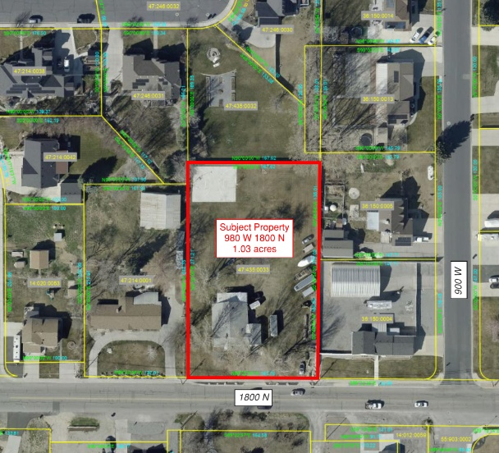

Public Hearing: Vicinity Plan Amendment – Located at approx. 152 N 1400 E
(Grove Creek Neighborhood)
Public Hearing to consider the request of Daniel Judd Wray for a vicinity plan amendment on approximately 4 acres of land, located at approximately 152 North 1400 East in the R1-20 Zone. (Legislative Item)

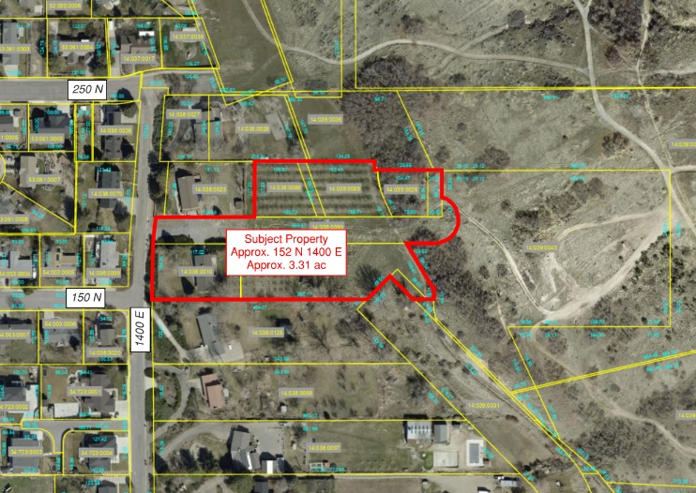

Public Hearing: Conditional Use Permit – Located at 675 W Garden Dr
(Mud Hole Neighborhood)
Public Hearing to consider a request from Artistic Dance Project for a Conditional Use Permit for Use #6830 – Special Training and Schooling, located at 675 W Garden Drive in the Commercial Sales-2 (CS-2) Zone. (Administrative Item)
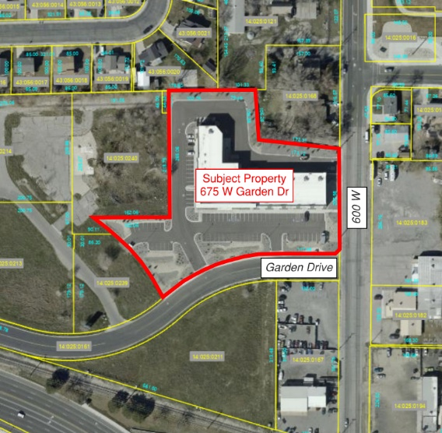

For assistance in understanding the above items, you may contact the Community Development Director, Daniel Cárdenas, or City Planner, Jacob Hawkins at (801) 785-6057.

CERTIFICATE OF POSTING:
I certify that the above public hearing notice items were posted in three public places within Pleasant Grove City limits and on the State (http://pmn.utah.gov) and City (www.pgcityutah.gov) websites.

Posted by: /s/ Maria Arteaga, Planning & Zoning Assistant
Date: August 17, 2026
Time: 12:00 p.m.
Public Places: City Hall, Library, and Community Room at 108 S 100 East

*Note: In accordance with the Americans with Disabilities Act, Pleasant Grove City will make reasonable accommodation for participation in the meeting. Request assistance by contacting Pleasant Grove City at (801) 785-5045, at least 48 hours prior to the meeting.

