Present: Tony Jolley (Information Technology), Megan Hillyard-online (Administrative Services), Richard Jaussi (Auditor), Talia Butler-online (Public Works), Rashelle Hobbs-online (Recorder), Brad Townley-online (Treasurer), Chris Stavros-online (Assessor), Lisa Ashman-online (District Attorney), Hoa Nguyen-online (Council), Robert Sampson-online (Community Services), David Sperry-online (Sheriff), Brad Park (Surveyor), Eric Biggart (Mayor Administration)
Representation Absent: Clerk, Human Services
Staff Present: Trevor Hebditch, Tony Jolley, Rina Shipley-online, Dean Bullock-online, Hillary Boccagno-online, Cherie Root, Mark Miller, Lee Wilstead-online, Jake Petersen-online, LeAnne Hodges-online, Kira Moody, Thomas Yeung-online, Nancy Caballero-online, Kimball Ball-online, Robert Fowler-online, Wendy Ormsby.
Welcome & Remote Meeting Instructions | 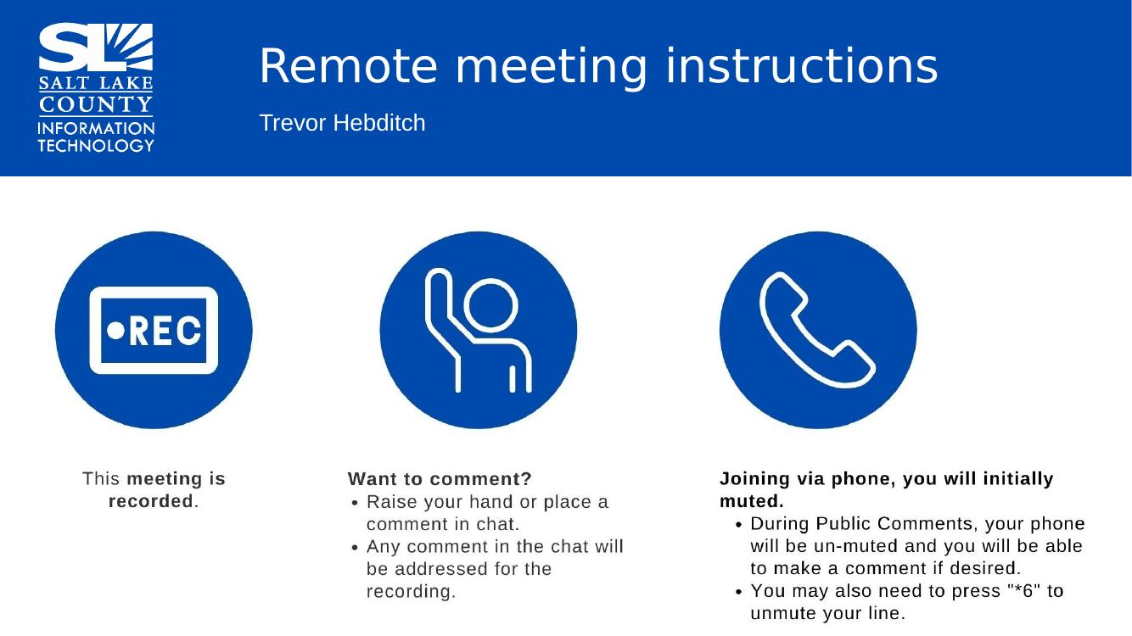
Public Comments | No public comments
Approval of minutes from May 28, 2026 TAB Meeting | Motion to approve the minutes by Richard Jaussi. Eric Biggart seconds the motion. No discussion.  Motion passed unanimously.
Follow-up Items  (Cherie Root) | 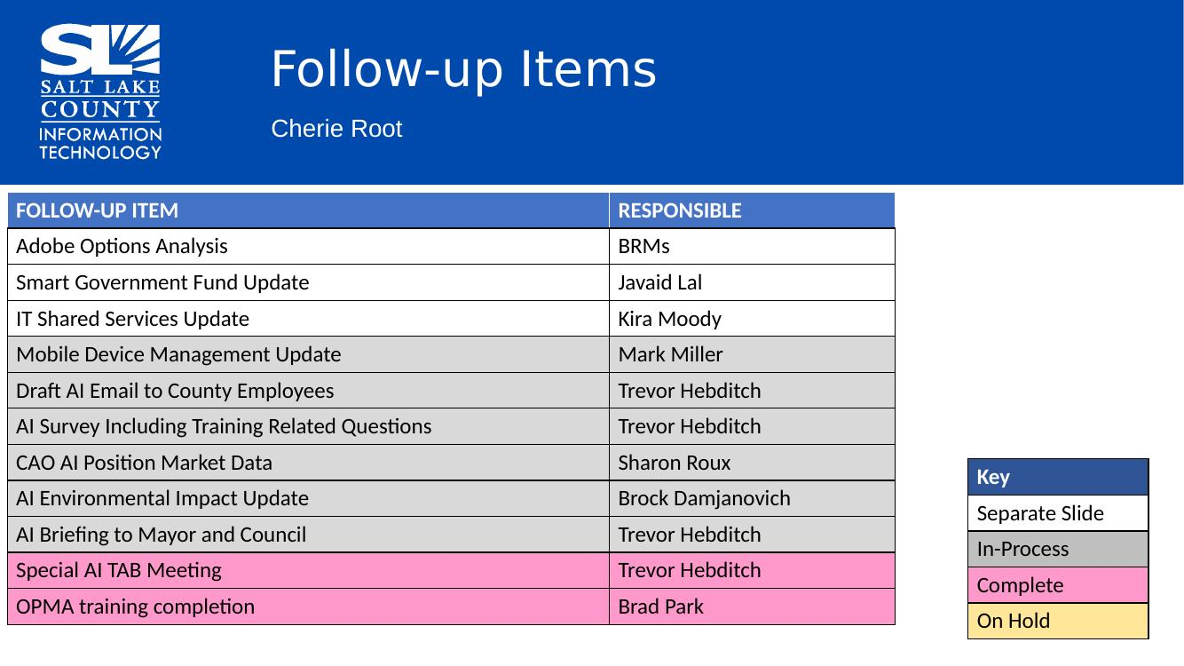
IT Shared Services Update  (Kira Moody)  We are starting agency technology and risk assessments—first with Library.  Kira will be sending out the Shared Services Catalog to the committee for feedback. | 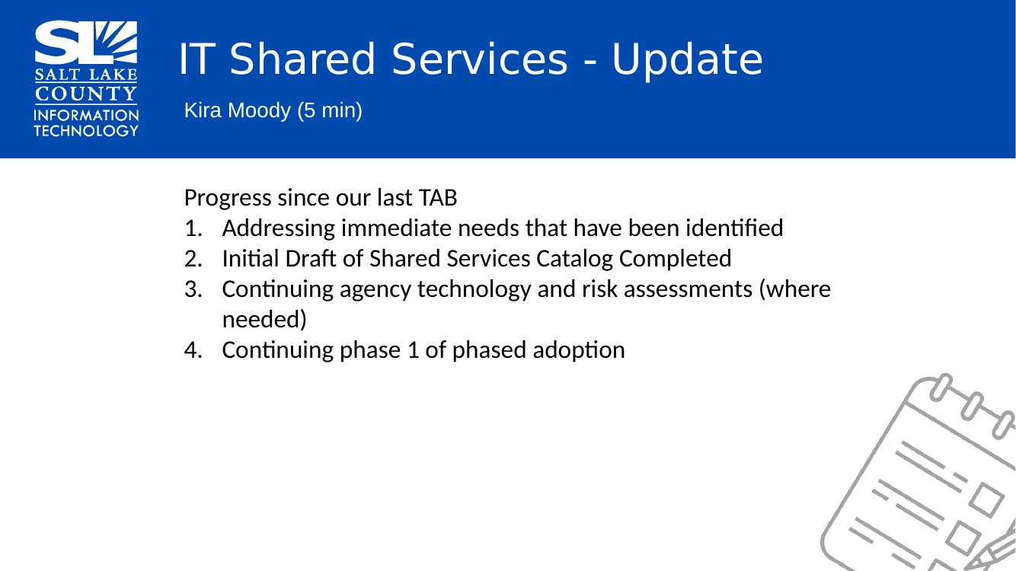
ADOBE Renewal Update  (Cherie Root)  We are working hard to negotiate with Adobe to bring costs down. Alternative platforms aren’t as complete as Adobe and Adobe is integrated throughout the County. Doesn’t appear to be an appetite within the County to continue the search for an alternative.  Anyone with questions as to what functionality your office may need in relation to Adobe, please reach out to your BRM’s. | 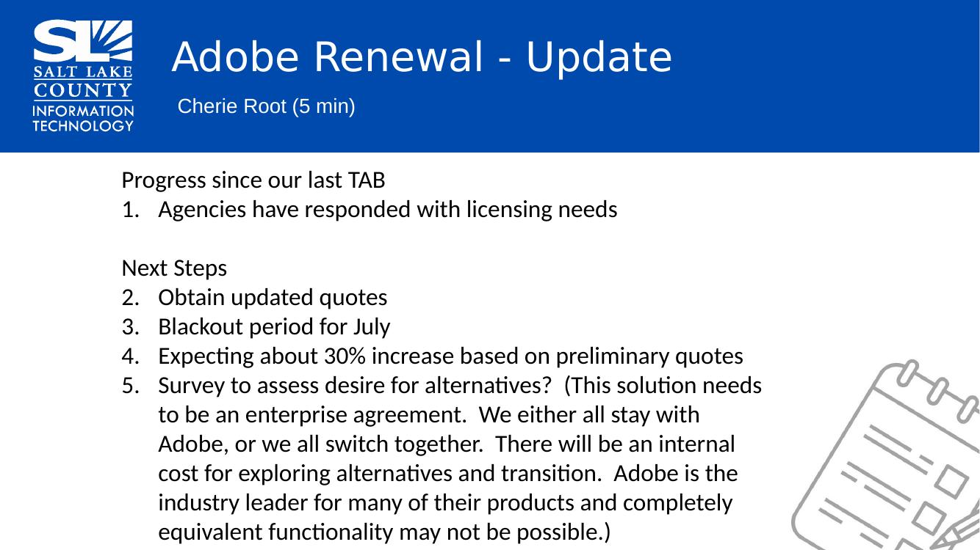
TAB Working Group Milestones  (Tony Jolley)  Last quarter the SharePoint Working Group Guidebook was completed.  Next quarter, we are working on reviewing 2027 technology requests. | 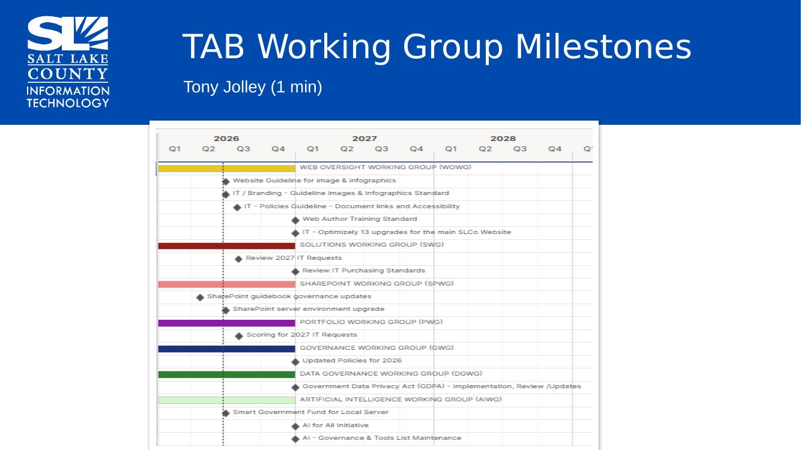
Portfolio Working Group  (Lee Wilstead) | 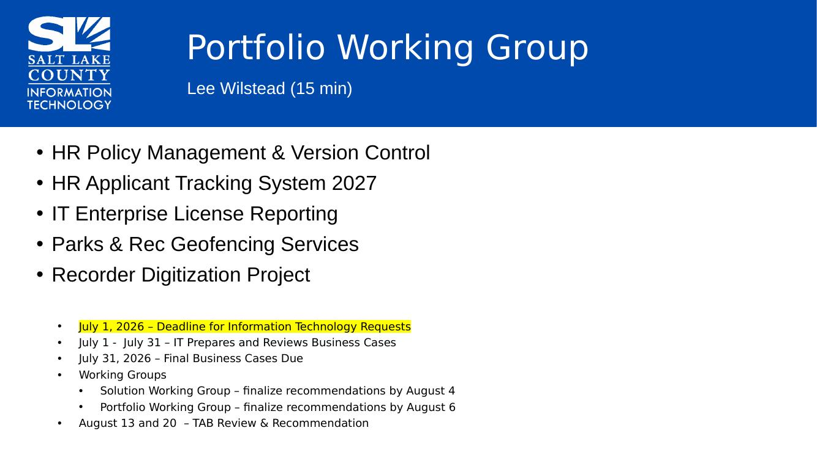  - HR needs a policy management version control system. HR can work on documents showing tracked changes, but County employees will only see the most current policy.  - HR needs an RFP (request for proposal) for the applicant tracking system which needs modernization, speed improvement, and data integrity.  - Working to consolidate licensing into a single dashboard (ex. Adobe, Smartsheet, ESRI, etc.) All reports will be found in one place.  - Parks & Rec is looking at a geo fencing solution. Currently, trail counters are susceptible to UV damage, vandalism, theft, and inaccurate readings. A new solution passively gathers anonymized cell data. Right now, they want proof of concept for 15 trails. This solution is more cost effective. It’s going through privacy impact assessment currently and robust conversation is happening.  - Update: Recorder’s office, along with IT, thanks to the Smart Govt. Fund, has purchased a large-scale scanner. This facilitates access to decades of historical documents. This equipment will be shared across County depts.
Web Oversight Working Group  (Thomas Yeung) | 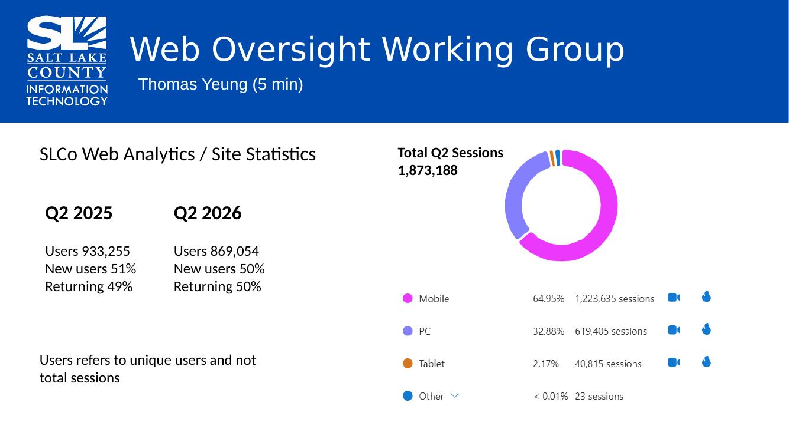
 | 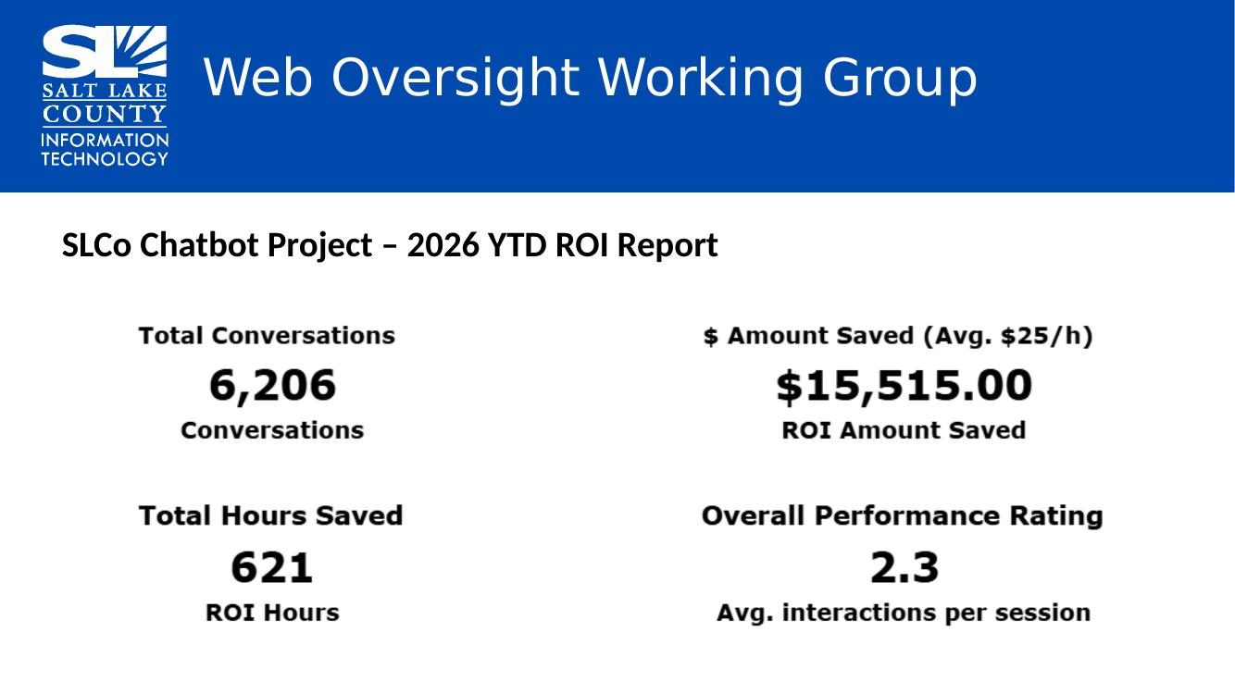
AI Working Group  (Trevor Hebditch)  Working to determine AI tools, structure of oversight, and policy for use of AI tools within the County.  This is a fluid, complex issue. We are looking for TAB to help refine the data and help steer the way forward. | 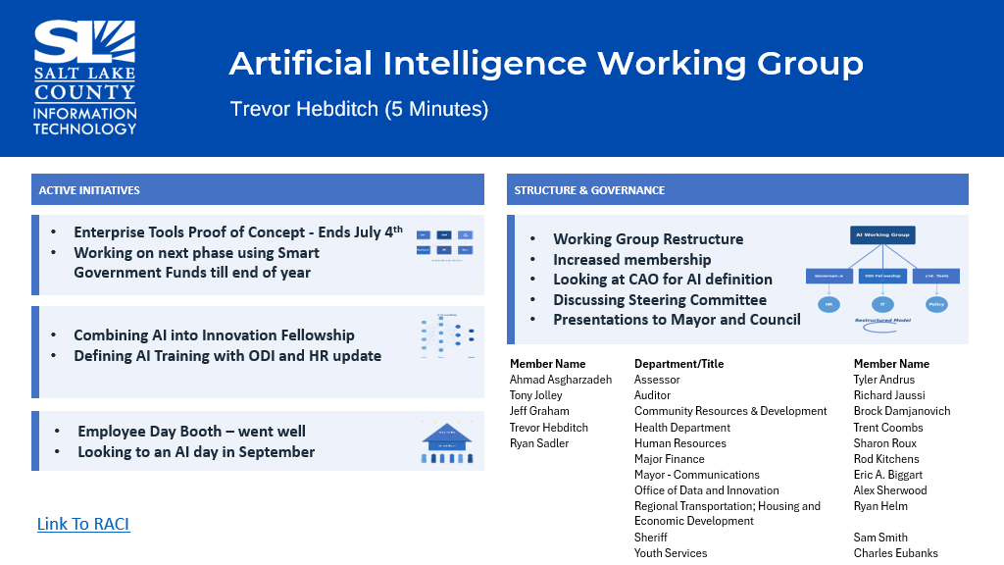
Privacy Program Overview  (Javaid Lal & Aaron Moyes) | 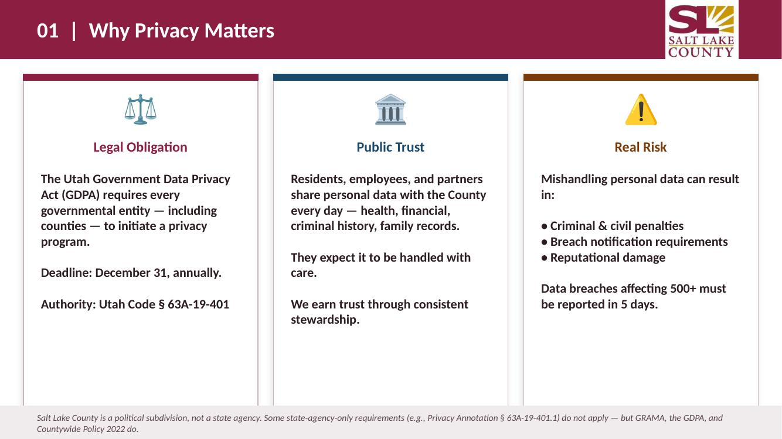
Privacy Program Overview cont.  (Javaid Lal & Aaron Moyes)  All of these pillars require a lot of time. Some can be done concurrently but a lot has to be completed after others. | 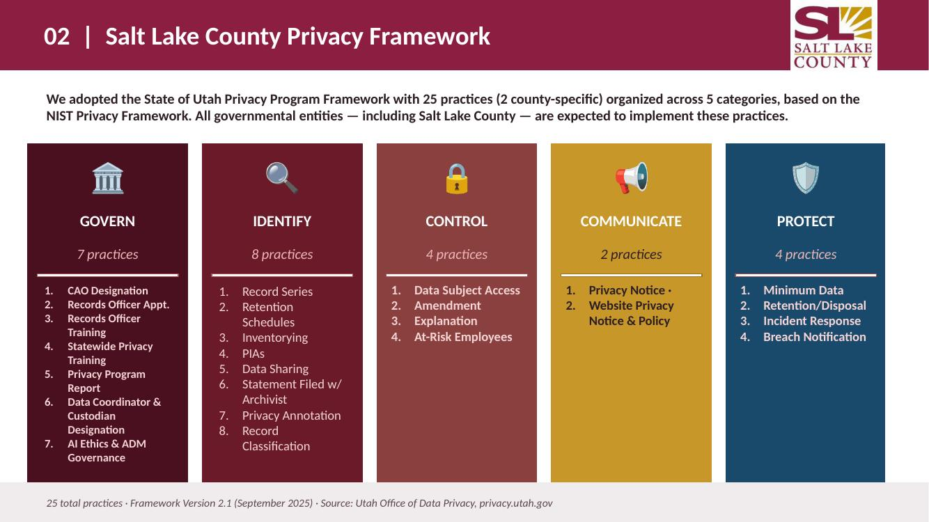
 | 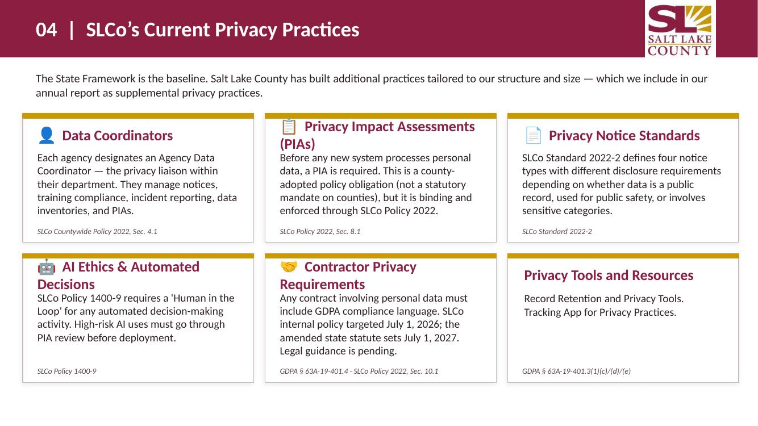
Privacy Program Overview cont.  (Javaid Lal & Aaron Moyes)  Our goal is to get to a 2 or 3 maturity assessment. It’s unlikely we need to reach a 5 as this is very costly and often not necessary for our County value investment.  Agencies have access to their model analysis and rating. | 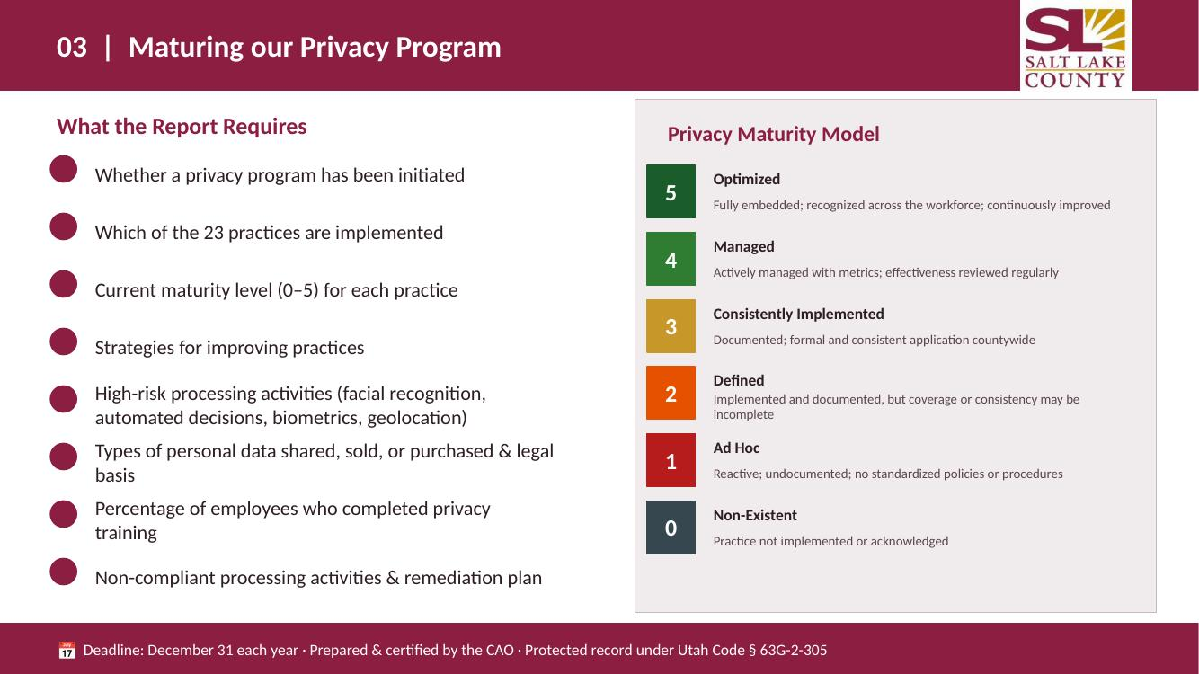
Some of these steps can be completed concurrently, some are previous step dependent. | 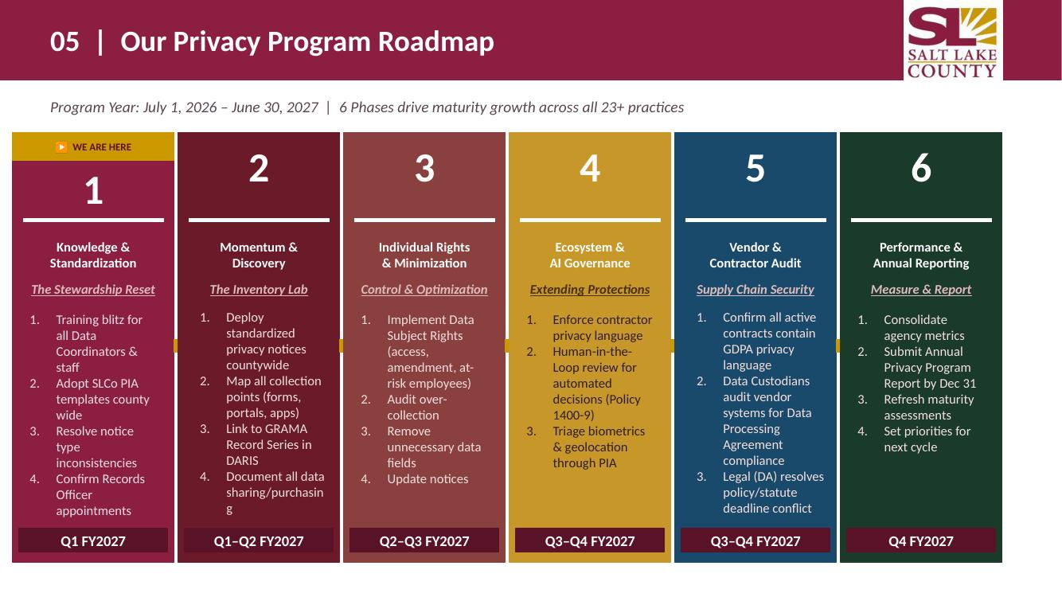
Privacy Program Overview cont.  (Javaid Lal & Aaron Moyes) | 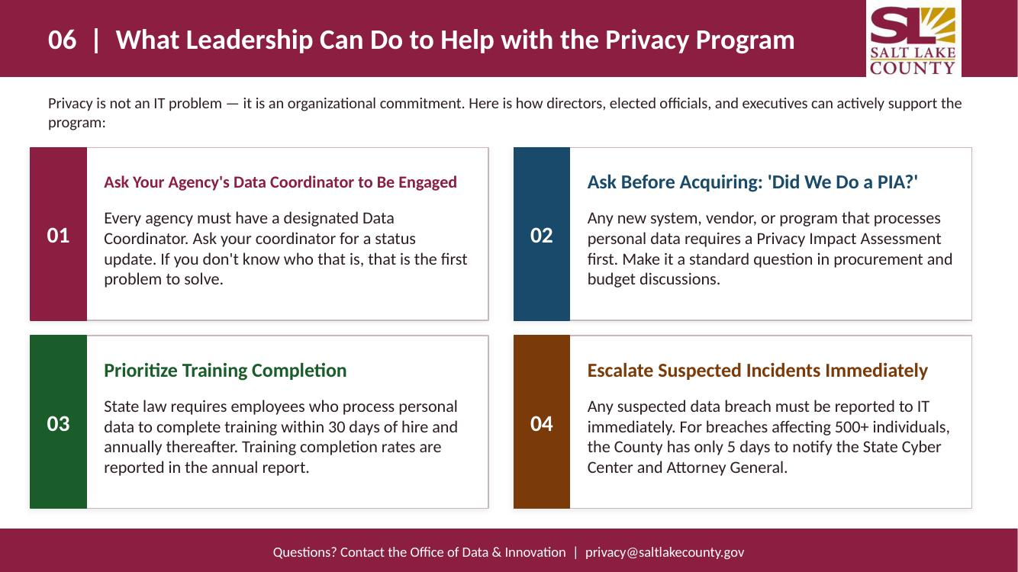
 | 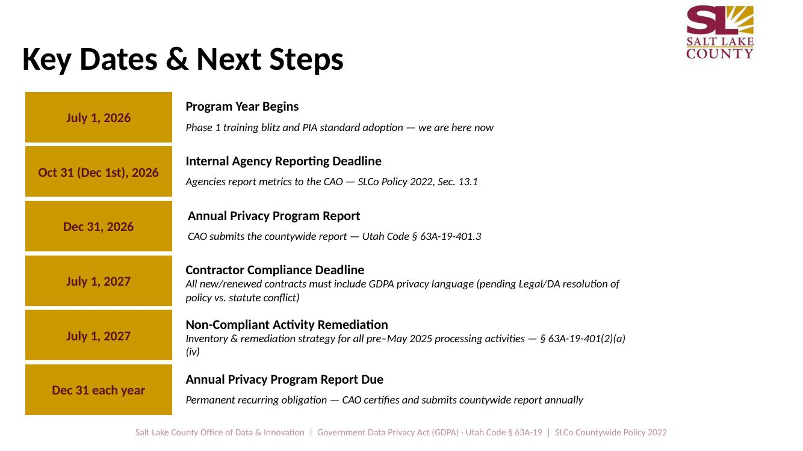
Smart Government Fund Update  (Javaid Lal) | 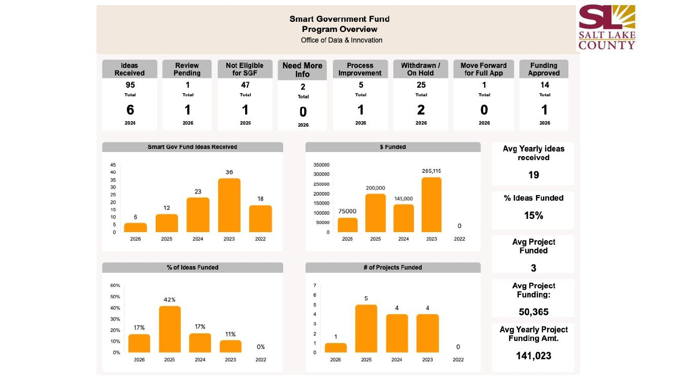
 | 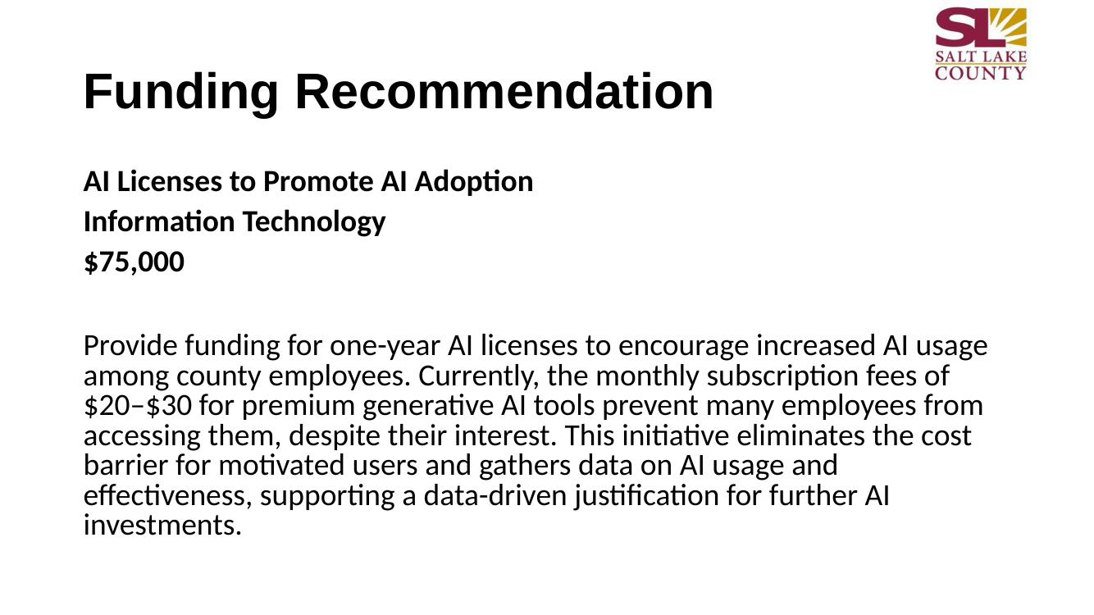
Motion for Closed Session for Security Update  (Rina Shipley) | 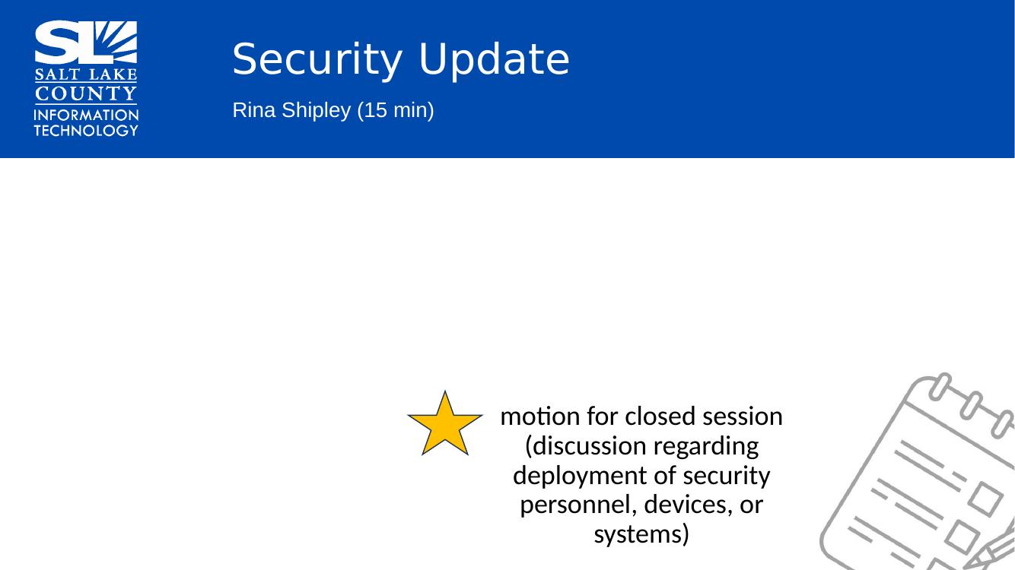  Motion to enter a closed session to discuss deployment of security personnel, devices, or systems by Richard Jaussi, Eric Biggart seconds the motion. No discussion.  Aye: Administrative Services, Assessor, Auditor, Community Services, District Attorney, Mayor Administration, Public Works, Recorder, Sheriff, Surveyor, Treasurer  Nay: None  Roll Call Absent: Clerk, Human Services  Motion passed unanimously.  Motion to exit the closed session by Richard Jaussi and Eric Biggart, seconded.  Motion passed unanimously.
Other Business | Richard Jaussi expressed appreciation to the Torus project team because the Auditor will be able to run NOV (Notice of Valuation) using the new system this year.
Communication Items  The Smart Government Fund AI request will be forwarded to Council as an interim budget adjustment. | 
Upcoming Meeting Schedule | 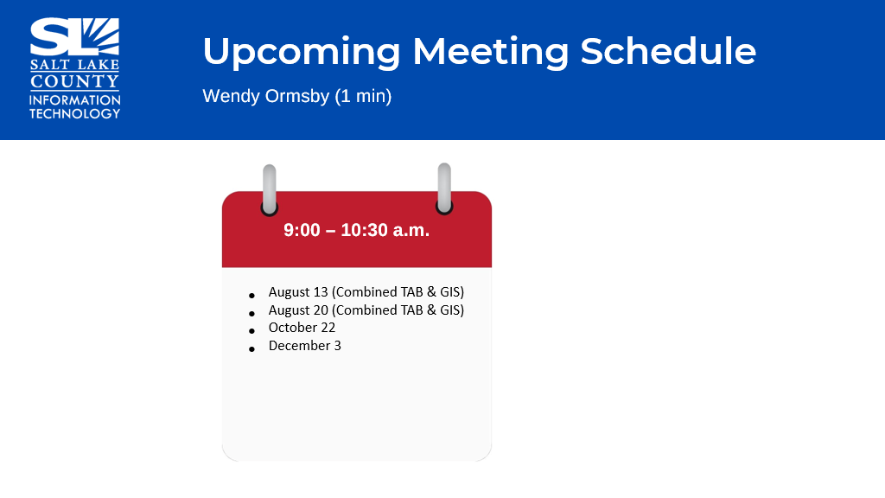
Review Action Items  (Wendy Ormsby)  Kira Moody will send the Shared Services Catalog to TAB members for review. | 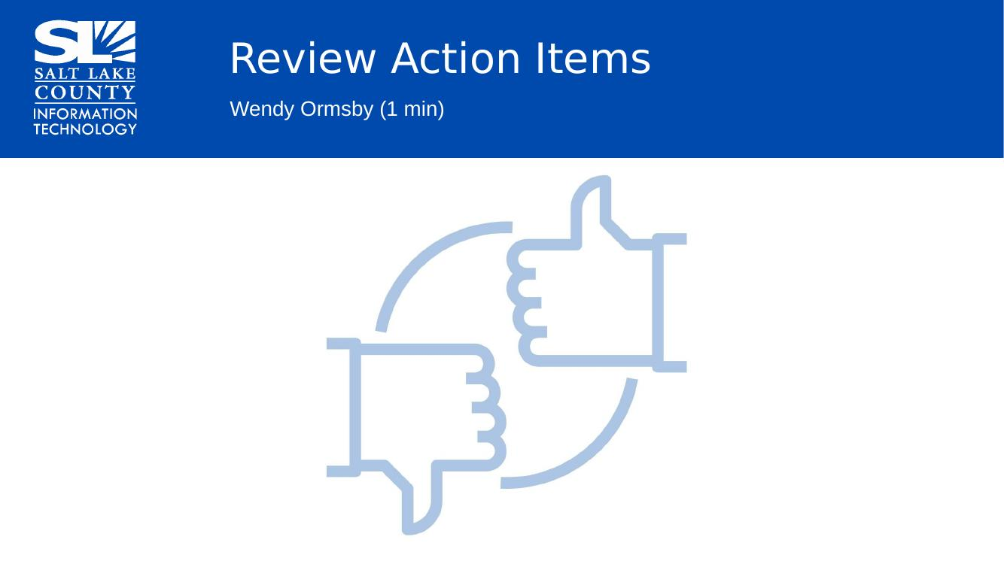
Next TAB meeting: August 13, 2026. | 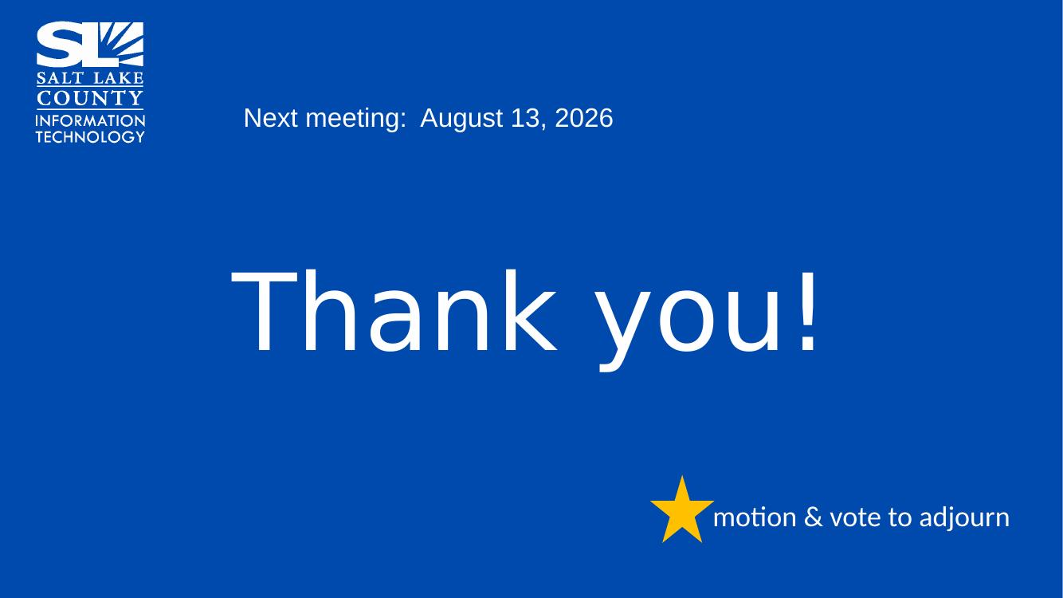
End of Session | Motion to adjourn the meeting by Richard Jaussi. No objections. Meeting Adjourned. So moved.
Submitted by Wendy Ormsby

