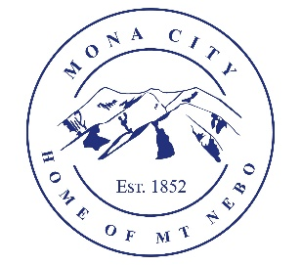
Mona City
435-623-4913
www.monacity.org
20 West Center Street Mona, Utah

Mona City Council Work Session
Tuesday, August 18, 2026
7:00 pm
Mona City Council Room – 20 West Center

Notice is hereby given that the Mona City Planning and Zoning will hold a Development Review session on Tuesday, July 28, 2026, at 6:00 p.m. in the Mona City Council Chambers at 20 West Center Street, Mona City. The purpose of the work session is to discuss the following:

- Mona City 40-year Water Right Plan by Sunrise Engineering
- Water update by Jonathan Jones
- Sewer plant air conditioning

CERTIFICATE OF POSTING

This agenda is hereby properly advertised on the 16th day of July, 2026, by posting copies of this agenda at the Mona City Office, at the United States Post Office located in Mona City, on the Mona City website at monautah.gov, and on the Utah Public Notice Website at www.utah.gov/pmn/index.html.

Upon Request, in compliance with the Americans with Disabilities Act, reasonable accommodations for individuals with disabilities will be provided. For assistance, please call 435-623-4913.

