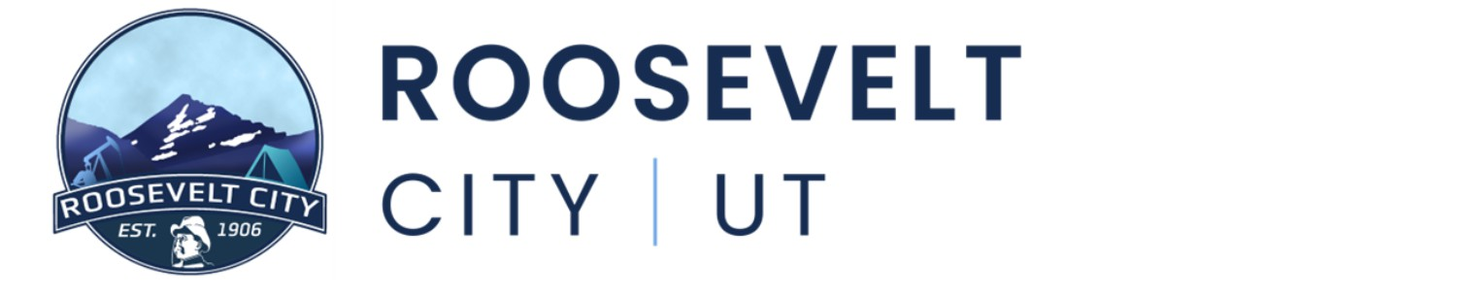

August 18th, 2026
Notice is hereby given that the Roosevelt City Council will hold their regularly scheduled meeting on Tuesday August 18th, 2026, at the Roosevelt Municipal Building located at 255 S State Street, Roosevelt, UT. The meeting shall begin promptly at 5:30pm.
- CALL TO ORDER
- ROLL CALL
- OPENING CEREMONY
Prayer and Pledge of Allegiance
- APPROVAL OF PREVIOUS MINUTES
  - APPROVAL OF PREVIOUS MINUTES, SIERRA WISENER
Meeting Minutes from 8.4.26
- PUBLIC COMMENT PERIOD
Three (3) minute time limit per speaker. If you would like to make a comment, but are unable to attend the meeting, please consider emailing your comment to citycouncil@rooseveltcity.com.
- COMMITTEE APPOINTMENTS/PUBLIC RECOGNITION
  - CHAD MORTENSON – UBIC
  - API - PRESENTATION
- PUBLIC HEARING(S)
  - FY27 BUDGET REOPEN
- ACTION ITEMS
  - FY27 BUDGET REOPEN, ZEKE ATWOOD
  - LAGOON STREET BID AWARD, KIRBY WOLFINJER
  - SM ENERGY ROW AGREEMENT, DREW ESCHLER
  - REQUEST FOR RFP ROOSEVELT CITY AUDITING SERVICES, ZEKE ATWOOD
  - HUNTING ON CITY OWNED PROPERTY DISCUSSION
  - APPOINTMENT OF CITY TREASURER, MAYOR OLSEN

- EXPENDITURE APPROVAL & FINANCIAL REVIEW
- CITY MANAGER REPORT
- COMMITTEE REPORTS
- ITEMS FOR FUTURE DISCUSSION
- CLOSED SESSION
As for the purposes listed in Utah Code 52-4-205
- ADJOURN

Further information can be obtained by contacting Sierra Wisener at (435) 401-8198 In compliance with the Americans with Disabilities Act, individuals needing special accommodations (including auxiliary communicative aids and services) during these hearings should notify Sierra Wisener at 255 South State Street, Roosevelt, Utah, 84066, at least three days prior to the hearing to be attended.

