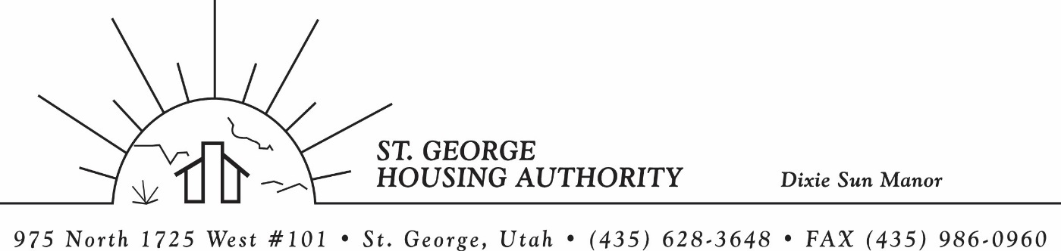
BOARD MEETING
DIXIE SUN MANOR 975 N. 1725 W. # 101
Tuesday June 9, 2026

PRESENT: Mike Barben, Jane Fehrenbacher, Daniel Baldwin, Steve Kemp, Gloria Shakespeare, Greg Whitehead

EXCUSED: Kenny Miller

MINUTES: Minutes of Board Meeting held May 12, 2026 were reviewed. Motion made by Greg Whitehead to approve minutes as reviewed, motion seconded by Steve Kemp. Motion carried.

Review Housing Assistance Report for June 2026: Mike Barben handed out the HAP reports for June 2026. Board members were able to see the money spent for the months on rental assistance, see the average unit cost, and verify the units leased for the month. The board was also able to ask questions and have a discussion about portability, C of C, VASH, EHV, & Mainstream Vouchers. Each board member present signed off on the HAP payments and month end totals.

Review current 2025-2026 budget: Mike Barben handed the board a copy of the fiscal year 2025-2026 SGHA budget. The board was able to see how the SGHA is doing in the current fiscal year budget. Mike reported that for the most part, SGHA was right on budget, and let the board ask questions on any of the items on the report. The board has asked Mike to provide and present the most recent budget accounts at each board meeting. By providing the current budget monthly, the board can see how the SGHA is keeping up with the current budget throughout the whole year. The board thought it would be great to ask questions and be on top of what the SGHA is doing financially. Greg Whitehead asked Mike if he could break the budget down into separate programs to verify which programs are doing well and which ones are needing help. Mike has now separated the budget into 3 programs so the board can better understand the flow of money in each program. Steve Kemp requested that Mike make a report showing the previous years budget aligned with the current years budget. Mike said he work on that report for next meeting.

Grievance Process (Daniel Baldwin): Mike Barben set up a time with Daniel Baldwin on June 23, 2026 to finish up the grievance process for the SGHA and DSM tenants. Daniel mentioned that it should not take more than an hour finish this and put into SGHA/DSM Admin plans. Mike will report back to board at next board meeting how this went.

Jane Fehrenbacker report on DSM: Jane reported that the community is doing well, reported that DSM is a great place to live. Jane reported that all units are full. Reported on Dixie Sun Manor Pot lucks. Jane expressed how important it is to have these social activities for DSM tenants. Jane would like to work with Mike Barben to figure out ways to get more tenants involved at these functions. Mike agreed to meet with Jane and discuss.

Steve Kemp City Council Report: Steve kemp was able to report a few items going on within the city. First Shawn Guzman is retiring and the city is having a retirement party for him towards the end of the month. Mike mentioned that he would like to go and show his gratitude for Shawn. Second the county commission is getting ready for elections and voting is due by the June 23’rd. Third, Steve reported that the city council is functioning well and are getting a lot done for our wonderful city.

Reports from Board Member & Housing Director: None

Request of a closed meeting to discuss litigation, security, property acquisition or sale, or the character and professional competence or physical or mental health of an individual: None

Motion made by Greg Whitehead to close the meeting. Steve Kemps seconded the motion. Motion carried. Meeting adjourned at 9:30 a.m. Next board meeting will be Tuesday July 14, 2026 at 8:30 am.

