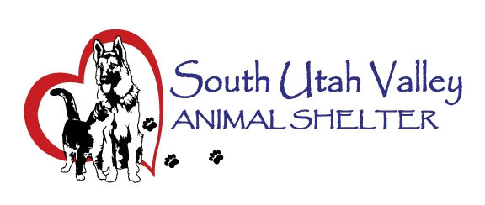

SOUTH UTAH VALLEY ANIMAL SERVICES SSD
GRAMA FEE SCHEDULE AND COST RECOVERY POLICY
Purpose
This policy establishes fees for responding to requests made under the Utah Government Records Access and Management Act (GRAMA), Utah Code § 63G-2-203, and is intended to recover the actual costs incurred by the District in providing records while ensuring public access to government records.
Copying Charges
The District may charge the actual cost of reproducing records, including:
• Black and White Copies (8.5" x 11" or 8.5" x 14"): $0.15 per page
• Color Copies (8.5" x 11" or 8.5" x 14"): $0.50 per page
• Oversized Documents: Actual reproduction cost
• Electronic Media (USB drives, CDs, DVDs, etc.): Actual cost
• Postage and Shipping: Actual cost
Staff Time Charges
Pursuant to Utah Code § 63G-2-203, the District may charge for staff time required to:
• Locate records;
• Retrieve records;
• Review records for responsiveness;
• Determine record classifications under GRAMA;
• Segregate public records from protected, private, controlled, or otherwise restricted records;
• Redact protected, private, controlled, or otherwise restricted information;
• Compile records when necessary to fulfill a request;
• Prepare records for release.
The first fifteen (15) minutes of staff time shall be provided without charge.
Thereafter, staff time shall be billed at the hourly rate of the lowest-paid District employee possessing the necessary skill, training, authority, and responsibility to perform the requested work, as determined by the District's Records Officer.
Records Officer Designation
The South Utah Valley Animal Services SSD designates the Executive Assistant as the District's Records Officer.
The Records Officer is responsible for administering GRAMA requests, determining record classifications, reviewing records for legal compliance, identifying protected information, performing required redactions, and ensuring compliance with applicable provisions of Utah Code Title 63G, Chapter 2.
The District has determined that GRAMA review and redaction duties require specialized training, knowledge, and authority that are not possessed by general administrative or clerical staff. Employees who have not received GRAMA training or who are not authorized to make classification and redaction determinations shall not be considered qualified to independently perform GRAMA review functions.
Accordingly, when a records request requires review, classification, legal analysis, segregation of records, or redaction of non-public information, staff time may be charged at the hourly rate of the Records Officer as the lowest-paid employee possessing the necessary skill and training to perform those functions.
When a records request involves only routine reproduction of records that have already been reviewed and approved for release, the District may charge based upon the hourly rate of the lowest-paid employee qualified to perform the reproduction work.
Current Staff Rates
• Records Officer (Executive Assistant): $28.00 per hour
• Clerical/Administrative Reproduction Rate: $17.00 per hour
The District reserves the right to update hourly rates administratively as employee compensation changes without requiring amendment of this policy.
Fee Waivers
Fees may be waived, in whole or in part, when:
- Releasing the records primarily benefits the public rather than an individual or private entity;
- The requester is the subject of the record or the requester's legal representative;
- The requester demonstrates that payment would impose a substantial financial hardship and that a waiver serves the public interest; or
- The District determines that a waiver is otherwise appropriate.
Advance Payment
The District may require payment of estimated fees before processing a request when anticipated costs exceed $50.00.
If actual costs exceed the estimate, additional payment may be required before records are released. If actual costs are less than the estimate, the requester shall receive a refund of the overpayment.
Appeals
Any denial of a fee waiver request may be appealed in accordance with Utah Code § 63G-2-401.
Effective Date
This policy shall become effective upon approval by the South Utah Valley Animal Services SSD Board of Directors and shall remain in effect until amended or repealed by the Board.

