MEMORANDUM

DATE: Tuesday, August 11, 2026
TO: Marlo Oaks, State Treasurer and Utah Charter School Finance Authority Board
FROM: Japheth McGee, Vice President and Johnathan Ward, Senior Vice President of Zions Public Finance
RE: Treeside Charter School Application to the Utah Charter School Finance Authority

Conflicts of Interest

In general, Zions Bancorporation, National Association is made up of many departments and provides various services. Some of those services and departments can be involved on the same transaction. Zions Public Finance Inc. and Zions Corporate Trust are affiliated entities operating under Zions Bancorporation and we all benefit from a strong stock price derived from strong performance by the company and its component members and affiliates across the country. Zions Public Finance does not receive financial or other benefits in association with transactions performed by Zions Corporate Trust who may act as Trustee on charter school transactions. Likewise, Zions Public Finance operates separately from commercial loan divisions of the Bancorporation who may have provided private financing to developers or charter schools to construct the school initially. Zions Public Finance is not aware of the circumstances where this occurs unless told when a charter school applies. Zions Public Finance does not receive financial or other benefits that could result from actions taken by the Charter School Finance Authority outside of the agreed upon fees for services rendered to the Authority.

Zions’ entities engaged with the School:

Zions Public Finance: | Yes. (Advisor to the Authority)
Zions Corporate Trust: | No
Zions Commercial Involvement: | No

Executive Summary

Borrower: | Treeside Charter School
Management Company: | Business Manager: Red Apple Financial
Municipal Advisor: | RoundTable Funding: Clint Biesinger
Borrower’s Counsel: | Farnsworth Johnson: Brandon Johnson
Underwriter: | Raymond James: Hanna Degen
Bond Counsel: | Chapman & Cutler: Eric Hunter
Issuer’s Counsel: | Gilmore & Bell: Jacob Carlton
Trustee: | US Bank: Laurel Bailey
Par Amount: | $15,415,000 in tax-exempt and taxable bonds.
Enhancement Requested: | No
Purpose: | Fund construction of the School’s new facility, fund a debt service reserve fund, fund capitalized interest, and pay costs of issuance.
Structure: | Bonds will be repaid over an 8-year period with interest only payments in 2027 and 2028 followed by amortization of debt in 2029 through 2033 based off a 25-year amortization after a two-year capitalized interest period. The bonds will carry a fixed rate of interest.
Term: | Final maturity in 2034. Bonds will likely carry a 4 or 5-yr call feature.
Rating: | N/A
Costs of Issuance Estimate: | $260,000
Underwriter Fee Estimate: | $7.00/$1,000 (est. $107,905)
Litigation: | None of which we are aware.
Summary: | The School has been operating for roughly a decade. Recent disputes with the developer-landlord led to a desire to leave its lease and pursue owning its own building. The School was operating at the capacity of the prior building and will build in more space at the new facility to expand enrollment in the future. The School left its old facility and is currently leasing an interim space during the construction period. Enrollment has dropped in the transition period but the School expects enrollment to return upon completion of its new facility. Historic net revenues have been sufficient to meet future debt service in some years (though not at required coverage levels). The ability to meet the new debt service assumes enrollment is able to return to historic levels.

Purpose

The purpose of this memo is to document the adherence of Treeside Charter School (the “School”) to the application requirements of the Utah Charter School Finance Authority (the “Authority”) and provide credit analysis of the School for the Authority’s consideration. The analysis contained herein is based on the School’s application to the Authority and inquiry for clarification of the Municipal Advisor to the Authority.

Introduction

The School is a non-profit, 501c3 designated, public K-6 charter school with one campus in Provo. The School was approved by the Utah State Charter School Board (the “SCSB”) and opened for operation in 2016.

MISSION
Creating the leaders, life-long learners, innovators & artisans of tomorrow by educating the head, heart and hands today.

Enrollment/Student Demand

October enrollment for the 2025 - 2026 school year was 364 students. The School plans to increase enrollment to 450 students, in part by expanding into 7th grade. The School has no waitlist and has shown retention below State averages in most years. Average daily membership is above 99%.

Academic Performance

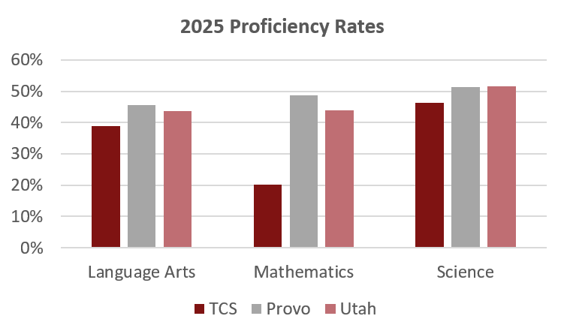
Management

- The School currently has a five-member board. The board members have backgrounds in: business management, real-estate and military leadership, marketing, the arts, and communications.
- The School employs Rachel Brunson as Director. Ms. Brunson received a Master of Arts in Administration and Supervision from Southern Utah University; endorsements in mathematics, instructional coaching, and English as a second language (also from SUU); and a BS in Elementary Education from Utah State University.
- The School will employ Red Apple for business management services.
- The School has formal policies for cash handling, fundraising and donations, and procurement. No formal policies on budgeting, debt, and investments were found.

Plan of Finance

The School is seeking authorization to sell up to $15,415,000 of non-rated bonds via negotiated sale with Raymond James serving as the Underwriter. The School is NOT seeking credit enhancement through the Utah Charter School Credit Enhancement Program. The bonds will be tax-exempt bonds for the purpose of funding the construction of a new campus, a debt service reserve fund, capitalized interest, and costs of issuance. The bonds will carry a fixed rate of interest and will likely carry a 4 to 5-year call. The bonds are secured by an assignment and secured interest in the revenues of the School and trust accounts and a security interest and pledge of the deed of trust in the land and building located at:

- 235 E 1600 South, Provo, Utah 84606

Financial Performance

Summary:
The School used strong operating margins in the early years of the lookback to build up a large cash balance. That cash balance was significantly depleted by a $1.457 million dollar payment to the School’s former landlord of previously unpaid property taxes and lease escalation fees. The School was advised by legal counsel not to make those payments until the lease dispute was resolved. Figures for FY 2026 are unaudited.

- School budgeting has been challenged over the past five years as the School has dealt with the lease dispute. FY 2025 saw a spike in the total expenditures 33% greater than the original budget as a result of a $1.457 million payment to resolve the lease dispute.

- Cash Position
 | Benchmark | Measure at end of FY 2025
 | At least 75 days | 191

The School’s cash on hand of 191 DCOH is strong. Cash levels declined significantly in FY 2025 as the School resolved its dispute with its prior landlord and made a payment of back property taxes and lease escalation costs.

- Fund Balance

 | BB Benchmark | Measure at end of FY 2025
 | At least 15% of following year expenses | 16%

The School built a significant fund balance that was reduced to meet its prior lease obligations. Future fund balance has been estimated by taking expected operating expenditures and revenues for each given year and assuming 75% of net operating income (after payment of debt service) is retained as fund balance.

- Debt Coverage Ratio
 | BB Benchmark | Measure at end of FY 2025
 | At least 120% | 62%

The School had some years with strong MADS coverage on its building leases though those should be discounted slightly as the School was not paying all the fees associated with the lease. The School’s historical operating net income has bounced around the figure the School needs in order to meet its future debt service requirements in the last three years. The School will need enrollment to return to historic levels and margins to remain at recent levels in order to achieve the projected result.

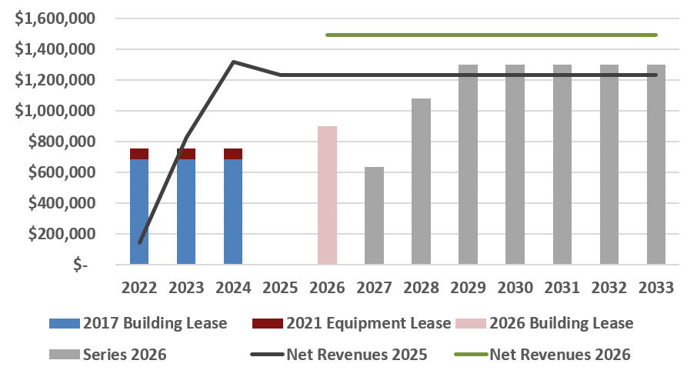

- Debt Burden Ratio
 | BB Benchmark | Measure at end of FY 2027
 | Less than 16% | 26.7%

The School’s debt burden is measured here against its lease payments and future expected debt service as compared with unrestricted operating revenues. The School expects a significant jump in its debt burden in the near term.

- Operating Margin
 | BB Benchmark | Measure at end of FY 2025
 | At least 14% | 22.3%

Recent operating margins have been strong as the School has moved campuses and saved to meet its expected obligations under its old lease agreement. The School is projecting future margins that are healthier than most schools. This will put significant pressure on the School in the medium term.

- Curren Ratio
 | BB Benchmark | Measure at end of FY 2025
 | At least 150% | 172%

Bond Documents

Legal bond documents are being reviewed by Gilmore & Bell in its capacity as Issuer’s Special Counsel to the Authority, and all requirements are being incorporated. In addition, Chapman & Cutler, as Bond Counsel, has certified that each of the required legal provisions is present in the bond documents.

Continuing Disclosure

The School has not been under a continuing disclosure requirement previously.

Conclusion

The School has had troubled operations due to lease and building related disputes. Recent facility movements have caused a drop in student enrollment. The School believes this is a temporary drop and is building a new facility that should allow it to operate at greater scale. Historical operations have been close to the levels necessary to support this debt.

