MEMORANDUM

DATE: Tuesday, August 11, 2026
TO: Marlo Oaks, State Treasurer and Utah Charter School Finance Authority Board
FROM: Japheth McGee, Vice President and Johnathan Ward, Senior Vice President of Zions Public Finance
RE: Beehive Science and Technology Academy Application to the Utah Charter School Finance Authority and Credit Enhancement Program

Conflicts of Interest

In general, Zions Bancorporation, National Association is made up of many departments and provides various services. Some of those services and departments can be involved on the same transaction. Zions Public Finance Inc. and Zions Corporate Trust are affiliated entities operating under Zions Bancorporation and we all benefit from a strong stock price derived from strong performance by the company and its component members and affiliates across the country. Zions Public Finance does not receive financial or other benefits in association with transactions performed by Zions Corporate Trust who may act as Trustee on charter school transactions. Likewise, Zions Public Finance operates separately from commercial loan divisions of the Bancorporation who may have provided private financing to developers or charter schools to construct the school initially. Zions Public Finance is not aware of the circumstances where this occurs unless told when a charter school applies. Zions Public Finance does not receive financial or other benefits that could result from actions taken by the Charter School Finance Authority outside of the agreed upon fees for services rendered to the Authority.

Zions’ entities engaged with the School:

Zions Public Finance: | Yes. (Advisor to the Authority)
Zions Corporate Trust: | Yes
Zions Commercial Involvement: | No

Executive Summary

Borrower: | Beehive Science and Technology Academy
Management Company: | Business Manager: Ram Prasad Boppana
Municipal Advisor: | RoundTable Funding: Clint Biesinger
Borrower’s Counsel: | Farnsworth Johnson: Brandon Johnson
Underwriter: | Crews & Associates: Michael Lambert
Bond Counsel: | Gilmore & Bell: Jacob Carlton
Issuer’s Counsel: | Chapman & Cutler: Eric Hunter
Trustee: | Zions Bancorporation: Pasquel Hansen
Par Amount: | $28,790,000 in tax-exempt bonds.
Enhancement Requested: | Yes
Purpose: | Fund the construction of a new campus in Saratoga Springs, fund renovation of the second floor of the Sandy campus, fund capitalized interest, fund a debt service reserve fund, and pay costs of issuance.
Structure: | Bonds will be repaid with a roughly level amortization of principal and interest over 40 years. The bonds will carry a fixed rate of interest.
Term: | Final maturity in 2067. Bonds will likely carry a 5 to 7-yr call feature.
Rating: | Moody’s Ratings: Ba1
Costs of Issuance Estimate: | $250,000
Underwriter Fee Estimate: | $4.24/$1,000 (est. $122,069.60)
Litigation: | None of which we are aware.
Summary: | Beehive Academy is well known for its academics. This has led to a historically strong demand profile. The School has utilized its historical waitlist to increase the size of its enrollment through a recent expansion at its original campus. Now the School would like to expand to an additional campus in Saratoga Springs. The School provided a breakeven analysis that shows that it could cover the debt service with 238 students at the Saratoga Springs campus in FY 2028. Existing resources are not sufficient to cover expected debt service. The School’s strong demand profile and location in a fast-growing area should allow it to meet these demands. However, the Authority has seen a number of charter schools looking to expand into this same market in recent years. Currently strong cash balances help to mitigate near-term concerns and the School’s historically conservative budgeting and operations should allow it to weather any unforeseen problems.

Purpose

The purpose of this memo is to document the adherence of Beehive Science and Technology Academy (the “School”) to the application requirements of the Utah Charter School Finance Authority (the “Authority”) Credit Enhancement Program Standards and provide credit analysis of the School for the Authority’s consideration. The analysis contained herein is based on the School’s application to the Authority and inquiry for clarification of the Municipal Advisor to the Authority.

Introduction

The School is a non-profit, 501c3 designated, public K-12 charter school with one campus in Sandy City. The School is using funds from this financing to expand to a second campus in Saratoga Springs. The School was approved by the Utah State Charter School Board (the “SCSB”) and opened for operation in 2005.

MISSION
At Beehive, students of diverse cultures achieve academic excellence and personal skills in a challenging and innovative STEM environment to become contributing global citizens.

VISION
Students of Beehive Science and Technology Academy excel in a diverse and supportive learning community as they acquire the academic, social, and technological skills necessary to become responsible leaders and citizens of a globalizing world.

Enrollment/Student Demand

October enrollment for the 2025 - 2026 school year was 893 students. The School plans to increase student enrollment to 1,993 by 2034. The School has a strong waitlist and has shown strong retention and resulting enrollment throughout the entire look back period. Average daily membership is above 98%.

Academic Performance

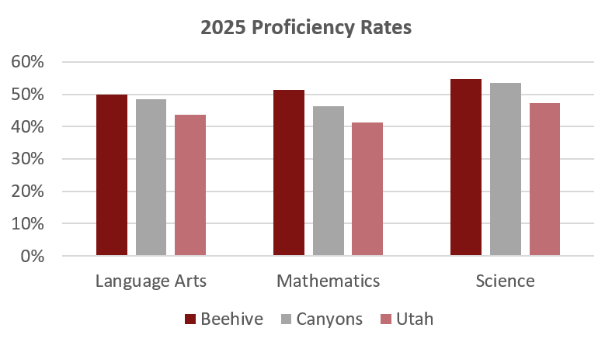

Management

- The School currently has a five-member board. The board members have backgrounds in: computer engineering, education, data analysis, budget analysis, and a former student currently enrolled at the University of Utah studying Mathematics, Quantitative Analysis, and Computer Programming.
- The School employs Hanifi Oguz as Executive Director/Principal. Mr. Oguz has a Master of Education from Concordia University in educational leadership, a BS in teaching mathematics from Bogazici University in Istanbul, and a School Leadership Management Certificate from the Harvard Business School. He was named principal of the year by the Best of State Utah in 2017.
- The School employs Ram Prasad Boppana for accounting and business services. Mr. Boppana has a bachelor’s degree in commerce (cost accounting and auditing). Mr. Boppana serves as a consultant for Utah International Charter School (since 2013). He is the 2009 and 2019 Utah Association of Public Charter Schools Business Manager of the year. He has consulted with other charter schools over the years and oversaw finance and operations for the Utah Association of Public Charter Schools from 2008 to 2010.
- The School has formal policies for budgeting, cash handling, fundraising and donations, and procurement. The school has no formal policies on debt or investments.

Plan of Finance

The School is seeking authorization to sell up to $28,790,000 of Ba1 rated bonds via negotiated sale with Crews & Associates serving as the Underwriter. The School is seeking credit enhancement through the Utah Charter School Credit Enhancement Program. The bonds will be tax-exempt bonds for the purpose of funding construction of a new campus in Saratoga Springs, renovating the second floor of the Sandy campus ($1.5 million), funding a debt service reserve, funding capitalized interest, and paying costs of issuance. The bonds will carry a fixed rate of interest and will likely carry a 5 to 7-year call. The bonds are secured by an assignment and secured interest in the revenues of the School and trust accounts and a security interest and pledge of the deed of trust in the land and building located at:

- 10 S. Saratoga Rd, Saratoga Springs, UT 84045
- 2165 E 9400 S, Sandy, UT 84093

Ratings

The bonds are rated Ba1 by Moody’s Ratings. Moody’s noted the following credit strengths in its rating report.
- Reputation as a high performing and unique STEM school.
- Solid operating performance driving good coverage of existing debt and growing liquidity.
- Favorable demographics within service area benefit enrollment growth trajectory.

The following credit challenges were noted:
- High leverage relative to similarly rated peers with cash to pro-forma debt of 11%.
- Risks associated with replicating a school with a unique model and teacher needs.
- Continued enrollment growth will be required to comfortably support debt service.

Moody’s noted that the School could achieve a rating upgrade with continued liquidity growth and stronger coverage through the expansion. Inability to achieve expected enrollment and revenue targets or declining cash balances could lead to a rating downgrade.

Financial Performance

Summary:
The School has taken advantage of strong operating margins in expansion to build cash balances. Increased scale while managing strong debt coverage has allowed the School to increase its cash balances as a percent of operations. Conservative budgeting procedures have facilitated the healthy margins. Figures presented for FY 2022 through FY 2025 represent audited figures. Figures for FY 2026 are unaudited. Comparisons to Credit Enhancement Program Standards are generally given against audited figures with other figures presented for context.

- End-of-year audited financials have differed significantly from original budgets in part due to additional revenues and related to its expansion over the past five years. The School has managed this transition well keeping expenditures below original budgets in each of the past two years while revenues have exceeded expectations in each of the past five years.

- Cash Position
 | Requirement | Measure at end of FY 2025
 | At least 75 days | 178

Often during expansion periods, small schools that enroll more students see large increases in expenditures. That increase in expenditures tends to cause a decline in the overall days cash on hand. The School saw that during its initial expansion phase but has been able to use the expansion and continued strong operations to improve both the total cash on hand and the days cash on hand (which is representation of cash to expenditures).

- Fund Balance
 | Requirement | Measure at end of FY 2025
 | At least 15% of following year expenses | 27%

The School has met this metric each year in the look back period.

- Debt Coverage Ratio
 | BB+ Requirement | Measure at end of FY 2025
 | At least 115% | 185%

Debt service coverage has been strong on the School’s existing debt. Net revenues for FY 2025 were $2.4 million. Annual debt service is expected to max out at nearly $3 million. This means that at current operating levels the School will be unable to meet debt service needs. Future enrollment growth is necessary to meet debt service requirements.

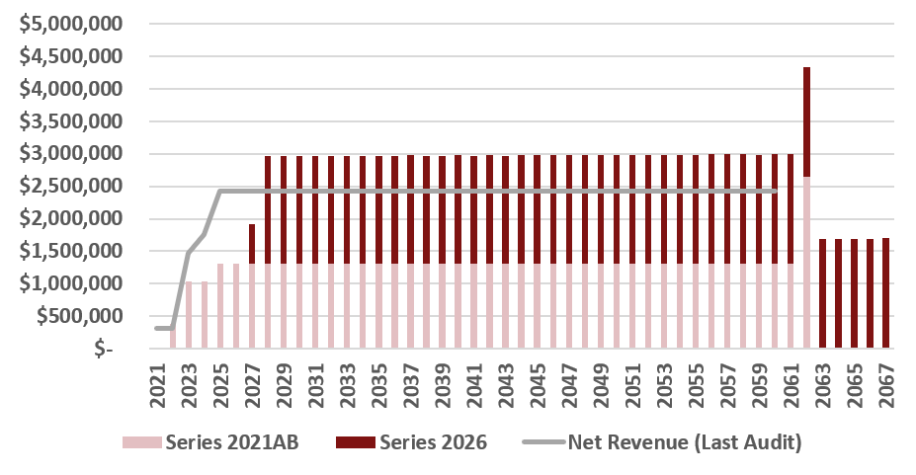

- Debt Burden Ratio
 | BB+ Requirement | Measure at end of FY 2027 | Measure at end of FY 2025
 | Less than 18% | 21.6% | 11.6%

The School met this metric in each year of the look back period but would not using Maximum Annual Debt Service against FY 2027 Operating Revenues. The Standards for Credit Enhancement requirement reads, “demonstrating substantial compliance for the three years prior to and after application”. By year two and three of the pro-forma the School is expected to meet this metric.

- Operating Margin
 | BB+ Requirement | Measure at end of FY 2025
 | At least 14% | 21.4%

The School has maintained strong operating margins through the expansion with the lone exception in FY 2022. Projections show slightly improved margins but are not outside the realm of possibility if the School achieves economies of scale.

- Current Ratio
 | Requirement | Measure at end of FY 2025
 | At least 150% | 201%

The School’s current ratio was strong for the past four years. FY 2022 was an expansion year which typically muddies the financial picture.

Bond Documents

Legal bond documents are being reviewed by Chapman & Cutler in its capacity as Issuer’s Special Counsel to the Authority, and all requirements are being incorporated. In addition, Gilmore & Bell, as Bond Counsel, has certified that each of the required legal provisions is present in the bond documents.

Continuing Disclosure

The School did not file FY 2025 Audited financials until right around the time its application was submitted to the Authority. This is several months late. The School had submitted the report to the Trustee on time but the Trustee had failed to file the report. While the ultimate responsibility for filing lies with the School, this mitigates some concerns. The School had several Quarterly Financial Report filings that were several months late for similar reasons.

Conclusion

The School meets each of the requirements for credit enhancement. It has a history of high academic performance that should give it credibility in entering a new fast growing charter school market. Historical operations have been conservative and allowed the School to operate at much smaller scales. The School should be able to take advantage of the increased scale multiple campuses provides to meet the challenges of expansion. Moody’s Ratings rated the School at Ba1 and noted the challenges facing the School that are balanced by a strong management team.

