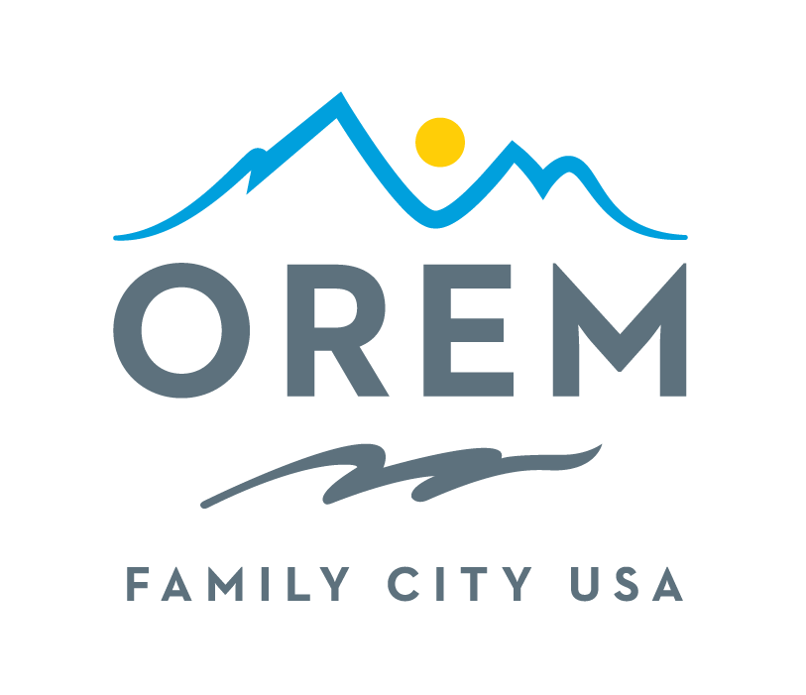
CITY OF OREM
ADVISORY BOARD/COMMISSION
MEETING AGENDA
meeting may be held electronically to allow a board/commission member to participate.
PUBLIC BODY: Events Advisory Commission
DATE: Thursday, August 13, 2026 ROOM: City Council Conference Room #1002
(Right next to the City Council Chambers)
TIME: 4:00 p.m. - 5:30 p.m. ADDRESS: 56 North State Street, Orem, Utah

AGENDA ITEMS:
Welcome Ashley Shumway
Review and Approve Minutes of July 9, 2026 Ashley Shumway

City Updates
- City Council Comments Crystal Muhlestein & Jeff Lambson
- Upcoming Events/Announcements Kenice Whitaker

Discussion Items Ashley Shumway
- Taste of Orem
- Idea Generation
- Day of Event/Set Up/Take Down
- Information Booth
- Support with Cultural Group Tent
- Support with Stage Entertainment, Announcements, Green Room Hosting

- Truck or Treat
- Idea Generation
- Treat Bag Assembly
- Information Booth
- Event Day – Line Management for face painting and other activities

Review Action Commitments Ashley Shumway

Next Meeting – Thursday, September 10, 2026 Ashley Shumway

Adjournment Ashley Shumway

THE PUBLIC IS INVITED TO PARTICIPATE IN ALL CITY MEETINGS.
If you need special accommodation to participate in Advisory Commission meetings
Please contact us on the City's website at orem.org or call (801) 229-7000 at least three working days.
prior to the meeting. This agenda is available on the Utah Public Notice website at utah.gov/pmn.

