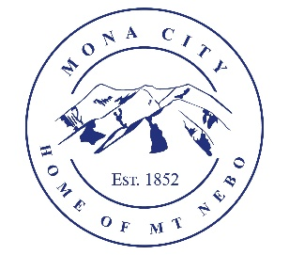
Mona City 20 West Center Street
Planning and Zoning 435-623-4913
www.monautah.gov

Planning and Zoning Meeting Agenda
Wednesday, August 5, 2026

7:30 pm
Mona City Council Room
20 West Center Street, Mona

- Approval of July 1, 2026 Meeting Minutes

- Discussion and Action Items:
- Ryan Lynn – Accessory Building Permit with electrical – 435 East 100 North
- Joe Huphrey/Richard Hatfield – Mona Commercial

- Secretary Items
- Proposed updates to Mona City Code

CERTIFICATE OF POSTING

This agenda is hereby properly advertised on the 4th day of August, 2026, by posting copies of this agenda at the Mona City Office, at the United States Post Office located in Mona City, on the Mona City website at monautah.gov, and on the Utah Public Notice Website at www.utah.gov/pmn/index.html.

Upon Request, in compliance with the Americans with Disabilities Act, reasonable accommodations for individuals with disabilities will be provided. For assistance, please call 435-623-4913.

