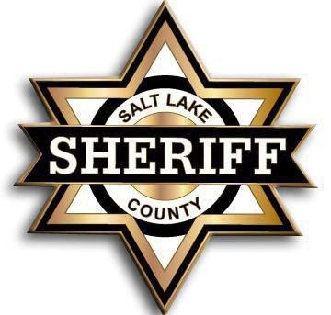

SALT LAKE COUNTY SHERIFF’S OFFICE

PEACE OFFICER MERIT COMMISSION
MINUTES
Thursday July 9th, 2026

MEMBERS PRESENT: David Salazar, Chair
Martha Stonebrook – Vice Chair

OTHERS PRESENT: Carita Lucey Merit Administrator
Lieutenant Scott Laughlin, Merit Coordinator
Sergeant Michael Russell, Merit Coordinator
Lindsey Moseley, Merit Coordinator
Chief Deputy Kari Huth, Public Safety
Chief Deputy Jason Ackerman, Law Enforcement
Captain David Sperry, Corrections
Lieutenant Kevin Schwieger, Corrections
Lieutenant Glenn Sullivan, Corrections
Lieutenant Ryan Scothern, Public Safety
Sergeant Matthew Thompson, Public Safety
Deputy Skyler Anderson, Corrections
Deputy Dakota Kingdon, Corrections

Commissioner David Salazar called the meeting to order at the Salt Lake County Government Center, Room S2-830, this meeting was also available via-Webex. Commissioner Salazar turned the time over to Carita Lucey to present the entry and lateral exam plans and then will open to public comment at the end.

Carita Lucey went over the following information regarding the exam plan:

Agenda item 2- Entry Level Exam Plan

- Adding to the minimum qualifications must have completed the nation police officers standardized test NPOST with a passing score of 70% or higher overall score. This test is not required through POST but will help us raise the bar of our applicants now that our vacancy numbers are lowering.

- Adding a link of locations that can take the NPOST and how they submit their scores during their hiring process.

- Removing the oral interview portion after the physical fitness test.

- Changing the background interview to be weighted at 60% instead of pass/fail.

Commissioner David Salazar opened the meeting to public to comment.

Matt Thompson with the Salt Lake Valley Law Enforcement Association supports adding the NPOST to the entry level exam plan.

Lieutenant Scott Laughlin clarifying that 70% is the minimum for the NPOST but due to the number of applicants we can raise overall passing percentage.

Lieutenant Mark Haws stated that he appreciates bringing back the NPOST test and is supportive.

Commissioner Stonebrook recommended formatting changes to provide clarity.

Commissioner David Salazar and moved to approve the entry level exam plan with the approved changes. Commissioner Martha Stonebrook seconded the motion to approve with the changes noted and passed unanimously.

Agenda item 2- Lateral Level Exam Plan

- Includes the Law Enforcement Bureau
- Adding more information to clarify the exam content
  - Background interview process
  - Final interview process

Commissioner David Salazar opened the meeting to public to comment.

Chief Deputy Kari Huth stated that she was supportive of both exam plans.

Public comments for the entry level exam plan were closed by Commissioner David Salazar

Commissioner David Salazar requested adding more clarification to the lateral exam plan of this exam plan being for all three bureaus in the exam content section.

Commissioner Martha Stonebrook motioned to approve the lateral exam plan with the changes that were made during the meeting.

Commissioner David Salazar added an additional comment to cover the verbiage changes that were made to the entry exam plan. Commissioner David Salazar seconded the motion to approve and passed unanimously.

Reviewed and Approved by ________________________ DATE:____________
David Salazar, Chair
Peace Officer Merit Commission

