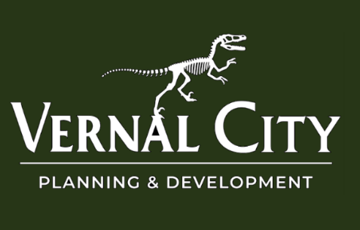

Public Notice
July 29, 2026
VERNAL CITY PUBLIC HEARING
Dear Property Owner,
You are hereby notified of a public hearing to be held before the Vernal City Planning Commission on August 11, 2026, at 5:30 p.m. The meeting will take place in the Vernal City Council Chambers, located at 374 East Main Street, Vernal, Utah.
The purpose of this hearing is to consider a request submitted by Heather and Russel Smith to rezone the following property:
Address: 291 South Vernal Avenue, Vernal, UT
Parcel Number: 05:032:0156
Current Zoning: R-3 Residential Zone (VMC Section 16.42)
Proposed Zoning: C2 Heavy Commercial Zone (VMC Section 16.48)
Following the public hearing, the Planning Commission will make a recommendation to the Vernal City Council regarding this request.
All interested persons are invited to attend the public hearing and provide comment regarding this request. Written comments may also be submitted prior to the meeting to the Vernal City Planning Department, 374 East Main, Vernal, UT 84078 or Braeden Christofferson at bchristofferson@vernal.gov. To be included in the public record, written comments should be received no later than August 10, 2026, at 5:00 p.m. Each written objection filed with the municipality will be provided to the municipal legislative body for consideration.
Additional information regarding this application is available for review at the Vernal City offices during regular business hours. If you have any questions, please contact the Vernal City Planning Department at (435) 789-2271.
In compliance with the Americans with Disabilities Act, individuals needing special accommodations during this meeting should notify Braeden Christofferson, 374 East Main, Vernal, Utah at least five days before the hearing at (435) 789-2271.
This notice has been:
- Posted on the Utah Public Notice Website;
- Posted on the Vernal City Website;
- Posted in conspicuous locations within Vernal City; and
- Mailed to property owners of the area proposed for amendment

Posting Date: July 29, 2026
Notice to remain posted through: August 11, 2026

