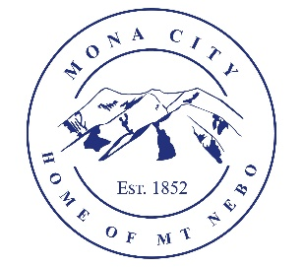
Mona City
435-623-4913
www.monautah.gov
20 West Center Street, Mona, Utah

Mona City Council Meeting Agenda
Tuesday, July 28, 2026
Mona City Building – 20 West Center
7:00 p.m.

Pledge
Prayer
Previous Meeting Minutes
- Approval of July 14, 2026, City Council Meeting Minutes
- Approval of July 22, 2026, City Council Emergency Meeting Minutes
Action Items
- Consideration and Approval of Hiring Recommendations
- Additional asphalt repair (change order) for up to $5,000.
Smith Steele Works Representative
R6 Advisor Shay Morrison
- Commercial Development
Jones and Demille Engineer Dan Fechner
- Development Standards
Secretary
Finance Director
- Approval of Finances
- Quarterly Report
Recorder
Gas & Water & Roads
Sewer
Council Reports
Public Comment
Adjournment

CERTIFICATE OF POSTING
This agenda is hereby properly advertised on this 27th day of July, 2026, by posting copies in the following places: the Mona City Office, on the Mona City website at monautah.gov, at the United States Post Office Mona City Branch, and on the Utah Public Notice Website at www.utah.gov/pmn/index.html.

Upon Request, in compliance with the Americans with Disabilities Act, reasonable accommodations for individuals with disabilities will be provided. For assistance, please call 435-623-4913.

