ORDINANCE 26-09

AN ORDINANCE OF TREMONTON CITY CORPORATION AMENDING THE OFFICIAL ZONING MAP TO REZONE AN APPROXIMATELY 36.29-ACRE PARCEL FROM AN EXISTING R1-10/RM-16 SPLIT-ZONE DESIGNATION BY EXTENDING THE BOUNDARY OF THE APPROXIMATELY 3.57-ACRE RM-16 PORTION OF THE PROPERTY TO THE PARCEL'S NORTHERN BOUNDARY, REZONING THE REMAINDER OF THE PROPERTY FROM R1-10 TO RM-8, AND ESTABLISHING AN EFFECTIVE DATE

WHEREAS, a landowner, owning land in said certain area within the Tremonton City limits, as better described in Exhibit “A”, has petitioned the City for a zone change located at approximately the current terminus of North 1650 West; and
WHEREAS, it has been determined that RM-8 and RM-16 are types of multiple residential zoning; and
WHEREAS, the Planning Commission held a public hearing on June 23, 2026 and received meaningful input, and formulated a recommendation to present to the City Council; and

WHEREAS, the City Council held a public meeting and received meaningful input; and

WHEREAS, all required notices have been provided and public hearing has been held in accordance with State Law and County Ordinances to amend the Tremonton City Zoning Map.

NOW, THEREFORE, BE IT RESOLVED BY THE CITY COUNCIL OF TREMONTON CITY CORPORATION, STATE OF UTAH, AS FOLLOWS:

Section 1. Map Amendment. The Tremonton City Zoning Map is hereby amended for the property more particularly described in the attached Exhibit “A” from an existing R1-10/RM-16 split-zone designation by extending the boundary of the approximately 3.57-acre RM-16 portion of the property to the parcel's northern boundary, rezoning the remainder of the property from R1-10 To RM-8.

Section 2. Severability. If any section, part, or provision of this Ordinance is held invalid or unenforceable, such invalidity or unenforceability shall not affect any other portion of this Ordinance and all sections, parts, and provisions of this Ordinance shall be severable.

Section 3. Effective Date. This ordinance shall become effective immediately upon its adoption.
ADOPTED AND PASSED THIS 7th day of July, 2026, and shall be effective upon its adoption.
TREMONTON CITY CORPORATION
_________________________________
Mayor Bret Rohde
ATTEST:
_________________________________
Cynthia Nelson, City Recorder

Publication Date: ___________________

Exhibit “A” BUCHANAN ZONING MAP AMENDMENT FROM AN EXISTING R1-10/RM-16 SPLIT-ZONE DESIGNATION BY EXTENDING THE BOUNDARY OF THE APPROXIMATELY 3.57-ACRE RM-16 PORTION OF THE PROPERTY TO THE PARCEL'S NORTHERN BOUNDARY, REZONING THE REMAINDER OF THE PROPERTY FROM R1-10 TO RM-8 LEGAL DESCRIPTION:

A PART OF THE SOUTH HALF OF SECTION 4, TOWNSHIP 11 NORTH, RANGE 3 WEST, OF THE SALT LAKE BASE AND MERIDIAN. BEGINNING AT THE NORTHWEST CORNER OF THE WOODFIELD P.U.D. SAID POINT ALSO BEING ON THE EAST RIGHT-OF-WAY LINE OF INTERSTATE 15 BEING LOCATED SOUTH 88°41'12" WEST 2939.15 FEET ALONG THE SOUTH LINE OF SAID SECTION AND NORTH 00°00'00" EAST 872.79 FEET FROM THE SOUTHEAST CORNER OF SAID SECTION 4; RUNNING THENCE ALONG SAID EAST RIGHT-OF-WAY LINE NORTH 00°38'09" WEST 1789.36 FEET; THENCE NORTH 88°56'17" EAST 946.80 FEET; THENCE SOUTH 01°06'22" EAST 1147.31 FEET TO THE NORTH LINE OF THE FAIRVIEWESTATES SUBDIVISION PHASE 2; THENCE ALONG THE BOUNDARY LINE OF SAID FAIRWAYS ESTATES SUBDIVISION PHASE 2 THE FOLLOWING FOUR (4) COURSES: (1) SOUTH 89°59'58" WEST 257.91 FEET; (2) SOUTH 00°00'02" EAST 110.00 FEET; (3) SOUTH 08°24'01" WEST 60.65 FEET; (4) SOUTH 01°06'22" EAST 573.91 FEET TO THE NORTH LINE OF THE FAIRVIEWESTATES SUBDIVISION PHASE 1; THENCE ALONG THE NORTH LINE OF SAID FAIRVIEW ESTATES SUBDIVISION PHASE 1 SOUTH 88°41'14" WEST 368.03 FEET TO THE EAST RIGHT-OF-WAY LINE OF 1650 WEST STREET; THENCE ALONG SAID EAST RIGHT-OF-WAY LINE NORTH 01°19'26" WEST 96.69 FEET; THENCE SOUTH 89°16'08" WEST 323.10 FEET TO THE POINT OF BEGINNING. LESS AND EXCEPTING THERFROM, ANY PORTION OF FAIRVIEW ESTATES SUBDIVISION, PHASE 1 AND 2, CONTAINED THEREIN.

Exhibit “B”: Existing Zoning

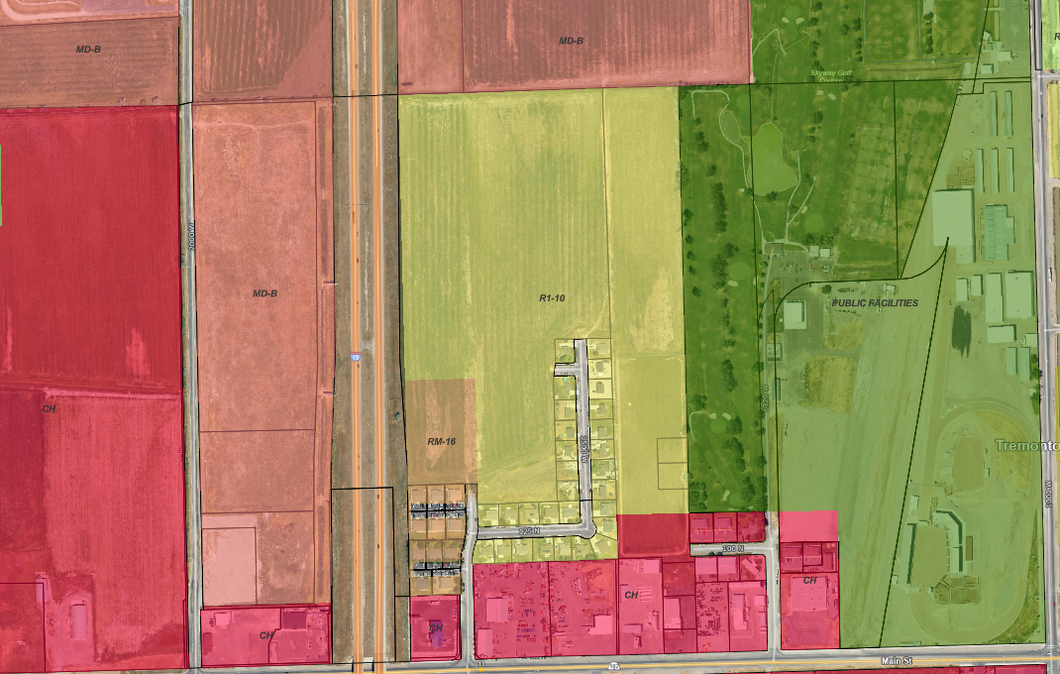
36.29 acres
Subject Property

STATE OF UTAH )
: ss.
COUNTY OF BOX ELDER )

I, Cynthia Nelson, the City Recorder of Tremonton, Utah, do hereby certify that the above and foregoing is a full and correct copy of Ordinance No. 26-09, entitled “AN ORDINANCE OF THE TREMONTON CITY CORPORATION AMENDING THE OFFICIAL ZONING MAP TO REZONE AN APPROXIMATELY 36.29-ACRE PARCEL FROM AN EXISTING R1-10/RM-16 SPLIT-ZONE DESIGNATION BY EXTENDING THE BOUNDARY OF THE APPROXIMATELY 3.57-ACRE RM-16 PORTION OF THE PROPERTY TO THE PARCEL'S NORTHERN BOUNDARY, REZONING THE REMAINDER OF THE PROPERTY FROM R1-10 TO RM-8, AND ESTABLISHING AN EFFECTIVE DATE” Adopted and passed by the City Council of Tremonton, Utah, at a regular meeting thereof on the 7th day of July 2026, which appears of record in my office.

IN WITNESS WHEREOF, I have hereunto set my hand and affixed the corporate seal of the City this _____ day of 2026.

Cynthia Nelson, City Recorder

