Avon Cemetery Board Meeting
July 6, 2026 7pm
11235 S. 1200 E. Avon, UT
ATTENDANCE: Kirsten Knowles, Michele Watkins, David Maughan, Jim Atkinson, Roger Pulsipher

- Sign certificates
- Stagger term limits- draw lots
Lots drawn. Roger Pulsipher & Michele Watkins drew the two-year spots. We will submit minutes to the County for staggered term limits.

- Cemetery expansion ideas
  - Plots to the north – Every board member agreed that when the time comes, we will begin sectioning and selling plots on the north end of the cemetery. This will prolong the need to expand the cemetery.
  - Right of way for road – It was discussed and benched for a later time
  - Dirt road – Concern is plowing in the winter.
  - Digital map now? – Holding off for now.
  - The Cemetery Board feels that having the new “driveway” along the perimeter 5’ from boundary line increases parking ability. When section is expanded to the north we will need to run the sprinkling line down. Possible road guy: Randy Hoops
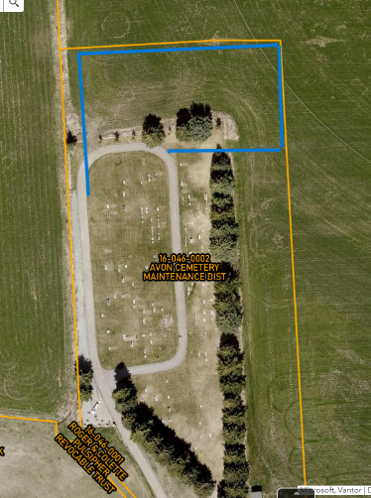
  - Once plots to the north are sold and we need to expand we will potentially expand to the north looping the road as shown. Will discuss further when necessary.

- Bench and Flag donations
Kirsten had been approached by patrons about the donation of a bench. The cemetery board agreed to accept the donation and feel they will be able to find a place for it. Kirsten had been approached about someone putting flags along driveway leading up to the cemetery for Memorial Day, Veterans, & 4th of July. The board okayed it.

- Email, website (QR Code) and new documentation for tracking information (burials, owners, training etc.)
  - Ideal for new board members everything in one place, easy transfer.
David requested a metal QR code be made in place of current paper form. Board approved the purchase of metal QR code. David has done a lot of work scanning and linking documents to plots. He has created a cemetery email: avonutcmd@gmail.com opening 15 gigabytes for cemetery purposes. He is currently working on a complex excel document and allowing all board members access to the paper trails.

- Follow up on tasks assigned:
  - Training
  - David Maughan
    - Reclaiming old plots
Started with plot 1 it had the wrong names and David did a lot of detective work. Come to find out Jim Atkinson is related to the plot owner and will reach out to the next of kin to see if they are interested in the plot still. David has a large stack of papers to go through; he will figure out a way the rest of the board can help so that the burden isn’t completely on him. The board feels that this is a good use of time and that as old plots are grandfathered back to the cemetery it will slow the need to expand. Efforts will be focused here instead of expansion.
    - Update on Chris Bailey request (Orton?)
David has Chris’ contact information and has resolved all but one of the requested plot transfers.
John Orton’s notarized document has not arrived yet to transfer plots 102 & 103a/b. Michele checked with the post office and it shouldn’t have had a problem arriving. We will continue to watch for it. 7/7/26
    - Cache County recorder will record plot ownership for free
David went in to find out what format they want the information in & no one knew what he was talking about. They found a supervisor who said no other cemeteries record the plots. The cemetery board has decided not to utilize the County Recorder; our records will suffice.

- Archibald plots 81 & 82
Roger has been getting phone calls about Marie Archibald’s plots. Roger will get signed document that he received from Marie to David to add to his excel document. The board agrees that the ownership will stay how it is unless the other family members (Kirk Archibald) can provide paper documents stating otherwise.

- Fence on Southwest corner and North Fence
SW corner the fence was taken down by Chris Bailey to put something up on Casey Snider’s property. The board will not repair the fence as it was between the land owner and Chris Bailey. The north fence can come down anytime, especially when we begin to sell plots.

MSC:
The cemetery will put up flags on veterans for Memorial Day, Veterans Day & the 4th of July.

