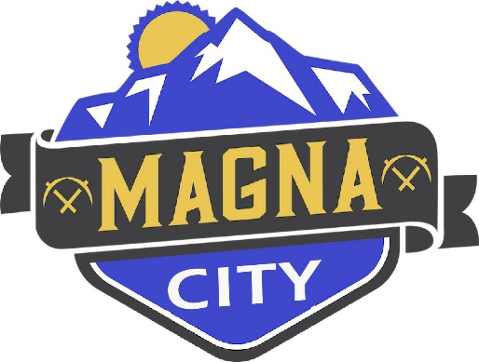
NOTICE OF CANCELLATION
The Magna City Council Meeting scheduled for July 28, 2026 has been canceled.

The next City Council Meeting will be August 11, 2026 as scheduled
A copy of this notice may be viewed or obtained from the following:
- Utah Public Notice Website: https://www.utah/gov/pmn
- Webster Center
- Magna City Website: https://www.magna.utah.gov

