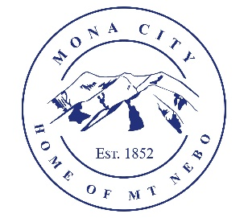
Mona City
435-623-4913
www.monacity.org
20 West Center Street Mona, Utah

Mona City Council Emergency Meeting
Wednesday, July 22, 2026
7:00 pm
Mona City Council Room – 20 West Center

Notice is hereby given that the Mona City Council will hold an emergency meeting on Wednesday, July 22, 2026, at 7:00 p.m. in the Mona City Council Chambers at 20 West Center Street, Mona City. The purpose of the meeting is to approve the following:

- Approval of outsourcing a CPA firm for accounting
- Consideration and approval of hiring recommendations
- Service opportunities and ideas

CERTIFICATE OF POSTING

This agenda is hereby properly advertised on the 20th day of July, 2026, by posting copies of this agenda at the Mona City Office, at the United States Post Office located in Mona City, on the Mona City website at monautah.gov, and on the Utah Public Notice Website at www.utah.gov/pmn/index.html.

Upon Request, in compliance with the Americans with Disabilities Act, reasonable accommodations for individuals with disabilities will be provided. For assistance, please call 435-623-4913.

