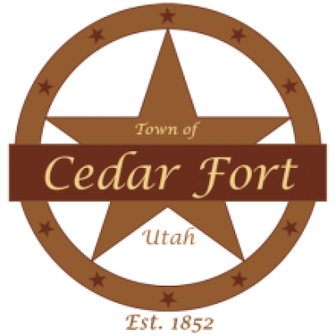
Town Council Meeting Agenda

Mayor Wyatt Cook
Council Member Alex Carter
Council Member Travis Giles
Council Member Jed Berry

Town of Cedar Fort
Tuesday, July 21, 2026 @ 7:00 pm
Town Hall, 50 East Center Street, Cedar Fort, UT 84013
POLICY MEETING
CALL TO ORDER
1. Roll Call.
2. Prayer/Thought.
3. Pledge of Allegiance.
PUBLIC HEARINGS
The Council will accept public comment and may approve the following items:
1. Proposed amendments to Title 10 of the Cedar Fort Town Code, including but not limited to updates related to MG40 zoning, Sensitive Overlay Zones, APWA Standards, and other related ordinance amendments as deemed necessary by the Planning Commission.
2. Proposed amendments to Title 5 and Title 6 of the Cedar Fort Town Code.
3. Consideration of one or more proposed resolutions relating to Town business.
REPORTS
1. Mayor.
2. City Council.
3. Department Reports: Police, Fire, Water, Treasurer, Billing Clerk, Clerk, Building Clerk, Sexton, Cemetery Committee Chair, Planning Commission, Public Information Officer.
PUBLIC COMMENT
Time for Public Input is limited to no more than 2-3 minutes per person. This time has been set aside for the public to express ideas, concerns, and comments for subject matter not listed as public hearing on the agenda.
CONSENT ITEMS
The Council may approve these items without discussion or public comment and may remove an item to the Business Items for discussion and consideration.

1. Approval of Minutes: June 16, 2026.
2. Approval of Budget/Town Bills.
BUSINESS ITEMS
The Council will discuss (without public comment) and may approve the following items:
1. Impact Fee
2. Website Manager
3. Cedar Berry Subdivision Concept Review
4. Code Amendments
5. MAG Grant Match Agreement

CLOSED MEETING
Possible motion to enter into closed meeting for the purchase, exchange, or lease of property; pending or reasonably imminent litigation; the character, professional competence, or the physical or mental health of an individual; or the deployment of security personnel, devices, or systems.
ADJOURNMENT

Town Council Regular Meeting
Tuesday, July 21 · 7:00 – 9:00pm
Time zone: America/Denver
Google Meet joining info
Video call link: https://meet.google.com/sdo-qojb-chp

PLEASE NOTE: The order of items may be subject to change with the order of the Mayor. One or more council members may participate by electronic telecommunication means such as phone, internet, etc. so that they may participate in and be counted as present for all meeting purposes, including the determination that a quorum is present.

In compliance with the Americans with Disabilities Act, individuals needing special accommodations (including auxiliary communicative aids and services) during this meeting should notify the City Recorder (Kandice Johnson) at 801-768-2147 or clerk@cedarfort.gov at least two days prior to the meeting.
Posted ____ day of July 2026 at ________ AM/PM By: _____________________

Certificate of Posting
The Town does hereby certify that the above notice and agenda has been posted at the designated meeting place and the Utah Public Notice Website.

