MEMORANDUM

DATE: Thursday, July 23, 2026
TO: Marlo Oaks, State Treasurer and Utah Charter School Finance Authority Board
FROM: Japheth McGee, Vice President and Johnathan Ward, Senior Vice President of Zions Public Finance
RE: Wallace Stegner Academy Application to the Utah Charter School Finance Authority and Credit Enhancement Program

Conflicts of Interest

In general, Zions Bancorporation, National Association is made up of many departments and provides various services. Some of those services and departments can be involved on the same transaction. Zions Public Finance Inc. and Zions Corporate Trust are affiliated entities operating under Zions Bancorporation and we all benefit from a strong stock price derived from strong performance by the company and its component members and affiliates across the country. Zions Public Finance does not receive financial or other benefits in association with transactions performed by Zions Corporate Trust who may act as Trustee on charter school transactions. Likewise, Zions Public Finance operates separately from commercial loan divisions of the Bancorporation who may have provided private financing to developers or charter schools to construct the school initially. Zions Public Finance is not aware of the circumstances where this occurs unless told when a charter school applies. Zions Public Finance does not receive financial or other benefits that could result from actions taken by the Charter School Finance Authority outside of the agreed upon fees for services rendered to the Authority.

Zions’ entities engaged with the School:

Zions Public Finance: | Yes. (Advisor to the Authority)
Zions Corporate Trust: | Yes
Zions Commercial Involvement: | No

Executive Summary

Borrower: | Wallace Stegner Academy
Management Company: | Business Manager: AW Services, LLC
Municipal Advisor: | LRB Public Finance Advisors, Inc.: David Robertson
Borrower’s Counsel: | Farnsworth Johnson: Brandon Johnson
Underwriter: | DA Davidson: Eric Duran
Bond Counsel: | Gilmore & Bell: Jacob Carlton
Issuer’s Counsel: | Dorsey & Whitney: Nate Canova
Trustee: | Zions Bancorporation: Pasquel Hansen
Par Amount: | $59,040,000 in tax-exempt bonds.
Enhancement Requested: | Yes
Purpose: | Fund the purchase of the Kearns Elementary School, Kearns High School, and Sunset Elementary; fund a classroom expansion at the Kearns campus; fund a debt service reserve fund; and pay costs of issuance.
Structure: | Bonds will be repaid with a roughly level amortization of principal and interest over 35 years. The bonds will carry a fixed rate of interest.
Term: | Final maturity in 2061. Bonds will likely carry a 10-yr call feature.
Rating: | S&P Global Ratings: BB+
Costs of Issuance Estimate: | $418,900
Underwriter Fee Estimate: | $3.95/$1,000 (est. $233,208)
Litigation: | None of which we are aware.
Summary: | The School has grown significantly over the past several years. That growth has allowed the School to scale fairly significantly to smooth out pressures from earlier times. The School’s current enrollment and operating margins are sufficient to meet future debt service obligations at 116%. Additional enrollment should help the School to meet obligations. The School could face pressure in a decreasing enrollment environment or if State funding were to reverse its recent trend of increases.

Purpose

The purpose of this memo is to document the adherence of Wallace Stegner Academy (the “School”) to the application requirements of the Utah Charter School Finance Authority (the “Authority”) Credit Enhancement Program Standards and provide credit analysis of the School for the Authority’s consideration. The analysis contained herein is based on the School’s application to the Authority and inquiry for clarification of the Municipal Advisor to the Authority.

Introduction

The School is a non-profit, 501c3 designated, public K-10 charter school with 4 campuses in Salt Lake City, West Valley, Kearns, and Sunset. The School was approved by the Utah State Charter School Board (the “SCSB”) and opened for operation in 2016.

MISSION
Wallace Stegner Academy will foster a community of active learners through academic rigor and citizenship by providing an opportunity for at risk students to close the achievement gap and achieve academic excellence through
- Academic rigor
- Direct instruction
- Data-driven instruction
- Ability-based mathematics, language arts, and reading classes
- Positive learning environments
- Character development

Enrollment/Student Demand

October enrollment for the 2025 - 2026 school year was 2,848 students. The School will increase student enrollment to nearly 3,500 by 2028. The School has a strong waitlist and has shown strong retention and resulting enrollment throughout the entire look back period. Average daily membership is above 98%.

Academic Performance

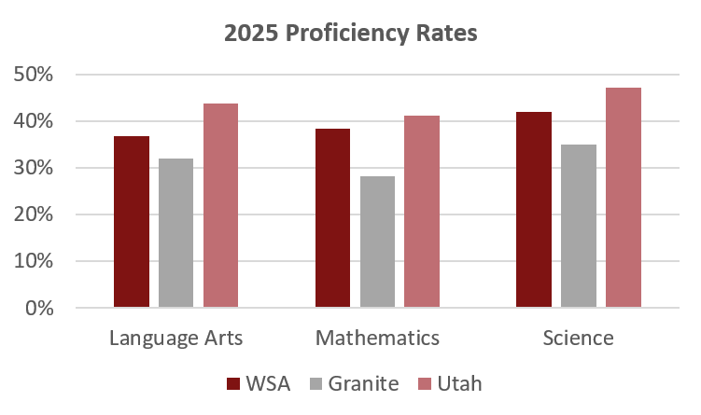

Management

- The School currently has a seven-member board. The board members have backgrounds in: agricultural consulting, healthcare, aviation startup finance, banking, and data analysis.
- The School employs Adam Gerlach and Anthony Sudweeks as Co-Chief Executive Officers. Mr. Gerlach holds a Master’s Degree in Educational Leadership from Southern Utah University and a Bachelor’s Degree in Psychology from Weber State University. Mr. Sudweeks holds two Master of Education degrees: one in Educational Leadership and Administrative Development from Southern Utah University, and another in Instructional Design and Educational Technology from the University of Utah. He also earned a Bachelor of Arts in English and holds both a Utah Administrative License and a Level 2 Professional Teaching License.
- The School employs AW Services for business management services.
- The School has formal policies for budgeting, cash handling, investments, fundraising and donations, and procurement. The school has no formal policy on debt.

Plan of Finance

The School is seeking authorization to sell up to $59,040,000 of BB+ rated bonds via negotiated sale with DA Davidson & Co. serving as the Underwriter. The School is seeking credit enhancement through the Utah Charter School Credit Enhancement Program. The bonds will be tax-exempt bonds for the purpose of funding the purchase of the Kearns Elementary and Kearns High School buildings, funding the purchase of the Sunset campus, funding a 5 classroom ( plus bathrooms) addition at the Kearns campus, funding a debt service reserve, and paying costs of issuance. The bonds will carry a fixed rate of interest and will likely carry a 10-year call. The bonds are secured by an assignment and secured interest in the revenues of the School and trust accounts and a security interest and pledge of the deed of trust in the land and building located at:

- 980 Bending River Road, Salt Lake City, 84104
- 2671 Stegner Way, West Valley City, 84128
- 4590 W 5600 W, Kearns 84120
- 160 W 2525 N, Sunset, 84015

Ratings

The bonds are rated BB+ by S&P Global Ratings. S&P noted the following positive factors in its rating report.
- Successful expansion to a fourth campus allowing for strong enrollment and expected future growth.
- Healthy academic performance compared to peers.

The following factors for concern were noted:
- Elevated leverage with a high-proforma debt burden and debt per student.
- Relatively short operating history.

S&P noted that the School was unlikely to see a rating upgrade in the near future but could achieve a rating increase with sustained coverage and liquidity after the expansion is complete. A rating downgrade could occur if the School demonstrates a trend of declining liquidity, deficit operations, or below 1x lease-adjusted MADS coverage.

Financial Performance

Summary:
Wallace Stegner Academy has significantly expanded its operations and improved its financial position over the past several years. Coverage and operating margins have been strong in each year since the weak 2022 results. Cash balances have risen despite going through dramatic expansion which tends to lend itself to drawdowns of cash.

- End-of-year audited financials have differed significantly from original budgets in part due to additional revenues and financials obligations related to its expansion over the past five years.

Backing out capital-related expenditures shows a better but still volatile picture.

- Cash Position
 | Requirement | Measure at end of FY 2025
 | At least 75 days | 205

Moody’s threshold for Baa rated schools’ cash balance is 125 DCOH. The School is above that mark for the first time in the unaudited FY 2026 financials.

- Fund Balance
 | Requirement | Measure at end of FY 2026 (unaudited)
 | At least 15% of following year expenses | 23%

At the end of FY 2025, the School had an unassigned fund balance of 13% of the following year’s operating expenses. Below the requirement in the Standards. However, the School added substantially to fund balance in FY 2026 and should be in a good position going forward considering the strength of its operating margins over the past several years. This item is not technically a requirement under the CEP but is something required by the conduit issuance program.

- Debt Coverage Ratio
 | BB+ Requirement | Measure at end of FY 2025
 | At least 115% | 177%

Lease adjusted coverage in FY 2022 was under 110%. However, the School was quickly able to absorb the additional costs and improved coverage significantly. Net revenues in FY 2025 (audited figures) would be sufficient to cover future debt service costs at 116%.

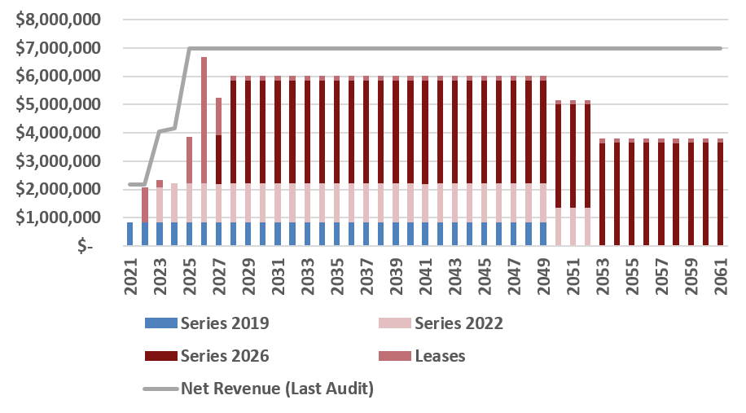

- Debt Burden Ratio
 | BB+ Requirement | Measure at end of FY 2027
 | Less than 18% | 15.2%

The School met this metric in each year of the look back period. FY 2026 unaudited figures contain short term lease payments that will be taken out by the anticipated financing. Debt burden under the expected expansion would be more favorable.

- Operating Margin
 | BB+ Requirement | Measure at end of FY 2025
 | At least 14% | 24.9%

The School has maintained strong operating margins through the past five years and expansion. Projections are in line with the historical past.

- Current Ratio
 | Requirement | Measure at end of FY 2025
 | At least 150% | 176%

The School’s current ratio was strong for the lookback period. Unaudited financials from FY 2026 did not yet contain payroll accrued liabilities or other end of year entries painting a rosier picture of current liabilities.

Bond Documents

Legal bond documents are being reviewed by Dorsey & Whitney in its capacity as Issuer’s Special Counsel to the Authority, and all requirements are being incorporated. In addition, Gilmore & Bell, as Bond Counsel, has certified that each of the required legal provisions is present in the bond documents.

Continuing Disclosure

The School did not have any major issues with disclosure over the past five years. It has an acceptable continuing disclosure policy.

Conclusion

The School has meet each of the requirements of the Credit Enhancement Program. Historical operations have improved significantly with the scale of the School. Academics are strong which is typically associated with a strong future demand profile. The School’s current enrollment and operating margins are sufficient to meet future debt service obligations at 116%. Additional enrollment should help the School to meet obligations. The State is in an overall declining student enrollment environment that should be considered but, at current enrollment levels the School should be able to meet the obligations it is planning to incur.

Appendix A: Additional Enrollment Information

