MEMORANDUM

DATE: Thursday, July 23, 2026
TO: Marlo Oaks, State Treasurer and Utah Charter School Finance Authority Board
FROM: Japheth McGee, Vice President and Johnathan Ward, Senior Vice President of Zions Public Finance
RE: Utah Charter Academies Application to the Utah Charter School Finance Authority and Credit Enhancement Program

Conflicts of Interest

In general, Zions Bancorporation, National Association is made up of many departments and provides various services. Some of those services and departments can be involved on the same transaction. Zions Public Finance Inc. and Zions Corporate Trust are affiliated entities operating under Zions Bancorporation and we all benefit from a strong stock price derived from strong performance by the company and its component members and affiliates across the country. Zions Public Finance does not receive financial or other benefits in association with transactions performed by Zions Corporate Trust who may act as Trustee on charter school transactions. Likewise, Zions Public Finance operates separately from commercial loan divisions of the Bancorporation who may have provided private financing to developers or charter schools to construct the school initially. Zions Public Finance is not aware of the circumstances where this occurs unless told when a charter school applies. Zions Public Finance does not receive financial or other benefits that could result from actions taken by the Charter School Finance Authority outside of the agreed upon fees for services rendered to the Authority.

Zions’ entities engaged with the School:

Zions Public Finance: | Yes. (Advisor to the Authority)
Zions Corporate Trust: | Yes
Zions Commercial Involvement: | No

Executive Summary

Borrower: | Utah Charter Academies: Dba American Preparatory Academy
Management Company: | Business Manager: American Preparatory Schools, Inc – David Sharette
Municipal Advisor: | Buck Financial Advisors, LLC.: John Buck
Borrower’s Counsel: | Farnsworth Johnson: Brandon Johnson
Underwriter: | Robert W. Baird & Co.: Peter Hoselton and Jim Blandford
Bond Counsel: | Chapman & Cutler: Eric Hunter
Issuer’s Counsel: | Dorsey & Whitney: Nate Canova
Trustee: | Zions Bank: Josh Elsmore
Par Amount: | $70,370,000 in tax-exempt bonds.
Enhancement Requested: | Yes
Purpose: | Fund an expansion to the School’s existing facility in Salem, fund an expansion at the School’s existing West Valley 2 campus, construction of a new campus in Eagle Mountain, refunding a USDA loan to put it on parity, fund a debt service reserve fund, fund capitalized interest, and pay costs of issuance.
Structure: | Bonds will be repaid with a roughly level amortization of principal and interest over 35 years including a one-year capitalized interest period. The bonds will carry a fixed rate of interest.
Term: | Final maturity in 2061. Bonds will likely carry an 8-yr call feature.
Rating: | S&P Global Ratings: BB+
Costs of Issuance Estimate: | $524,125
Underwriter Fee Estimate: | $5.00/$1,000 (est. $351,850)
Litigation: | None of which we are aware.
Summary: | The School is in a fast expansion mode. It added a new campus (that was a previously operating charter school) in Cedar City in 2025 and is planning for additional enrollment at nearly every campus with significant increases at West Valley, Salem, and a new Eagle Mountain campus being funded in part by this project. S&P noted that the increased leverage from this project was a reason why they downgraded the School from BBB- to BB+. However, lease adjusted coverage on future debt service based off FY 2024 audited financial figures shows the School has sufficient revenues to repay the obligation. Additional student enrollment should allow the School to meet the new obligation.

Purpose

The purpose of this memo is to document the adherence of Utah Charter Academies dba American Prep Academy (the “School”) to the application requirements of the Utah Charter School Finance Authority (the “Authority”) Credit Enhancement Program Standards and provide credit analysis of the School for the Authority’s consideration. The analysis contained herein is based on the School’s application to the Authority and inquiry for clarification of the Municipal Advisor to the Authority.

Introduction

The School is a non-profit, 501c3 designated, public K-12 charter school with seven campuses in Draper, West Valley, Salem, and Cedar City. The proceeds of this financing will begin the process for opening a new campus in Eagle Mountain. The School was approved by the Utah State Charter School Board (the “SCSB”) and incorporated in 2003. The School has a unique relationship with its charter management company. The original operating team from the first campus spun a charter management company off the School and have since operated that as a separate for profit entity. The management contract was recently reviewed for renewal and the status of that was not known at the time of this memo.

MISSION STATEMENT
The Charter School is a classical, liberal-arts school dedicated to providing an orderly, safe and nurturing learning environment wherein content-rich, efficient curriculum and research based instructional methodologies are utilized to ensure that every student achieves academic success and develops good character based on concrete measurements.

Enrollment/Student Demand

October enrollment for the 2025 - 2026 school year was 5,451 students. The School is using funds from this financing to expand and increase student enrollment to 7,129 by 2031. The School operates the 16th largest Local Education Authority (“LEA”) in the State and the largest charter school LEA. The School has a waitlist that is roughly 25% of total enrollment and has shown strong retention and resulting enrollment throughout the entire look back period. Average daily membership is above 98%.

Academic Performance

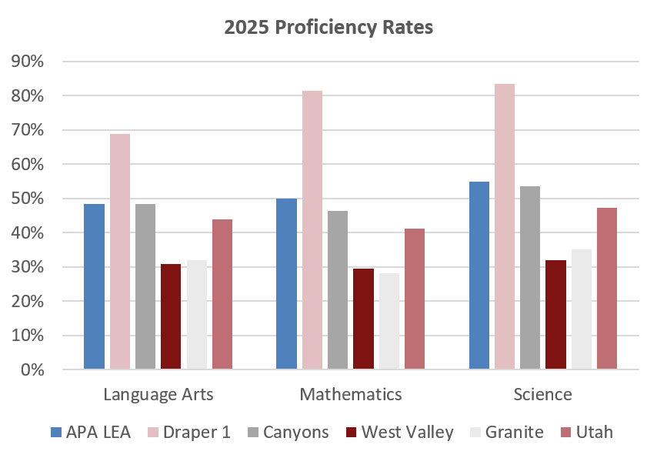

Management

- The School currently has a four-member board but plans to add a fifth member. The board members have backgrounds in: economics, accounting, and charter school development.
- The School employs Carolyn Sharette as Executive Director. Ms. Sharette holds a bachelor’s of science in general studies and a nursing degree from Brigham Young University. She is a past president of the Utah Association of Charter Schools and is the Superintendent of the American Preparatory Schools, Inc. the management company. She is a founding member of the School.
- The School employs American Preparatory Schools, Inc. (“APS”) for business management services. Casey Crellin serves as the Chief Financial Officer of APS and Utah Charter Academies. Mr. Crellin holds an MBA from the University of Colorado, Boulder and BS in Accounting from the University of Utah.
- The School has formal policies for budgeting, cash handling, investments, fundraising and donations, and procurement. The School does not have a formal debt policy.

Plan of Finance

The School is seeking authorization to sell up to $70,370,000 of BB+ rated bonds via negotiated sale with Robert W Baird & Co. serving as the Underwriter. The School is seeking credit enhancement through the Utah Charter School Credit Enhancement Program. The bonds will be tax-exempt bonds for the purpose of funding an expansion at the Salem facility ($13 million for a new gym and secondary classrooms), expansion at the West Valley 2 facility ($21 million for a new auditorium, 4 additional secondary classrooms, and 7 additional elementary classrooms), a new Eagle Mountain campus ($22 million for a building with approximately 21 classrooms), refunding a USDA loan ($4 million, to place it on parity with existing bonds), a debt service reserve fund, one year of capitalized interest, and costs of issuance. Construction on the Salem addition is expected to be completed by Fall 2027. The West Valley and Eagle Mountain projects are expected to be completed by Fall of 2028. The bonds will carry a fixed rate of interest and will likely carry an 8-year call. The bonds are secured by an assignment and secured interest in the revenues of the School and trust accounts and a security interest and pledge of the deed of trust in the land and buildings located at:

- 12892 S. Pony Express Road in Draper, Utah
- 11938 S. Lone Peak Parkway, Draper, Utah
- 3636 W. 3100 S., West Valley City, Utah
- 431 W. 11915 S., Draper, Utah
- 1255 W. Crystal Avenue, in West Valley City, Utah
- 1195 S. Elk Ridge Drive, Salem, Utah

Ratings

The bonds are rated BB+ by S&P Global Ratings. S&P noted the following positive factors in its rating report.
- Large and growing enrollment.
- Improved operating performance and liquidity, in part due to State funding increases.
- Continued state funding growth.

The following factors for concern were noted:
- Pro-forma MADS coverage expected to moderate during expansion.
- Materially higher debt burden.

S&P downgraded the School from its prior rating of BBB-. S&P noted that the current rating outlook was stable on the expectation that financial performance would remain positive and the School will likely meet the enrollment projections it provided. S&P cautioned it could take further negative rating action if the School experiences a drawdown in liquidity or if it failed to meet enrollment projections. S&P did not believe a positive rating action was likely in the next several years but noted that sustained higher liquidity levels and MADS coverage after completion of the expansion could lead to a rating upgrade.

Financial Performance

Summary:
The School has somewhat weak operating margins over the past five years compared to other credit enhanced schools, with operating margin dropping below the Authority standard in FY 2024. This has historically been coupled with a low debt burden relative to the School’s operational size. However, with the additional debt the School is taking on that will no longer be the case. Most schools rely on increased operations to help grow margins. The School is already the largest operating charter LEA in the State and it seems unclear whether scale will improve operating margins relative to the increase in debt burden. All FY 2026 data presented below are initial end of year financials and not audited.

- The School has budgeted for deficits in its original budgets each of the past three years. Actual performance only resulted in a paper deficit in one year. Largely this was a product of expected capital expenditures.

This shows up as significant variation from actuals in several years. Despite this, the School was able to achieve acceptable operating margins in each of the past two years and four of the five years in the look back period.

- Cash Position
 | Requirement | Measure at end of FY 2025
 | At least 75 days | 92

The School’s cash on hand rose slightly each of the past three years. Unaudited financials for FY 2026 show another slight increase. Cash levels in FY 2024 were below the Authority requirement for days cash on hand. When asked about the decline in cash levels (as well as related declines in fund balance and the current ratio) the School explained that post-COVID era fiscal funding reductions created a one-time net deficit and reduction in cash balances. The School anticipates continued improvement in cash, fund balance, and current assets.

- Fund Balance
 | Requirement | Measure at end of FY 2025
 | At least 15% of following year expenses | 16%

At the end of FY 2025, the School had an unassigned fund balance of 16% of the following year’s operating expenses. The School missed this metric in FY 2024. The School provided a similar explanation on fund balance as that on cash. A one-time decrease in cash and fund balance occurred due to post-COVID funding changes.

- Debt Coverage Ratio
 | BB+ Requirement | Measure at end of FY 2025
 | At least 115% | 203%

The School is adding significant leverage as a result of the current expansion plans. This leverage could put strain on the School’s financials. Pro-formas provided by the School show that coverage on Maximum Annual Debt Service (“MADS”), including leases, will drop to 114% when including future debt service. Using the last audited financials coverage on MADS would be 110%. Additional student enrollment should allow the School to improve coverage beyond that 110%.

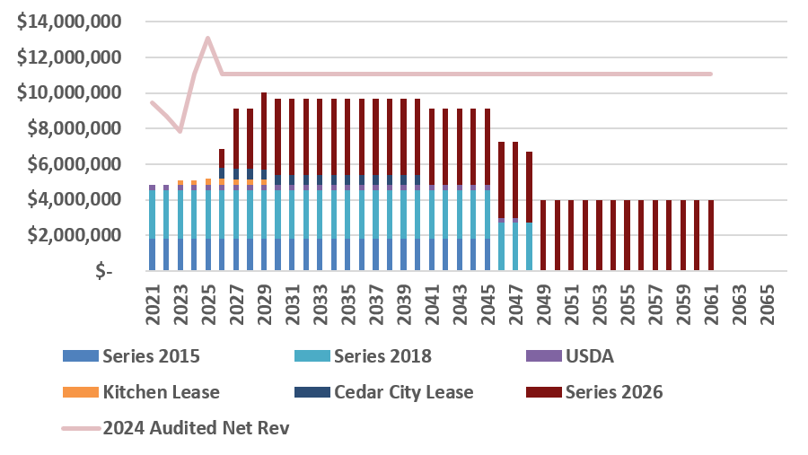

- Debt Burden Ratio
 | BB+ Requirement | Measure at end of FY 2027
 | Less than 18% | 13.2%

The debt burden ratio is expected to peak in FY 2027 at 13.2% of operating revenues. This is well below the Authority requirement.

- Operating Margin
 | BB+ Requirement | Measure at end of FY 2025
 | At least 14% | 17.6%

The School met this requirement in 4 of the last 5 years. FY 2024 was again an outlier related to the funding changes the School explained.

- Current Ratio
 | Requirement | Measure at end of FY 2025
 | At least 150% | 186%

The School met this metric in each year of the look back period.

Bond Documents

Legal bond documents are being reviewed by Dorsey & Whitney in its capacity as Issuer’s Special Counsel to the Authority, and all requirements are being incorporated. In addition, Chapman & Cutler, as Bond Counsel, has certified that each of the required legal provisions is present in the bond documents.

Continuing Disclosure

For the fiscal years ended June 30, 2022, June 30, 2023, June 30, 2024 and June 30, 2025, the Charter School filed its Audited Financial Statements and certain Annal Financial Information late and without late notice filings. The School has not adopted a formal policy for continuing disclosure.

Conclusion

The School is the largest charter school LEA in the State. It is intending to continue growing its enrollment with expansion projects funded by new bonds. These projects will increase leverage and could put a strain on the School’s financials. Overall enrollment in the State of Utah is down over the past few years and charter enrollment is flat. The School is expanding in some high growth areas which should allow it to take advantage of regional growth. Current enrollment is likely sufficient to maintain the expanded debt levels.

Appendix A – Additional Enrollment Information

