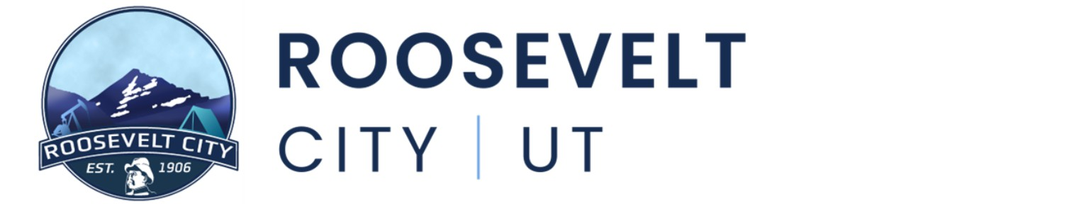

July 21st, 2026
Notice is hereby given that the Roosevelt City Council will hold their regularly scheduled meeting on Tuesday July 21st, 2026, at the Roosevelt Municipal Building located at 255 S State Street, Roosevelt, UT. The meeting shall begin promptly at 5:30pm.
- CALL TO ORDER
- ROLL CALL
- OPENING CEREMONY
Prayer and Pledge of Allegiance
- APPROVAL OF PREVIOUS MINUTES
  - APPROVAL OF PREVIOUS MINUTES, SIERRA WISENER
Meeting Minutes from 7.7.26
- PUBLIC COMMENT PERIOD
Three (3) minute time limit per speaker. If you would like to make a comment, but are unable to attend the meeting, please consider emailing your comment to citycouncil@rooseveltcity.com.
- COMMITTEE APPOINTMENTS
- PUBLIC HEARING(S)
  - FEE SCHEDULE
  - ORDINANCE CHANGE
- ACTION ITEMS
  - FEE SCHEDULE
  - ORDINANCE CHANGE, GRANT CHARLES
  - AQUATIC CENTER EMPLOYEE RECOGNITION, JOSHUA BAKE
  - FIREWORKS – 24TH OF JULY DISCUSSION/ACTION
  - SPILLMAN POLICE SOFTWARE CONTRACT APPROVAL, CHIEF MARK WATKINS
  - ROOSEVELT CITY RECORDER POSITION APPOINTMENT, JOSHUA BAKE
- EXPENDITURE APPROVAL & FINANCIAL REVIEW
- CITY MANAGER REPORT
- COMMITTEE REPORTS
- ITEMS FOR FUTURE DISCUSSION
- CLOSED SESSION
As for the purposes listed in Utah Code 52-4-205
    - Strategy sessions for purchasing, exchanging, leasing, or developing state-owned land (including water rights), if public discussion would reveal property value or prevent best terms.
    - Discussion of the character, professional competence, or physical or mental health of an individual;
- ADJOURN

Further information can be obtained by contacting Sierra Wisener at (435) 401-8198 In compliance with the Americans with Disabilities Act, individuals needing special accommodations (including auxiliary communicative aids and services) during these hearings should notify Sierra Wisener at 255 South State Street, Roosevelt, Utah, 84066, at least three days prior to the hearing to be attended.

