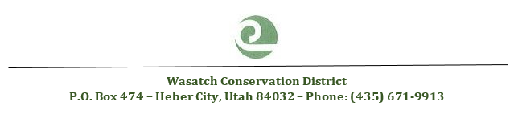

M I N U T E S
Wasatch Conservation District
Regular Meeting, June 10, 2026
WCWEP office, Heber City, Utah

ATTENDANCE:

Conservation District (CD) Supervisors
Addison Hicken, District Chair
Edd Sabey, Treasurer
George Muir, Supervisor
Allan Sulser, Supervisor
Ed Clyde, Supervisor

Conservation District Supervisors, Absent
Allan Sulser, Supervisor

Department of Agriculture and Food (UDAF):
Daniel Gunnell, Resource Coordinator
Rachel Winder, Conservation Planner-absent
Logan Davis, Conservation Planner

Conservation District Staff:
Heidi Hortin, Clerk

NRCS
Jenny Jo Cox, NRCS-absent
Alisha Franco, NRCS

USU Extension
Wesley Crump
Elizabeth Cohen-absent

County
-

Others
Sandy Wingert, DWQ - absent
Taylor Deppen, NRCS/DNR- absent

CD MEETING - CALL TO ORDER
10:30 a.m. - Addsion Hicken, WCD Chair, calls the Wasatch Conservation District budget meeting, held June 10, 2026, to order. The motion was made by Ed Clyde, WCD Supervisor and 2nd motion was made by Edd Sabey, WCD Supervisor. The board voted and approved to open the WCD budget meeting to open.

* Review of Tentative or Proposed Budget
- Presentation of budget updates by Addison Hicken, WCD Chairman
- The board and all attendees discussed the potential FY27 budget and any concerns raised.
* Formal Motions and Actions Taken
- Motion: Addison Hicken, WCD Chairman asks for motion to approve FY27 proposed budget. The motion was made by Edd Sabey, WCD Supervisor and 2nd motion was made by George Muir, WCD Supervisor. The board voted and approved the proposed FY27 budget as presented.
- Vote Tally:
  - Ed Clyde- yes * Addison Hicken - yes
  - Edd Sabey – yes * Allan Sulser - absent
  - George Muir - yes
- Motion passed
10:45 a.m. Meeting Adjourned:
Addison Hicken, WCD Chairman asks for motion to adjourn the FY27 Wasatch Conservation District Budget Hearing. The motion was made by George Muir, WCD Supervisor and 2nd motion was made by Ed Clyde, WCD Supervisor. The board voted and approved adjournment.

