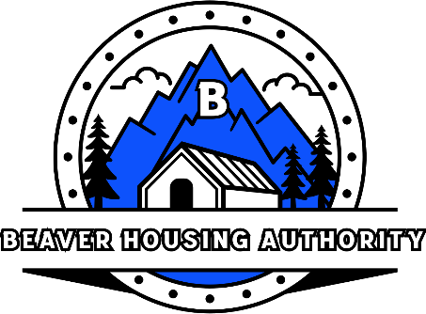
BEAVER HOUSING AUTHORITY
BOARD MEETING AGENDA
July 14th, 2026

- Welcome
- Prayer
- Attendance
- Minutes
- June Bills
- Waiting List Update
- Program Updates:
  - Public Housing (Hilltop)
  - USDA (Country Village)
  - LIHTC (Beaver & Milford Meadows)
  - CROWN Programs (Tushar, Milford, Mountain Shadows 1-4, Monroe, Casto)
  - Development (Property Management)
  - Section 8 (HCV & MS)
- Other Business
  - Project Updates
  - Water Shares
- Close Session
- Adjourn

