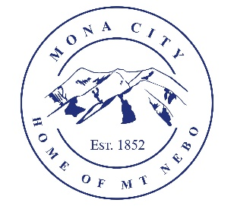
Mona City
435-623-4913
www.monautah.gov
20 West Center Street, Mona, Utah

Mona City Council Meeting Agenda
Tuesday, July 14, 2026
Mona City Building – 20 West Center
7:00 p.m.

Pledge
Prayer
Previous Meeting Minutes
Approval of June 23, 2026, Work Session Minutes
Approval of June 23, 2026, City Council Meeting Minutes
Action Items
- Continuation of Juab County EMS Services
- Consideration and Approval of Hiring Recommendations
Planning and Zoning
- Kayson Keyte – Accessory Building with Utilities – 200 West Center
Secretary
- Cemetery Policies
Finance Director
- Approval of Finances
Recorder
- Water work session for July 28th
- Main Street project will begin after the Mona Celebration
- Sewer Master Plan & Zoning Map on website
Gas & Water & Roads
Sewer
Council Reports
Public Comment
Adjournment

CERTIFICATE OF POSTING
This agenda is hereby properly advertised on this 13th day of July, 2026, by posting copies in the following places: the Mona City Office, on the Mona City website at monautah.gov, at the United States Post Office Mona City Branch, and on the Utah Public Notice Website at www.utah.gov/pmn/index.html.

Upon Request, in compliance with the Americans with Disabilities Act, reasonable accommodations for individuals with disabilities will be provided. For assistance, please call 435-623-4913.

