Kanosh Town Council Regular Meeting

Meeting Minutes
June 10, 2026, 7:00 PM
55 North Main Street, Kanosh, UT, US

*As mandated by law, a Public Hearing was held before the adoption of the 2026-2027 fiscal year final budget. The public hearing is held to receive public comments in reference to the budget.

Note: There were no public comments received.

Welcome and Call to Order of Regular Kanosh Town Public Meeting

The Kanosh Town Council Regular Meeting was called to order at approximately 7:00 PM on Wednesday, May 14, 2026, at 55 North Main Street, Kanosh, UT. Mayor Wenda Crabb presided.

Members present: Council Members present: Mayor Wenda Crabb, Council Members Josh Whitaker, Dan DeGraffenried, and Brian Batt. Council Member Tim White was unable to attend the meeting. Kanosh Town Clerk Kacie Whatcott was also in attendance.

Others in attendance: CERT Captain Geri Minton, Town Manager Lorin Shumway, Town Employee Jim Kooy, Pat Bennett, & Ben Coray

The invocation was offered by Council Member Josh Whitaker.

The Pledge of Allegiance was led by Council Member Dan DeGraffenried.

Approval of Minutes from the Previous Meeting

Mayor Crabb called for approval of the minutes from the prior meeting. A brief discussion addressed how council members could submit corrections by adding comments directly to the shared document so the clerk could track and resolve them. Council members indicated general satisfaction with the new format of the minutes.
Minutes of the May 2026 meeting were read and approved by motion Council Member Josh Whitaker; Council Member Brian Batt provided a second to the motion, and all council members voted in favor, as noted below:
Mayor Wenda Crabb Aye
Council Members
Josh Whitaker Aye
Dan DeGraffenried Aye
Brian Batt Aye

Approval of Payment of Warrants for the Current Meeting

Town Clerk Kacie Whatcott presented the warrant spreadsheet for review.
Warrants for June 2026 were read, discussed, and approved to be paid through a motion by Council Member Brian Batt. Council Member Dan DeGraffenried provided a second to the motion, and all council members voted in favor as noted below:
Mayor Wenda Crabb Aye
Council Members
Josh Whitaker Aye
Dan DeGraffenried Aye
Brian Batt Aye
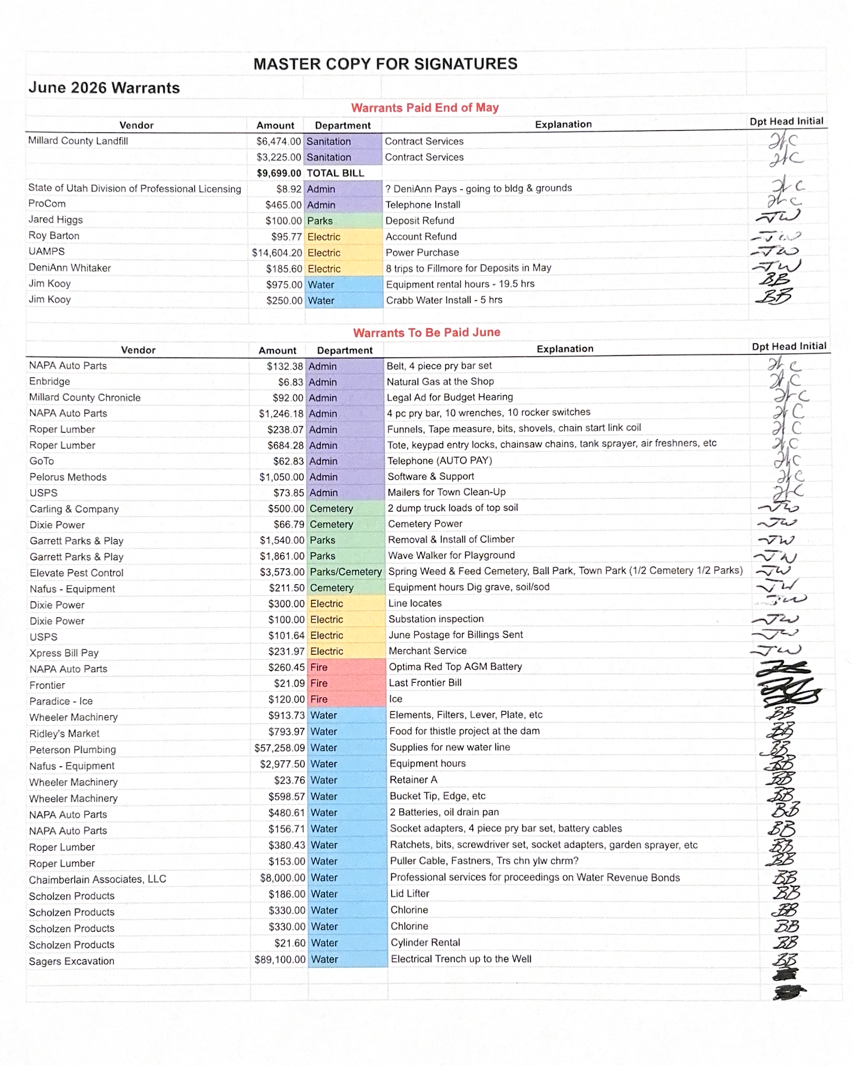

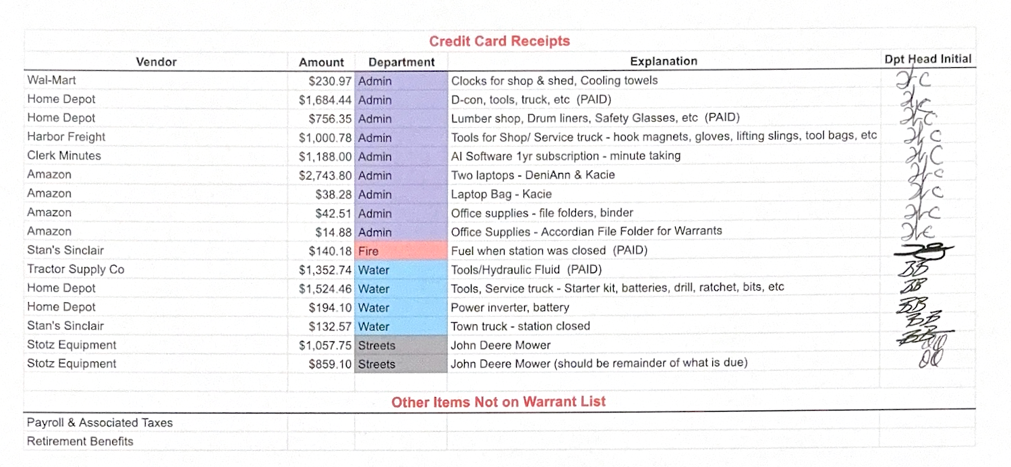

CERT
Geri Minton reported that Millard County has a new Emergency Manager affiliated with the Sheriff's Office, identified as Ken Skeem, replacing the retiring Shane Brunson. No CERT meetings have yet been scheduled with the new manager, and updates on meeting dates and new directives are forthcoming.
Fire Department
Fire Chief Lorin Shumway reported that conditions are extremely dry and urged all residents to exercise caution. He noted that a recent incident during valve work, where a grinder sparked a small grass fire, illustrated how quickly fire can spread under current conditions.
Fire Chief Shumway announced the addition of two new firefighters — his brother Chris and Zach Statler. He also noted that Jim Kooy will also be joining the department.
Regarding the 4th of July, the council and Fire Chief discussed the town's general policy of allowing fireworks consistent with state guidelines (the day of and the day after), while strongly encouraging residents to keep a hose ready and avoid areas near dry pastures. The council was in agreement with continuing this approach.
Fire Chief Shumway also clarified for the public record that the burn ban is in effect from June 1st through approximately October, with no open burning permitted during that period.
Planning and Zoning
Geri Minton reported that two building permits were approved at the most recent Planning and Zoning meeting: one for a prefabricated standalone garage for Kevin and Melanni Lang, and one for a shop for Cleve Christensen. Neither structure requires new water or power connections at this time. Both permit fees were collected.
Additionally, a lot split into six parcels was approved. The split had been surveyed and processed through the County Recorder's Office with participation from Molly Stevens of Signature Realty and Martha Stott. All required paperwork has been signed and filed.
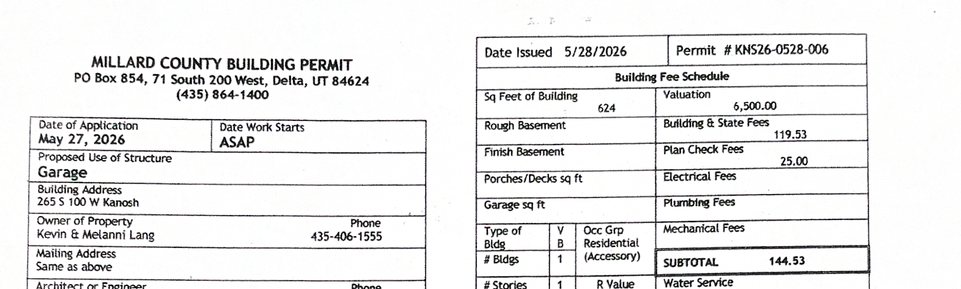
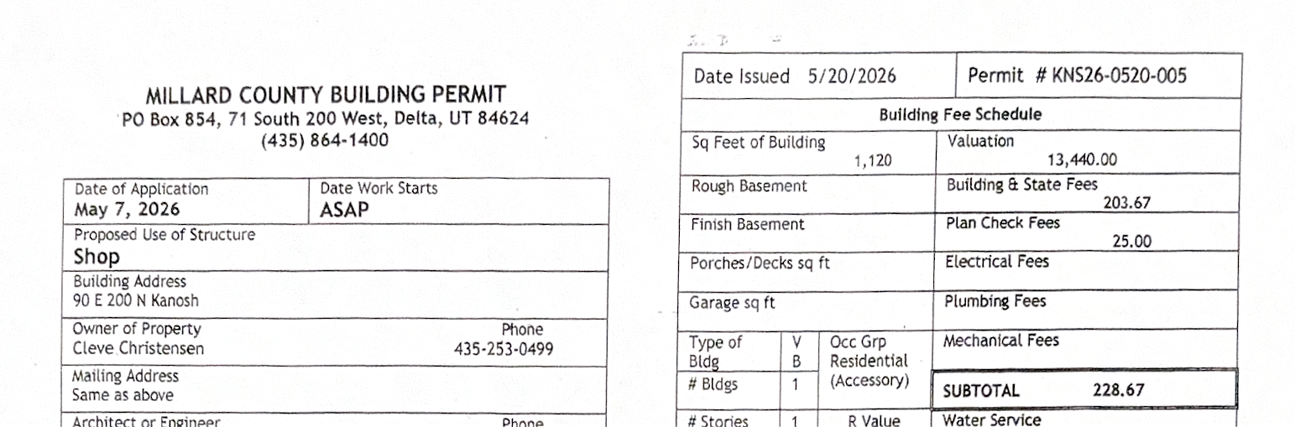

Review, Discussion, and Action Items

*Cemetery – Report on Hours with Projected Seasonal Expense
Mayor Crabb presented a detailed report on cemetery staffing hours and projected seasonal expenses. She noted that the three-person cemetery care team has been doing exceptional work and has received widespread positive feedback from the community, particularly during Memorial Week.
The team has been mindful of budgetary constraints and voluntarily accepted a lower pay rate when hired, despite their skill level warranting more. Based on actual hours logged in May and a projected 10% increase in hours for additional projects — including additional seeding, spot watering, and filling in low areas — the projected total seasonal cost at the current rate is approximately $10,234 (inclusive of employer taxes). If the council approved a $3.00 per hour raise, the projected seasonal cost would rise to approximately $12,000. Mayor Crabb noted this figure does not include bathroom cleaning, which would be funded separately through the park budget.
Discussion also touched on the condition of the undeveloped north field of the cemetery. Council members discussed options including mowing versus sterilizing the area, with general consensus that sterilizing could invite invasive weeds and that the space may eventually be needed for future burials.
It was agreed to raise the rate for the cemetery workers through a motion by Council Member Dan DeGraffenried. Council Member Josh Whitaker provided a second to the motion, and all council members voted in a roll call vote as noted below:
Mayor Wenda Crabb Aye
Council Members
Josh Whitaker Aye
Dan DeGraffenried Aye
Brian Batt Aye

*Corn Creek Watershed Project – Review Design Funds Request Letter
Mayor Crabb briefed the council on the status of the Corn Creek Watershed Project. The town has been officially approved to move to the next phase. The total estimated project cost remains approximately $33,000,000, with Corn Creek Irrigation responsible for a portion covered 75% by grant funds and 25% by irrigation company funds. The town's obligations remain limited to securing permits and easements, with the engineering firm working to mitigate associated costs.
The specific action before the council was authorization for Mayor Crabb to sign documents releasing design funds and accepting a 3% increase in the overall project budget, attributable to inflation since the project's inception. Mayor Crabb clarified this does not change the town's obligations but does increase the total grant request accordingly.
Council Member DeGraffenried raised broader questions about the town's long-term financial exposure as sponsor of the project alongside the Kanosh Tribe, noting that at some point a funding obligation will need to be addressed. Mayor Crabb confirmed the town's out-of-pocket cost is projected at approximately $125,000 to $150,000, and the project engineer (Lane) is actively working to reduce that figure through easement mitigation strategies. The significant community benefits — including a redesigned and more stable dam, pressurization of the water delivery system, a new storage pond, an extended irrigation season, and improved FEMA flood zone standing — were also discussed.
It was agreed to approve the funds for design and the increase by 3% through a motion by Council Member Josh Whitaker. Council Member Brian Batt provided a second to the motion, and all council members voted in favor as noted below:
Mayor Wenda Crabb Aye
Council Members
Josh Whitaker Aye
Dan DeGraffenried Aye
Brian Batt Aye

*Electric – Discussion on Adding a Possible Small Base Rate
*Floating Rate Adjustment: The six-month average cost of power has reached approximately $0.079 per kilowatt hour, with the current month coming in at approximately $0.08. The current floating surcharge on electric bills is $0.01 per kilowatt hour. Council Member Whitaker recommended increasing the floating rate by $0.01 (to $0.02) to prevent the town from absorbing significant losses. He noted the floating rate is designed precisely for this scenario, to avoid large structural rate changes.
It was agreed to increase the floating rate by $0.01/kw hour through a motion by Council Member Josh Whitaker. Council Member Dan DeGraffenried provided a second to the motion, and all council members voted in favor as noted below:
Mayor Wenda Crabb Aye
Council Members
Josh Whitaker Aye
Dan DeGraffenried Aye
Brian Batt Aye

*IPP Power Recall: Council Member Whitaker informed the council that IPP (Intermountain Power Project) is changing to a seasonal recall model. He has recalled the town's full IPP allocation for summer. For the winter season, he does not anticipate a need to recall the power, and IPP will sell the town's share on the open market, with the proceeds returned to the town. The council raised no objections.
*Base Rate / Meter Reading Fee Discussion: Council Member Whitaker raised the issue of meters in town that use little to no power — due to solar installations or seasonal vacancies — for which the town still incurs meter-reading labor costs without generating any revenue. He proposed either a universal base rate on all meters (similar to the water base rate) or a small fee for meters recording minimal usage. Council discussion favored a universal modest base rate spread across all meters — estimated at around $5.00 per meter per month — rather than singling out low-usage accounts. The council agreed to revisit this after the automatic meter-reading system is evaluated later in the year, with the understanding that a future town meeting and public process would be appropriate before implementation.

*Revisit Plan to Remove Stop Signs Along 300 S – Discuss Other Speed Control Options
Council Member Dan DeGraffenried led discussion on replacing the stop signs along Canyon Road (300 South) with speed control signage. After further reflection, the council moved away from speed bumps and toward solar-powered radar speed display signs. Council Member DeGraffenried researched options on the consumer market, identifying units in the $500–$700 range featuring LED displays, solar charging, battery backup, and color-coded feedback (green for at-or-under the speed limit, red for over).
Mayor Crabb added that research suggests radar speed signs are more effective when paired with contextual signage such as "Children at Play" or "Children in Area," and recommended purchasing such signs to accompany the radar units. The council agreed. Discussion also touched on optimal placement — suggested as roughly mid-block coming from both the east and west — to give drivers adequate time to slow down before reaching the residential core. It was noted that the town already has 25 mph speed limit signs in stock.
The council confirmed that the existing stop signs will be removed in coordination with installation of the new signage, with the understanding that the removal does not require a separate motion. The Sheriff's Office radar trailer currently in place will continue to be available from the county at no cost.
It was agreed to approve the purchase up to $2,000 for speed and traffic control along 300 S through a motion by Council Member Dan DeGraffenried. Council Member Josh Whitaker provided a second to the motion, and all council members voted in favor as noted below:
Mayor Wenda Crabb Aye
Council Members
Josh Whitaker Aye
Dan DeGraffenried Aye
Brian Batt Aye

*Cemetery & Town Equipment – Discuss Purchase of Town Equipment
Lorin (Town Manager) and council members discussed the ongoing need for additional town equipment, specifically a side-by-side utility vehicle, a riding mower with a bagger for the cemetery, and a utility trailer.
Regarding the side-by-side, Lorin noted that the oldest four-wheeler frequently overheats and that a utility-style side-by-side would significantly improve meter-reading operations. The council discussed the possibility of utilizing a fire department side-by-side that is being considered for surplus, pending evaluation of its mechanical condition and parts availability. The council agreed to explore that option for a defined trial period before committing to a purchase.
Regarding a mower with a bagger for the cemetery, discussion clarified that the town has always owned and maintained its own mowing equipment, even when cemetery care was contracted out. A mid-to-high grade commercial mower was estimated at $8,000–$14,000. The council expressed clear support for prioritizing the mower purchase.
Regarding a utility trailer, a smaller 14-foot trailer suitable for hauling mowers was discussed at an estimated cost of $2,500–$5,000. A larger trailer capable of hauling a mini excavator was acknowledged as a longer-term need.
Finance staff indicated that sufficient funds exist in the general fund's administrative budget — approximately $14,000 in unspent allocation — to cover equipment purchases. The cemetery's capital outlay line was also identified as an appropriate funding source for the mower. The council directed staff to return in July with specific pricing and options for the mower and trailer, and to continue evaluating the fire department side-by-side in the interim.

*Follow-up on Public Hearing – Adoption of FY27 Budget
Mayor Crabb thanked residents who attended the public budget hearing. After confirming that all prior discussions and amendments had been incorporated, the council moved to formally adopt the FY27 budget. Following adoption, a discussion regarding the well project (Item 8k) revealed that the budget did not fully account for costs associated with the Dixie Power electrical line for the new well — approximately $189,000 in remaining costs — requiring the budget to be reopened and re-adopted as amended.
It was agreed to approve the FY27 budget through a motion by Council Member Dan DeGraffenried. Council Member Brian Batt provided a second to the motion. A roll call vote was conducted:
Mayor Wenda Crabb Aye
Council Members
Josh Whitaker Aye
Dan DeGraffenried Aye
Brian Batt Aye
The motion carried. Motion Passed.

Following discussion of the well project, motion to reopen the FY27 budget was made by Council Member Brian Batt and seconded by Council Member Josh Whitaker. Council members in attendance voted in favor as noted below:
Mayor Wenda Crabb Aye
Council Members
Josh Whitaker Aye
Dan DeGraffenried Aye
Brian Batt Aye

Motion to adopt the FY27 budget as amended to reflect the additional water/power line expenditure was made by Council Member Josh Whitaker and seconded by Council Member Brian Batt. Council members in attendance voted in favor as noted below:
Mayor Wenda Crabb Aye
Council Members
Josh Whitaker Aye
Dan DeGraffenried Aye
Brian Batt Aye

*Department Reviews – Council Report on Departments
Parks: Mayor Crabb noted that Stephen has been handling park mowing and that Jim Kooy's assistance has been invaluable. A formal parks report was deferred to the July meeting as Council Member Tim White was not present.
Electrical: Council Member Whitaker reported that the town's share of the cost for a wind energy feasibility study came in at $8.54, reflecting the town's very small proportional stake in the project.
Roads: Council Member DeGraffenried reported that a flat stockpile area north of town has been graded and that road base chip deliveries from a contractor are expected to begin the following day. The contractor will finish work in Richfield and then proceed to Kanosh for road chip-sealing work.
Water: Council Member Brian Batt reported that the water main installation along 100 East, past the new ClearCom building, is nearly complete with only a few pipe sections and fire hydrant connections remaining. Testing is anticipated within a couple of weeks. Directional boring work is also being scheduled for later in the month or early July.
General (Mayor): Mayor Crabb provided an update on the town cleanup initiative, noting that residents have responded positively to having a designated drop-off location for bulky items. She reported receiving an offer from a metal recycling company ("The Recycling Place") to place a 40-yard metal-only dumpster at the town dump site at no cost to the town, serviced every three to six weeks. The council discussed the practical challenges of policing contamination in such a dumpster and expressed reluctance to take on enforcement responsibilities without camera monitoring at the site. The council was informed that Stan indicated Fernando (a local resident) may already accept metal for recycling at his location, which would be shared as a resource.
The council reached general consensus that trail cameras at the dump site would be a useful deterrent and enforcement tool regardless of the dumpster decision, and that this should be explored. The metal recycling dumpster proposal was tabled pending further consideration of the camera infrastructure.

*Utility Delinquency Review
Council Members reviewed the monthly delinquency list. It was determined, again, to handle those accounts in arrears according to the established Town policy.

*Public Comments
Pat Bennett, representative from the Millard County Sheriff's Office, addressed the council regarding a new state law — Senate Bill 215 — expanding on the 2021 Essential Services Bill. The new law requires municipalities and counties to issue a Request for Proposals (RFP) for 911 EMS response services and interfacility transports, and ties those agreements to the annual relicensure of EMS providers. The Millard County Ambulance license must be renewed by August, creating a near-term deadline.
Pat explained that rural municipalities may defer their RFP obligation to the county, allowing one consolidated county-level RFP to satisfy the requirement for all incorporated towns. Fillmore City and Holden have already agreed to this approach. He provided a copy of the enacted legislation and a sample deferral letter drafted by EMS Director Lindsey Mitchell. No formal action was taken, as the item was not on the agenda. Mayor Crabb directed that the item be placed on the July meeting agenda for formal ratification of the deferral letter.
Pat also noted a future possibility of a prepared food tax (up to 1–2%) that could help fund EMS operations, particularly given that approximately 35% of EMS calls involve non-residents. This would require a ballot measure and significant public education, and was presented as a longer-term consideration only.

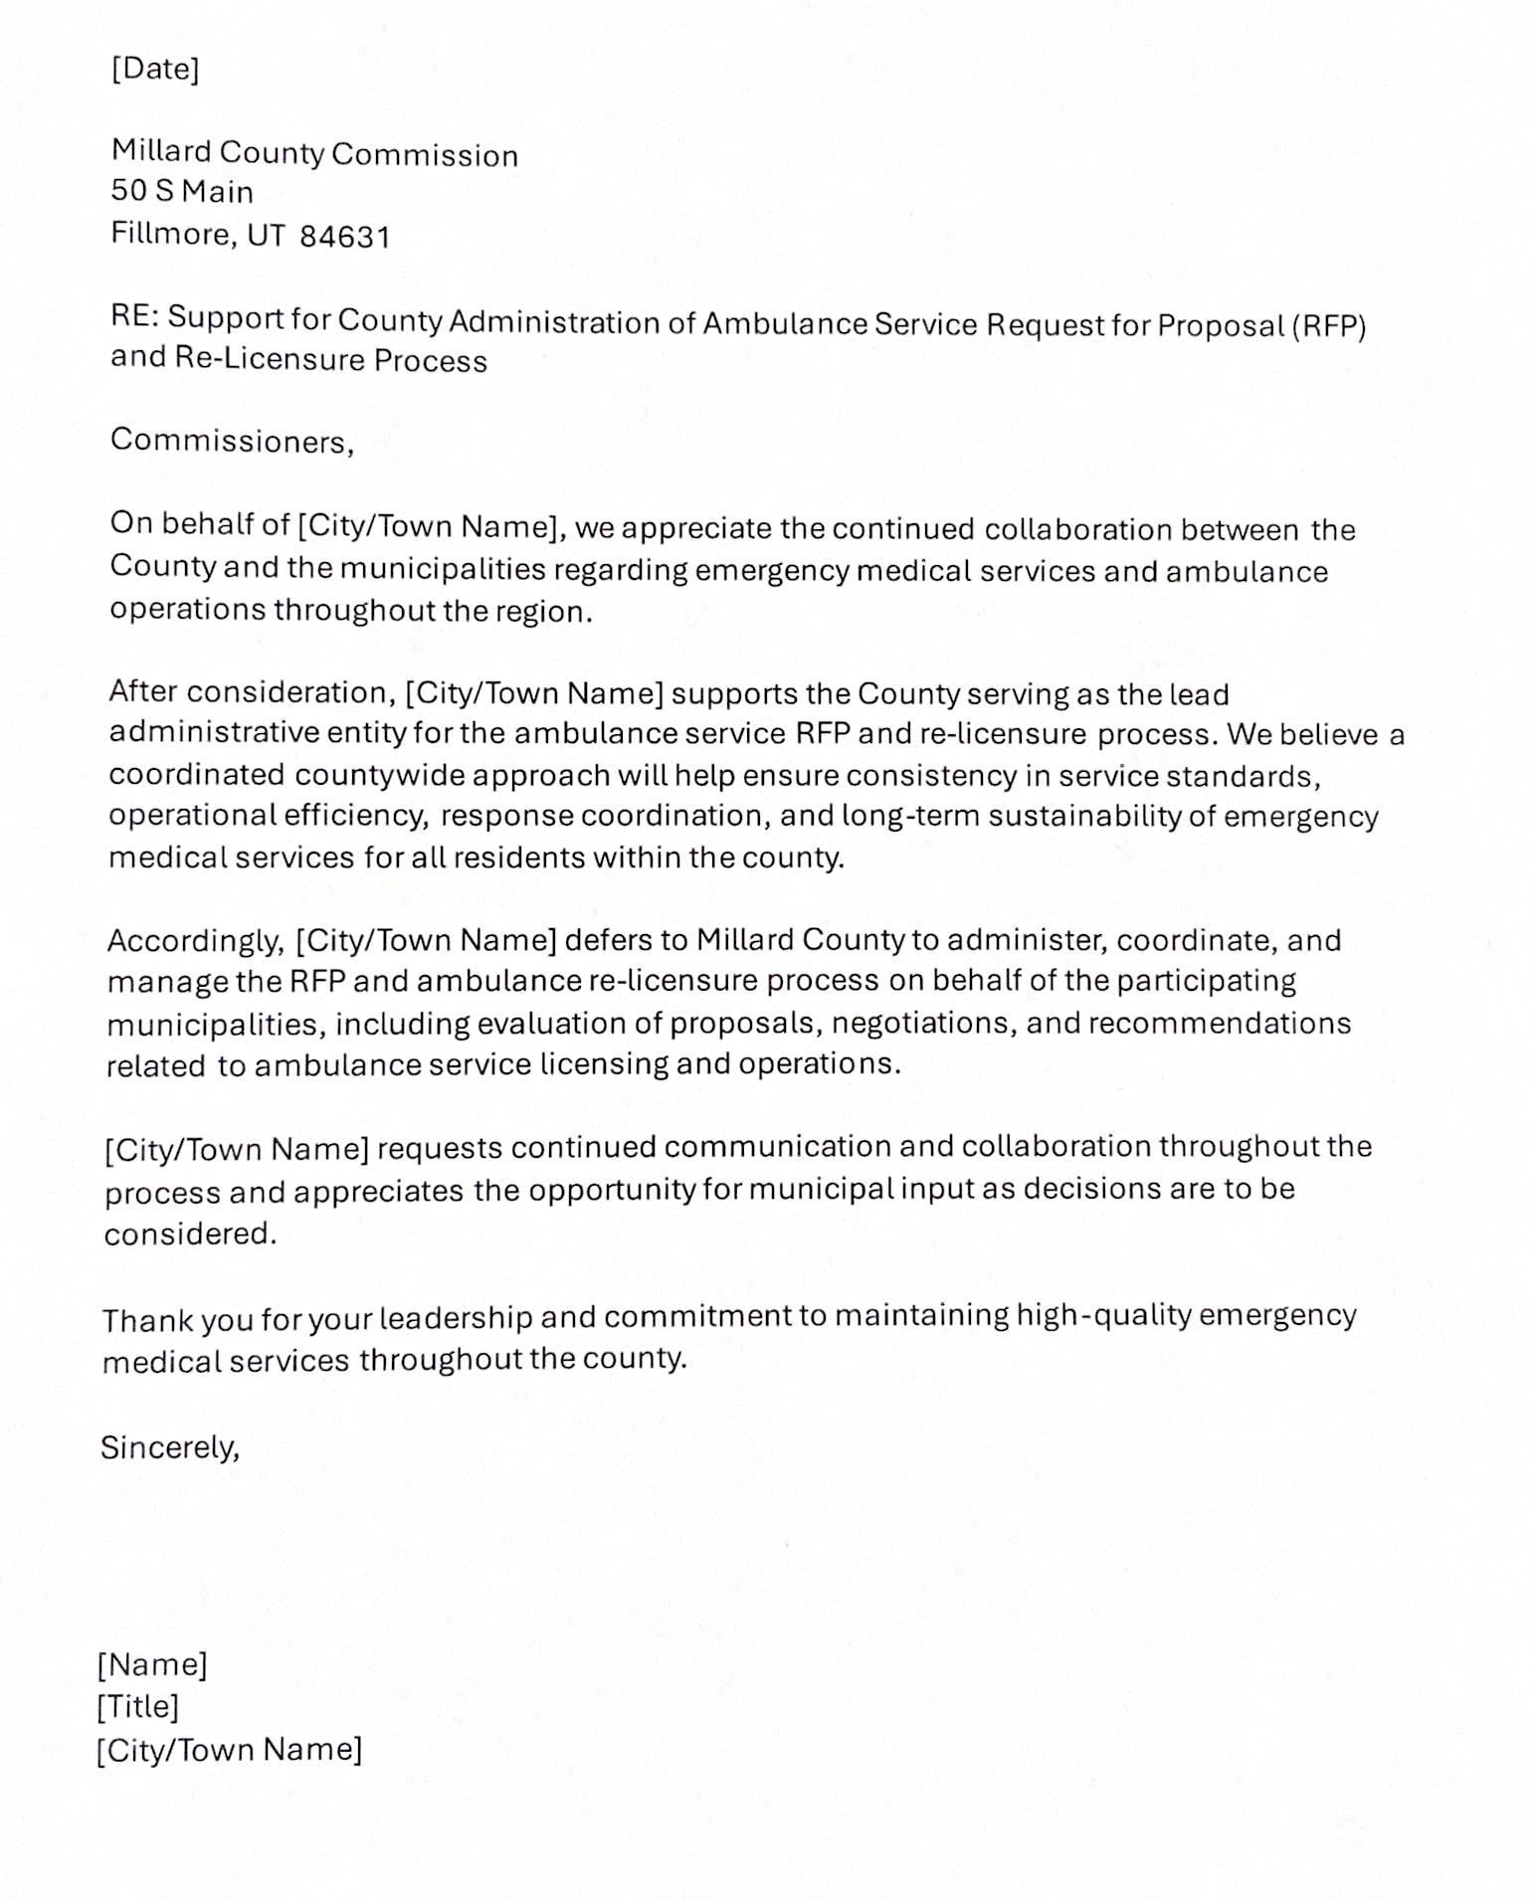
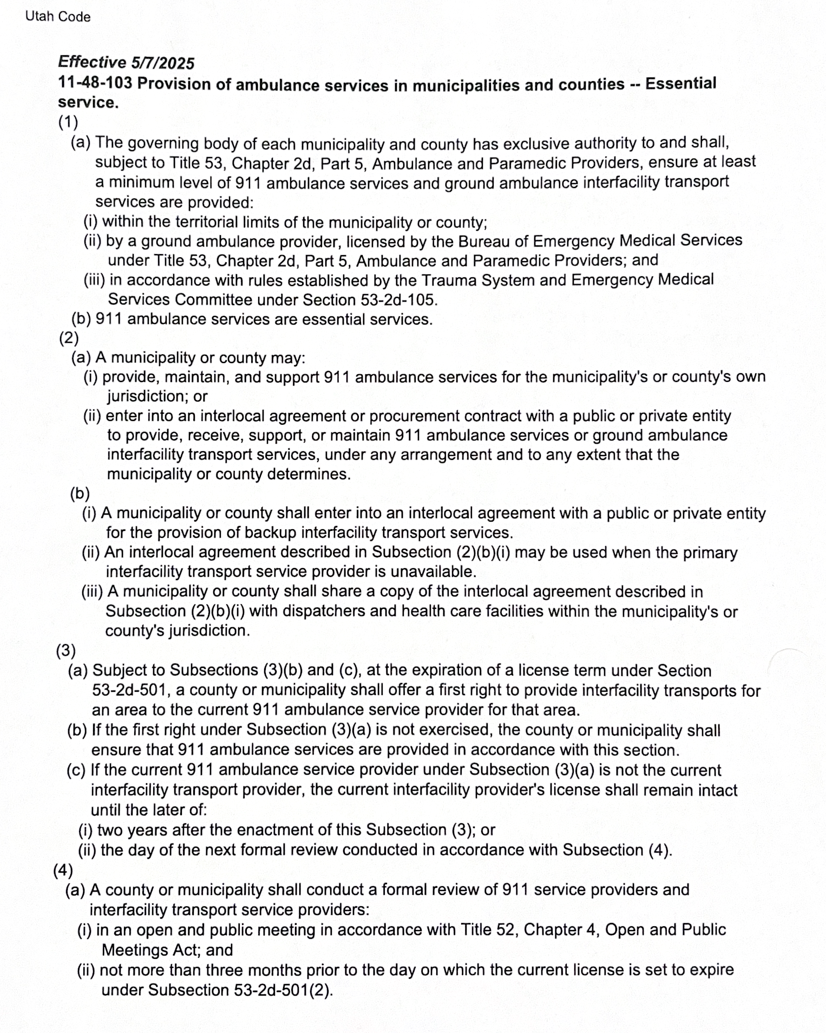

*Follow Up on Old Business

Well Project
The town's engineering consultant Ben provided a progress update on the new well project. He identified two primary reasons for delays: supply chain challenges related to Build America, Buy America (BABA) compliance requirements for electrical components, and scheduling. Specifically, certain 480-volt breakers are on back-order until September 1st.
To maintain progress, the contractor (Tusher) proposed installing temporary electrical components at their own cost to get the well operational for testing and approval, then swapping in the compliant permanent components upon their arrival. Ben expressed gratitude for this proactive approach.
Key milestones noted: the well pump installer is scheduled for the week of June 22nd; Dixie Power (Sager) is prepared to set the transformer and energize the site by end of the week or early the following week; and Ben expressed optimism that water could be flowing and testing underway before the 24th of July.
Ben also reported that valve replacement work at the storage tanks was completed, resolving one known leak. However, a second leaking valve — believed to be on the west tank, installed circa 2003 — continues to allow water to bypass. Ben recommended replacing that valve as well, estimated at under $10,000, and noted the remaining project contingency fund stands at approximately $60,000.
A broader budget discussion clarified that the cost of the Dixie Power electrical line — totaling approximately $239,000 when combining amounts already paid and amounts still owed — was not fully reflected in the adopted FY27 budget. It was determined that the remaining balance would need to be drawn from town investment/PTIF accounts, consistent with prior council understanding. This realization necessitated the reopening and re-adoption of the FY27 budget as noted under the “Follow-up on Public Hearing – Adoption of FY27 Budget” action item.
Ben also introduced the concept of a line extension cost-sharing ordinance, similar to one used by Fillmore City, which would allow the town to recoup a proportional share of the electrical line cost from any future entities that connect to that line within a defined period (typically up to 10 years).

*Adjourn
A motion to adjourn the meeting was made by Council Member Dan DeGraffenried and seconded by Council Member Tim White. All council members voted in favor as noted below:
Mayor Wenda Crabb Aye
Mayor Wenda Crabb Aye
Council Members
Josh Whitaker Aye
Dan DeGraffenried Aye
Brian Batt Aye
The meeting was adjourned at approximately 9:26 PM.

