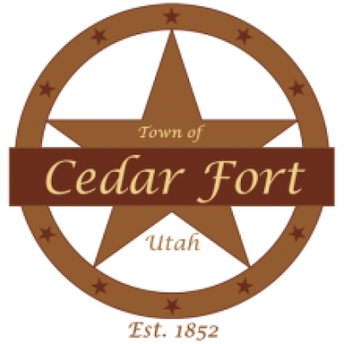
PUBLIC NOTICE

Town of Cedar Fort
Tuesday, July 21, 2026 @ 7:00 pm
Town Hall, 50 East Center Street, Cedar Fort, UT 84013

Notice is hereby given that the Town Council of the Town of Cedar Fort will hold a Public Hearing on Tuesday, July 21, 2026, at 7:00 p.m. at the Cedar Fort Town Hall, Cedar Fort, Utah.
The purpose of the public hearing is to receive public comment regarding the following items:
- Proposed amendments to Title 10 of the Cedar Fort Town Code, including but not limited to updates related to MG40 zoning, Sensitive Overlay Zones, APWA Standards, and other related ordinance amendments as deemed necessary by the Planning Commission.
- Proposed amendments to Title 5 and Title 6 of the Cedar Fort Town Code.
- Consideration of one or more proposed resolutions relating to Town business.
All interested persons are invited to attend and provide comment regarding these matters.

Meeting Details:
📅 Date: July 21, 2026
🕖 Time: 7:00 p.m.
📍 Location: Cedar Fort Town Hall
Google Meet joining info
Video call link: https://meet.google.com/sdo-qojb-chp

All interested persons are invited to attend and will be given an opportunity to be heard. Written comments may be submitted prior to the meeting in accordance with Town policy.
This notice is published in compliance with applicable public notice requirements.
Dated this 6th day of July, 2026.
Kandice Johnson
Town Clerk, Town of Cedar Fort
Certificate of Posting
The Town does hereby certify that the above notice and agenda has been posted at the designated meeting place and the Utah Public Notice Website.

