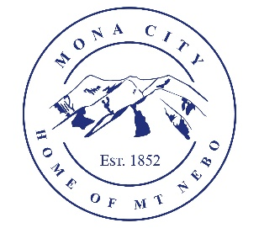
Mona City
435-623-4913
www.monautah.gov
20 West Center Street Mona, Utah

Planning and Zoning Meeting Agenda
Wednesday, July 1, 2026

7:30 pm
Mona City Council Room
20 West Center Street, Mona

- Approval of June 3, 2026 Meeting Minutes

- Discussion and Action Items:
- Kayson Keyte – Accessory Building with electrical – 200 West Center
- Oak Dutson – Accessory Building with electrical - 255 N 200 E
- Troy Linton – Garage – 390 East 200 North
- Mark Holden – Passive Solar Greenhouse – 563 Center

- Secretary Items

CERTIFICATE OF POSTING

This agenda is hereby properly advertised on the 30th day of June, 2026, by posting copies of this agenda at the Mona City Office, at the United States Post Office located in Mona City, on the Mona City website at monautah.gov, and on the Utah Public Notice Website at www.utah.gov/pmn/index.html.

Upon Request, in compliance with the Americans with Disabilities Act, reasonable accommodations for individuals with disabilities will be provided. For assistance, please call 435-623-4913.

